

P.S.S.A. TESTING WINDOW FOR 2025 – 2026

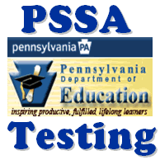

Assessment | Dates | Grades
English Language Arts (E.L.A.) | April 20, April 21, April 22, April 23 and April 24, 2026 | Grades 3 - 8
Mathematics | April 27, April 28, 2026 | Grades 3 - 8
Science | April 29, April 30, 2026 | Grades 5 and 8

