Berlin Brothersvalley School District
Chapter 339
Future Ready PA Index
Comprehensive K-12
Career Development and College/Career Readiness Program
August 30, 2022

Table of Contents
1. Introduction -5
2. Guidance Plan Committee/List of School Counselors and Assignments -6
3. School-Counseling Department Core Beliefs -7
4. Philosophy of the School-Counseling Department -8
5. School-Counseling Department Mission Statement -8
6. The Program Goals of the K-12 School-Counseling Program -8
7. Stakeholders -9
- Students -9
- Parents -9
- Educational -10
- School Board -10
- Administration-District Superintendent -10
- Building Principals -10
- District Counselors -10
- Teachers -10
- Business Community Representatives -11
- Post-Secondary Partners -11
8. Role of the School Counselor -11
- Foundation -12
- Delivery -12
- Management -13
- Accountability -14
- System Support -15
- As a Leader -16
- As an Advocate -16
- As a Collaborator -16
- As an Agent of Systemic Change -16
9. Advisory Council -16
10. Program Calendars -18
- Elementary School -18
- Middle School -23
- High School -33
11. Program Delivery -37
- Academic Domain -38
- Career Domain -40
- PA Academic Standards for Career, Education and Work -42
- Berlin Brothersvalley K-12 Career Development Implementation Plan -44
3. Personal/Social Domain -63
- Pennsylvania Standards for Interpersonal Skills -65
- Elementary School -68
- Middle School -68
- High School -68

12. Program Structure: Five Program Components -69
1. Guidance Curriculum -69
- Academic Development -69
- Career Development
- Personal/Social Development -69
- Community Involvement -70
2. Individual Planning -70
3. Prevention, Intervention, Responsive Services -71
- Counseling -73
- Consultation -73
- Collaboration -73
- Coordination -75
- Case Management -75
- Referrals -75
4. System Support -75
- Professional Development -75
- Action Plans -76
- Program Management/Agreements -76
- Program Evaluation -76
- Consultation with Staff -77
- Community Outreach -77
- Public Relations -77
- Technology -77
- Tools for System Support -78

13. Organizing Career/Postsecondary Resources -78
14. Individualized Academic/Career Plan -81
- Elementary School: My Student Planner -81
- Middle/High School: Career Concepts Portfolio -88
15. Career and Technical Center Strategy -97
- Student Awareness -98
- Parent Awareness -98
- Educator Awareness -98
16. Berlin Brothersvalley Guidance Counselor Job Description -99

Introduction

In Pennsylvania, School Counselors are integral in the academic, career and personal/social development of all PreK-12 students. A comprehensive guidance plan is required as part of Pennsylvania School Code in Chapter 339 – Guidance.

§ 339.31. Plan.
There shall be a written plan on file, approved by the local board of school directors, for the development and implementation of a comprehensive, sequential program of guidance services for kindergarten through 12th grade. The plan must include procedures to provide for guidance services to AVTSs.

Additionally, a comprehensive program of student services is required as part of Pennsylvania School Code in Chapter 12 – Services to Students. An abbreviated section is shown below.

§ 12.41. Student services.
(a) Each school entity shall prepare a written plan for the implementation of a comprehensive and integrated K-12 program of the student services based on the needs of its students. The plan shall be prepared and revised in accordance with the time frames and procedures described in § § 4.13(a), (b), (d), (e) and (f) (relating to strategic plans). Services offered by community agencies in public schools shall be coordinated by and under the general direction of the school entity…
(b) Though the variety of student services offered will differ from school to school depending upon its size and the needs of its students, the following categories of services shall be provided by each school entity in planning its student services:
(1) Developmental services for students that address their developmental needs throughout their enrollment in school. Developmental services include guidance counseling, psychological services, health services, home and school visitor services and social work services that support students in addressing their academic, behavioral, health, personal and social development issues …
(2) (c) Student services must:
(1) Be an integral part of the instructional program at all levels of the school system.
(2) Provide information to students and parents or guardians about educational opportunities of the school’s instructional program and how to access these opportunities.
(3) Provide career information and assessments so that students and parents or guardians might become aware of the world of work and of a variety of career options available to individual students. 2

In addition, Chapter 4 – Academic Standards and Assessment references the Academic Standards, including Career Education and Work, which address the importance of career planning for all students related to labor market projections and workforce needs.

For complete language for the references above, visit the Pennsylvania School Board of Education website at: http://www.pacode.com/secure/data/022/022toc.html.

II. Guidance/Career Plan Committee/List of School Counselors and Assignments

Guidance/Career Plan Committee

Larry Ogline School Board President
Dr. David Reeder Superintendent
Brian Thompson High School Principal
Martin Mudry Elementary/Middle School Principal
Maria Murphy Special Education Coordinator/Parent
Danielle Hay School Social Worker
Eric Lauer Curriculum Coach

Guidance Staff: Title: Counselor/Student Ratio:
Jenna Hankinson, M.Ed E.S. Counselor K-4 1/286
Mark Smith, M.Ed M.S. Counselor 5-8 1/225
Christy McMillen, M.Ed H.S. Counselor 9-12 1/211

Steering Committee:
Somerset County Counselor Association

III. School-Counseling Department Core Beliefs

The counselors in Berlin Brothersvalley believe that:

• every student has dignity and worth.

• every student has the right to participate in the guidance counseling program.

• every student regardless of ethnic, cultural, racial, sexual orientation, gender, etc., differences and special needs are considered in the planning and implementation of the program.

• all students K-12 shall have access to a full-time state certified Masters degree level school counselor.

and that the Berlin Brothersvalley K-12 Career Program:

• be based on specific goals and developmental student competencies

• be planned and coordinated with other representatives of the school and community

• utilize the many combined resources of the community.

• be evaluated on specific goals and agreed upon student competencies

• actively involve students and others to monitor student results.

and that all Berlin Brothersvalley counselors:

• abide by the professional ethics of guidance and counseling as advocated by the American School Counselor Association.

• participate in professional development activities essential to maintain a quality guidance program.

IV. Philosophy of the School-Counseling Department

Philosophy Statement
The Berlin Brothersvalley School Guidance and Counseling Program believes that all students at all grade levels will have access to a full-time certified school counselor and have a right to participate in the guidance program. The program will be based on specified goals and will be an integral part of the students’ education, through which students prepare for meaningful and rewarding lives as productive members in a changing society.

V. School-Counseling Department Mission Statement

Mission Statement
The mission of the Berlin Brothersvalley School District’s school counseling program is to provide all students with the academic, personal and social skills necessary to become responsible, productive and respectful individuals who develop into contributing members of society. The integrated program reflects the goals of the district’s Comprehensive Plan and is developmentally appropriate. In partnership with students, staff, family, community members, and employers, the counseling program prepares all students to achieve success in school, attain skills that will make them college and career ready, become lifelong learners and live healthy and fulfilling lives.

VI. The Program Goals of the K-12 School-Counseling Program

School counseling is an essential component of Berlin Brothersvalley School’s overall educational program, supporting academic success for each student. It is based on the belief that each student possesses intrinsic worth and specific rights, and is a unique and dynamic person capable of personal growth, lifelong learning and self- direction. The Berlin Brothersvalley comprehensive school counseling program supports the development of the competencies and skills that students will acquire to meet standards and expectations established by the state, the community and the district, and prepares our students to meet the challenges of life, work and citizenship.

The Berlin Brothersvalley Comprehensive School Guidance and Counseling Program is intentionally designed to be data driven and developmental, and contains sequential activities that are organized and implemented by certified school counselors, teachers, and administrators, and other staff who educate and collaborate with other key stakeholders such as students, parents/guardians, School Board Members and members of the local community. The program seeks to meet the needs of all students in three domains – academic, social/emotional, and career. The developmental aspect of the school counseling program focuses on attaining results related to skill acquisition and prevention, while the remedial aspect of the program ensures the provision of services that respond to immediate needs and concerns of students.

VII. Stakeholders

There are five key stakeholders that make the Berlin Brothersvalley K-12 Career Program possible. Education of these key stakeholders is essential to the programs success. These stakeholders are:

1. Students
• Provide a student perspective on curriculum, resources, and
career development needs.
• Participate in and develop in-school and after-school activities that promote the goals of the developmental guidance program. (Ex. Leo Club, Community Service Projects, Student/Teacher volunteers, Outdoor Odyssey Mentoring, Peer Tutoring, etc.)

2. Parents
• Support the Guidance Program mission by addressing topics with their children that are shared via classroom lessons and newsletters
• Volunteer to educate students on career topics, help support the teachers and the academic curriculum, and promote guidance related events.
• Utilize the Parent Teacher Student Organization (PTSO) to support the mission of the guidance program through programming, events and financial assistance.

3. Educational
a: School Board
• Supports policies for delivering the guidance program as an
integral part of the total educational process so that all of
students’ developmental needs are met.

b: Administration-District Superintendent
• Views all school personnel as having a part to play in Berlin’s developmental guidance program.
• Requires accountability and evaluation of the progress
toward goals, objectives, and student outcomes.
• Educates the School Board as to the goals and objectives of the developmental guidance program.

c: Building Principals
• Encourage staff members to upgrade skills and knowledge
for implementing guidance programming.
• Encourage counselors to assume managerial role to
facilitate the establishment of Berlin’s developmental guidance
program.
• Monitor program effectiveness for the goals, objectives,
and student outcomes identified in the Developmental
Guidance Program.

d: District Counselors
• Work with administration and supervisory staff to plan
and develop Berlin’s K-12 guidance curriculum.
• Assign staff and coordinate all curricular guidance
activities.
• Coordinate the guidance program and the resources
provided by teachers, parents, and others.
• Promote a comprehensive, pupil service developmental
guidance model delivery system.

e: Teachers
• Recognize the value of developmental guidance.
• Use subject areas to assist students in developing
personal/social, career, and learning competencies.
• Work as a team member to plan and implement guidance
activities essential to the overall development of students.
• Educate students on the link between education and work and instruct students about educational opportunities both at the high school and post high school levels. Information is shared about opportunities available through the local Somerset County Technology Center and other technical/college facilities.

4. Business/Community Representatives
• Local Business and Community agencies support the academic goals of the guidance curriculum through educational programming they provide to the students.
• Local Business and Community agencies support the career goals of the guidance curriculum by providing Job shadowing opportunities, career partnerships and financial assistance for many students
• Local Business and Community agencies support the Interpersonal Skills goals of the guidance curriculum through community service opportunities provided to our students.
• The Local Chamber of Commerce works to educate students as to the needs the community and make links between businesses and the Berlin Brothersvalley School District.

5. Post-Secondary Partners
• The Somerset County Technology Center supports the Guidance mission through learning opportunities provided for students.
• Local Community Colleges provide educational opportunities and resources for students
• Educational and Career experiences are offered via the Somerset County Technology Center Program and college level classes taught at the high school level.

VIII. Role of the School Counselor
The Professional School Counselor’s Role
The School Counselors at Berlin Brothersvalley School District have master’s degrees in school counseling, meet the state certification/licensure standards, and abide by the laws of the state of Pennsylvania. Berlin School Counselors address all students’ academic, personal/social and career development needs by designing, implementing, evaluating and enhancing the comprehensive school-counseling program that promotes and enhances student success. There are Professional school counselors employed in the elementary, middle and high schools at Berlin Brothersvalley School District.
The School Counselors at Berlin uphold the ethical and professional standards of ASCA and other applicable professional counseling associations, and promote the development of the school counseling program based on the following areas of the ASCA National Model: Foundation, delivery, management and accountability.
Foundation
Professional school counselors identify a philosophy based on school counseling theory and research/evidence-based practice that recognizes the need for all students to benefit from the school counseling program. Professional school counselors act on these philosophies to guide the development, implementation and evaluation of a culturally relevant and comprehensive school counseling programs. Professional school counselors create a mission statement supporting the school’s mission and collaborate with other individuals and organizations to promote all students’ academic, career and personal/social development.
Delivery
Professional school counselors provide culturally competent services to students, parents/guardians, school staff and the community in the following areas:
• School Guidance Curriculum – This curriculum consists of structured lessons designed to help students achieve the desired competencies and to provide all students with the knowledge and skills appropriate for their developmental level. The school guidance curriculum is delivered throughout the school's overall curriculum and is systematically presented by professional school counselors in collaboration with other professional educators in K-12 classroom and group activities.
• Individual Student Planning – Professional school counselors coordinate ongoing systemic activities designed to help students establish personal goals and develop future plans.
• Responsive Services – Responsive services consist of prevention and/or intervention activities to meet students’ immediate and future needs. These needs can be necessitated by events and conditions in students’ lives and the school climate and culture, and may require any of the following:
- individual or group counseling
- consultation with parents, teachers and other educators
- referrals to other school support services or community resources
- peer helping
- psycho-education
- intervention and advocacy at the systemic level
- confidential relationships with students to help them resolve and/or cope with problems and developmental concerns.
• System Support - consists of management activities establishing, maintaining, and enhancing the total school counseling program. These activities include professional development, consultation, collaboration, supervision, program management and operations. Professional school counselors are committed to continual personal and professional development and are proactively involved in professional organizations promoting school counseling at the local, state and national levels.
Management
Professional school counselors incorporate organizational processes and tools that are concrete, clearly delineated, and reflective of the school’s needs. Processes and tools include:
- agreements developed with and approved by administrators for each school year addressing how the school counseling program is organized and what goals will be accomplished
- advisory councils include: students, parents/guardians, teachers, counselors, administrators and community members to review school counseling program goals and results and to make recommendations
- the use of student data to effect systemic change within the school system so every student receives the benefit of the school counseling program
- action plans for prevention and intervention services defining the desired student competencies and achievement results
- allotment of the professional school counselor's time in direct service with students as recommended in the ASCA National Model
- the use of annual and weekly calendars to keep students, parents/guardians, teachers, administrators, and community stakeholders informed and to encourage active participation in the school counseling program.
Accountability
Professional school counselors develop and implement data/needs-driven, standards-based and research-supported programs, and engage in continuous program evaluation activities. They also create results reports that demonstrate immediate, intermediate, and long-range effectiveness of comprehensive school counseling programs. Professional school counselors analyze outcome data to guide future action and improve future results for all students. The performance of the professional school counselor is evaluated using an instrument based on the School Counselor Performance Standards found in the ASCA National Model, and the ASCA School Counselor Competencies. These standards of practice are expected of professional school counselors when implementing a school counseling program.
In the Berlin Brothersvalley School District, the role of the school counselor is to support the Berlin Brothersvalley K-12 Career Program by facilitating student development in academic, career and personal/social areas. The school counselor is a trained and certified professional, who works with students, administrators, teachers, parents and the community to promote a safe and successful learning environment. The school counselor assists all students within the total educational program to become
effective learners, responsible citizens, and contributing members of society. On-going communication and information exchange with parents/guardians are vital to all aspects of the School Guidance and
Counseling Program and is a key part of the counselor’s role.

School counselors plan, implement and evaluate developmental guidance curriculum programs that address the needs and priorities of their individual schools. Their work is further differentiated by attention to age-specific developmental stages of student growth, and by the needs, tasks, and student interests related to those stages. These programs are determined by needs assessments, integrated into the existing curriculum, and taught in collaboration with classroom teachers.

School counselors coordinate individual student planning which consists of ongoing systemic activities designed to help individual students establish personal goals and develop future plans.

School counselors deliver responsive services to all students to meet their immediate needs and concerns. These services can be delivered through such strategies as consultation, individual and small group counseling, crisis counseling, referrals and peer facilitation.

System support is an essential element of school counseling. System support consists of management activities that establish, maintain and enhance the total school-counseling program. Counselors incorporate organizational processes and tools to ensure the program is structured, concrete, clearly delineated, and reflective of the school’s needs. These processes and tools further ensure that the primary focus of the professional school counselor’s time is the delivery of direct service with students.

School counselors engage in regular evaluation of their programs and practices to demonstrate program effectiveness in measurable terms, using immediate, intermediate, and long-range data to show the impact on students and student performance. These results are also used to inform the ongoing evolution of the counseling program. Counselors use their leadership and advocacy skills to promote systemic change by adhering to ethical, legal and professional standards that are outlined in the American
School Counselor Association’s National Model. The standards of practice additionally form the basis for evaluating the performance of counselors.

School counselors are involved regularly in updating and sharing their professional knowledge and skills. They consult, collaborate and team with colleagues, parents and administration regularly in order to provide information, to support the school community and to receive feedback on the emerging needs of students.
In addition, school counselors plan and manage tasks needed to support activities conducted in the school counseling program. This includes fulfilling responsibilities as a staff member, such as budgeting, facilities, policies and procedures and research and resource development.

Finally, school counselors advocate and educate others as to the role of the professional school counselor…

a. As a Leader – Berlin Brothersvalley School Counselors work with the building principals and teachers to develop methods of delivery, lead in organized implementation, and assess data in order to maintain an effective school counseling program and improve student achievement.
b. As an Advocate— Berlin Brothersvalley School Counselors identify and diminish barriers that impede academic success, and provide support and direction to those students, parents or teachers who are in need.
c. As a Collaborator— Berlin Brothersvalley School Counselors work as team members and liaisons between teachers, parents, and the community to discuss and develop the best educational and career plan for each student.
- As an Agent of Systemic Change— Berlin Brothersvalley School Counselors work with open minds to hear new options and develop alternative systems to lead each student to success. The driving goal is to not remain stagnant, but to make ever-increasing changes in curriculum and instruction that enhance our students’ education and career opportunities.

IX. Advisory Council
A comprehensive K-12 Career Program needs the involvement of a district advisory council in order to make a measurable impact on student success. The Berlin Brothersvalley Advisory Council is comprised of those who have a vested interest in the school-counseling program. The advisory council meets annually. The council represents elementary, middle and high school level programs. Communication between these groups strengthens the comprehensiveness of the Berlin Brothersvalley K-12 Career Program.

The advisory council is a link between the school counseling program and the various groups to be served. Representatives of the advisory councils reflect the diversity of the school/community and include the following stakeholders.

Larry Ogline School Board President
Dr. David Reeder Superintendent
Brian Thompson High School Principal
Martin Mudry Elementary/Middle School Principal
Eric Lauer Curriculum Coach
Maria Murphy Special Education Coordinator/Parent

Guidance Staff:

Jenna Hankinson, M.Ed Elementary School Counselor K-4
Mark Smith, M.Ed Middle School Counselor 5-8
Christy McMillen, M.Ed High School Counselor 9-12

Additional Advisors:
Somerset County Counselor Association Members

Students:
Heidi Coleman
Jennifer Countryman
Shay Fochtman

Parents/guardians:
Jill Marker
Erika Stern
Marilyn Cornell

Educators:
Heather Kush
Jayme Brooks
Beth Anderson

Business/Community Members:
David Saylor
Cathy Rohrs
Trudy Landis

Postsecondary Representatives:
Verna Carberry (School Counselor: SCTC)
Adam Bowser (Penn Highlands Community College)
Barb Zuchelli (Allegheny College of Maryland: Somerset Campus)

X. Program Calendars

Berlin Brothersvalley School Counselors work in conjunction with the district administrators to analyze how time is used within the program. A master calendar of events is developed for the district as well as for each individual building. The School Counselors also document guidance related events on the district’s administration calendar. The School Counselors work in 3 Domains: Academic, Career, and Personal/Social. The percentage of time working in each area varies from day to day, week to week, and month to month.

Elementary Guidance Office
Calendar

September:
- Compile & distribute PSSA data for classroom teachers
- Enter PSSA data from previous year on tracking sheet
- Send home “Welcome Back” Guidance Newsletter
- Separate career folders by classroom and hand-out to teachers at beginning of year for grades K-4
- Make up new academic files for incoming Kindergarten students
- Review all Kindergarten files to be sure all required forms are included and send home 2nd request as needed (ie. Home Language Survey)
- Request that all classroom teachers send copies to the guidance office of anything that is sent home so that you have record of all correspondence for students’ permanent file.
- Review and revise Protection from Abuse (PFA)/Custody Issues list and distribute to secretaries
- Run list of grades lower than 60% on Powerschool for review
- Conduct Guidance Lesson in each classroom
- Update the Elementary Guidance Webpage
- Print and distribute the Career Surveys to grades K-4
- Deliver Lions Quest Skills for Growing student workbooks to Kindergarten
- Ensure that the BOTVIN Program is being conducted in grades 3 & 4
- Ensure that Lions Quest lessons are conducted in grades K-2.
- Conduct weekly Elementary Student Assistance Program (ESAP) Meetings
- Ensure that Olweus Anti-Bullying lessons are conducted in each classroom.
- Participate in the weekly district SAP meetings in the administrative office.
- Update the Berlin Brothersvalley Emergency Operations Plan and disseminate a copy to the PA State Police, Berlin Borough Police and Ambulance Depts., Berlin Volunteer Fire Department, The Berlin Borough Emergency Manager and the Somerset County Emergency Management Agency.
- Chair the District Safety Committee Meeting (email meeting agenda, note concerns and actions of the committee and email meeting minutes to all offices to be posted)
- Attend meetings and trainings related to school counseling or school safety.

October:
- Mid-Term Progress Reports…print grades 2-4 on Powerschool, make copy for file and mail original home
- Request copies from Kindergarten & Grade 1 of anything sent home
- Update Progress Report Tracking Sheet (cc Mr. Mudry and Mr. Lauer)
- File Progress Report copies in academic files
- Run list of grades lower than 60% on Powerschool for review
- Conduct Guidance Lesson in each classroom
- Ensure that the BOTVIN Program is being conducted in grades 3 & 4
- Ensure that Lions Quest lessons are conducted in grades K-2.
- Conduct weekly Elementary Student Assistance Program (ESAP) Meetings
- Ensure that Olweus Anti-Bullying lessons are conducted in each classroom.
- Participate in the weekly district SAP meetings in the administrative office.
- Update the Berlin Brothersvalley Emergency Operations Plan
- Chair the District Safety Committee Meeting (email meeting agenda, note concerns and actions of the committee and email meeting minutes to all offices to be posted)
- Attend meetings and trainings related to school counseling or school safety.

November:
- Send home Guidance Newsletter with important dates
- Run list of grades lower than 60% on Powerschool for review
- Ensure that the BOTVIN Program is being conducted in grades 3 & 4
- Ensure that Lions Quest lessons are conducted in grades K-2.
- Conduct weekly Elementary Student Assistance Program (ESAP) Meetings
- Ensure that Olweus Anti-Bullying lessons are conducted in each classroom.
- Participate in the weekly district SAP meetings in the administrative office.
- Conduct Guidance Lesson in each classroom
- Coordinate Christmas donations for needy families
- Update the Berlin Brothersvalley Emergency Operations Plan
- Chair the District Safety Committee Meeting (email meeting agenda, note concerns and actions of the committee and email meeting minutes to all offices to be posted)
- Attend meetings and trainings related to school counseling or school safety.

December:
- End of Grading Period - report cards go home…print grades 1-4 on Powerschool, give report cards to classroom teachers for review and signature (they put in an envelope and send home with students)
- Send home to parents with report cards a copy of the students’ Career Survey Results along with the parent letter
- Send home to parents with report cards the grades 3 & 4 PSSA results
- Update Progress Report Tracking Sheet (cc Principal)
- Run list of grades lower than 60% on Powerschool for review
- Conduct Guidance Lesson in each classroom
- Ensure that the BOTVIN Program is being conducted in grades 3 & 4
- Ensure that Lions Quest lessons are conducted in grades K-2.
- Conduct weekly Elementary Student Assistance Program (ESAP) Meetings
- Ensure that Olweus Anti-Bullying lessons are conducted in each classroom.
- Participate in the weekly district SAP meetings in the administrative office.
- Update the Berlin Brothersvalley Emergency Operations Plan
- Chair the District Safety Committee Meeting (email meeting agenda, note concerns and actions of the committee and email meeting minutes to all offices to be posted)
- Attend meetings and trainings related to school counseling or school safety.

January:
- Send out ATOMS information to parents
- Mid-Term Progress Reports…print grades 2-4 on Powerschool, make copy for file and mail original home
- Request copies from Kindergarten & Grade 1 of anything sent home
- Update Progress Report Tracking Sheet (cc Pam)
- File Progress Report copies in academic files
- Coordinate Mid-Year Possible Failure conferencing and action plan
- Conduct Guidance Lesson in each classroom
- Ensure that the BOTVIN Program is being conducted in grades 3 & 4
- Ensure that Lions Quest lessons are conducted in grades K-2.
- Conduct weekly Elementary Student Assistance Program (ESAP) Meetings
- Ensure that Olweus Anti-Bullying lessons are conducted in each classroom.
- Participate in the weekly district SAP meetings in the administrative office.
- Update the Berlin Brothersvalley Emergency Operations Plan
- Chair the District Safety Committee Meeting (email meeting agenda, note concerns and actions of the committee and email meeting minutes to all offices to be posted)
- Attend meetings and trainings related to school counseling or school safety.

February:
- Run list of grades lower than 60% on Powerschool for review
- Conduct Guidance Lesson in each classroom
- Ensure that the BOTVIN Program is being conducted in grades 3 & 4
- Ensure that Lions Quest lessons are conducted in grades K-2.
- Conduct weekly Elementary Student Assistance Program (ESAP) Meetings
- Ensure that Olweus Anti-Bullying lessons are conducted in each classroom.
- Participate in the weekly district SAP meetings in the administrative office.
- Update the Berlin Brothersvalley Emergency Operations Plan
- Chair the District Safety Committee Meeting (email meeting agenda, note concerns and actions of the committee and email meeting minutes to all offices to be posted)
- Attend any trainings related to school counseling or school safety.
- Update the Berlin Brothersvalley Emergency Operations Plan
- Chair the District Safety Committee Meeting (email meeting agenda, note concerns and actions of the committee and email meeting minutes to all offices to be posted)
- Attend meetings and trainings related to school counseling or school safety.

March:
- Prepare letter to parents regarding PSSA testing schedule
- End of Grading Period - report cards go home…print grades 1-4 on Powerschool, give report cards to classroom teachers for review and signature (they put in an envelope and send home with students)
- Update Progress Report Tracking Sheet (cc Principal)
- Prepare Kindergarten Registration materials and hand-outs
- Prepare PSSA Testing Materials
- Run list of grades lower than 60% on Powerschool for review
- Conduct Guidance Lesson in each classroom
- Ensure that the BOTVIN Program is being conducted in grades 3 & 4
- Ensure that Lions Quest lessons are conducted in grades K-2.
- Conduct weekly Elementary Student Assistance Program (ESAP) Meetings
- Ensure that Olweus Anti-Bullying lessons are conducted in each classroom.
- Participate in the weekly district SAP meetings in the administrative office.
- Update the Berlin Brothersvalley Emergency Operations Plan
- Chair the District Safety Committee Meeting (email meeting agenda, note concerns and actions of the committee and email meeting minutes to all offices to be posted)
- Attend meetings and trainings related to school counseling or school safety.

April:
- PSSA TESTING
- Mid-Term Progress Reports…print grades 2-4 on Powerschool, make copy for file and mail original home
- Request copies from Kindergarten & Grade 1 of anything sent home
- Update Progress Report Tracking Sheet (cc Pam)
- File Progress Report copies in academic files
- Collect & ship out completed testing materials
- Run list of grades lower than 60% on Powerschool for review
- Conduct Guidance Lesson in each classroom
- Ensure that the BOTVIN Program is being conducted in grades 3 & 4
- Ensure that Lions Quest lessons are conducted in grades K-2.
- Conduct weekly Elementary Student Assistance Program (ESAP) Meetings
- Ensure that Olweus Anti-Bullying lessons are conducted in each classroom.
- Participate in the weekly district SAP meetings in the administrative office.
- Update the Berlin Brothersvalley Emergency Operations Plan
- Chair the District Safety Committee Meeting (email meeting agenda, note concerns and actions of the committee and email meeting minutes to all offices to be posted)
- Attend meetings and trainings related to school counseling or school safety.

May:
- Do a Year-End Guidance Newsletter
- End of Grading Period - report cards go home…print grades 1-4 on Powerschool, take a copy for file, give report cards to classroom teachers for review and signature (they put in an envelope and send home with students)
- Update Master Tracking Sheet with final grades for Math/Reading (cc Pam)
- File final report cards in student academic files
- Collect all materials from classroom teachers (ie. career folders)
- Promote student files to next grade level
- Current year withdrawn student files should be taken out of blue folders and put in manila file to be stored in box
- Conduct Guidance Lesson in each classroom
- Ensure that the BOTVIN Program is being conducted in grades 3 & 4
- Ensure that Lions Quest lessons are conducted in grades K-2.
- Conduct weekly Elementary Student Assistance Program (ESAP) Meetings
- Ensure that Olweus Anti-Bullying lessons are conducted in each classroom.
- Participate in the weekly district SAP meetings in the administrative office.
- Update the Berlin Brothersvalley Emergency Operations Plan
- Chair the District Safety Committee Meeting (email meeting agenda, note concerns and actions of the committee and email meeting minutes to all offices to be posted)
- Attend meetings and trainings related to school counseling or school safety.

Daily/Weekly/Monthly (or as needed):
- Copy records for new/withdrawn students
- Copy records for requests from agencies
- Compile ESAP info and submit end of year report to PDE
- Conduct Individual or Group Counseling Session
- Participate in IEP Meetings
- Ensure that the BOTVIN Program is being conducted in grades 3 & 4
- Ensure that Lions Quest lessons are conducted in grades K-2.
- Ensure that Olweus Anti-Bullying lessons are conducted in each classroom.
- Phone or meet with parents
- Consult with classroom teachers or building administrators
- Conduct Elementary Student Assistance Program (ESAP) Meetings
- Participate in the Weekly SAP Meeting with Administration
- Participate in weekly Professional Learning Community (PLC) Meetings with each grade level.
- Participate in Data Analysis Meetings quarterly
- Attend Conferences or Workshops for Professional Development
- Update Safety Concerns Document (custody and Protection from Abuse orders)
- Participate in Monthly Meetings of the Somerset County Counselor Association
- Present annually regarding School Counseling as a career at the University of Pittsburgh Johnstown
- Collect data and attend Meetings for students receiving behavioral health Services
- Make referrals for counseling or other services for students and families.
- Participate as a seated member of the Somerset County Children and Youth Multi-Disciplinary Team to assess re-abuse cases for Somerset County
- Collect data for students determined in need of a Multi-Disciplinary Evaluation by the School Psychologist

Middle School Guidance Office
Calendar

August:
- Compile, distribute, analyze PSSA and Keystone Exam data for classroom teachers
- Enter PSSA and Keystone Exam data from previous year on tracking sheet and distribute grade level specific data to each grade level (5th, 6th, 7th and 8th)
- Conduct new student registration and orientation
- Notify staff in entire school district of the Olweus Bullying schedule that the district will follow for the current school year
- Update student tracking sheets with new student academic records and distribute to staff members
- Update Middle School Guidance Counselor web page with important dates for parents
- Inventory supplies ordered for guidance office
- Assist middle school principal with finalizing student schedules before posting student schedules
- Post August newsletter on Middle School Guidance web page
September:
- Begin organizing and preparing for the new Middle School Student Council (officer and representative campaigns and elections)
- Conduct review lesson on the types of bullying recognized at B.B.M.S. at each grade level. (Kick-Off Lessons)
- Begin Project ALERT lessons in sixth, seventh and eighth grade
- Begin career awareness/career exploration and update career portfolio in fifth, sixth, seventh and eighth grade.
- Complete career survey for grades five, six, seven and eight. Two copies per student. One copy to go home in report card the first nine-week grading period, the other copy goes into individual student career portfolios.
- Disseminate P.S.S.A. Diagnostic and Keystone Exam data to teachers
- Post September newsletter on Middle School Guidance web page
October:
- Mid-Term Progress Reports…print grades 5-8 on Power School, make copy for file and mail original home to parents
- File Mid-Term Progress Report copies in academic files
- Meet with student council members to discuss plans for the current school year
- Continue Project ALERT lessons in sixth, seventh and eighth grade
- Continue career awareness/career exploration and update career portfolio in sixth, seventh and eighth grade.
- Post October newsletter on Middle School Guidance web page
- Inventory Keystone Exam materials for the re-test students in the high school
- Finish Project ALERT lessons in seventh and eighth grade

November:
- Prepare middle school report cards for the first nine-week grading period. Make copies of duplicate report cards for divorced/separated parents
- Prepare list of students who qualify for the honor roll and high honors. Submit list to Superintendent, principal, and local newspapers for advertisement
- Prepare failure list of students that earned a 69% or below in their classes and submit to principal
- Begin touching base with those students identified with a 69% or below on their first nine-week report card
- Update awards day tracking sheet with those students that qualified for the honor roll or high honors
- Compile boy versus girl data for first nine-week grading period
- Compile data for G.P.A. study
- Continue Project ALERT lessons in sixth grade
- Finish career awareness/career exploration and update career portfolio in fifth, sixth, seventh and eighth grade. File career folders.
- Post November newsletter on Middle School Guidance web page
- Finish Project ALERT lessons in seventh and eighth grade
- Meet with student council members

December:
- Mid-Term Progress Reports…print grades 5-8 on Power School, make copy for file and mail original home to parents
- File Mid-Term Progress Report copies in academic files
- Continue Project ALERT lessons in sixth grade
- Post December newsletter on Middle School Guidance web page
- Prepare list of students that qualify for I.U. 08 A.T.O.M.S. program
- Complete supply requisitions for next school year
- Meet with student council members
- Finish Project ALERT lessons in sixth grade

January:
- Prepare middle school report cards for the second nine-week grading period. Make copies of duplicate report cards for divorced/separated parents
- Prepare list of students who qualify for the honor roll and high honors. Submit list to Superintendent, principal, and local newspapers for advertisement
- Prepare failure list of students that earned a 69% or below in their classes and submit to principal
- Begin touching base with those students identified with a 69% or below on their second nine-week report card
- Update awards day tracking sheet with those students that qualified for the honor roll or high honors
- Compile boy versus girl data for second nine-week grading period
- Compile data for G.P.A. study
- Compile possible failure list for first semester, send possible failure letter home to parents and begin meeting with those students to develop academic plan
- Distribute A.T.O.M.S. literature to students that qualified as well as submitting return applications to teachers to fill out. Submit completed applications to I.U. 08
- Post January newsletter on Middle School Guidance web page
- Disseminate P.S.S.A. information (E.L.L. accommodations guidelines, 504 and I.E.P. student accommodations guidelines, and students without 504 and I.E.P. guidelines, P.D.E. Calculator Policy, Code of Conduct for Test Takers, Confidentiality Agreements, copy of the Test Security Certification, Handbook for Secure Test Administration) to staff members across the district
- Review P.S.S.A. Handbook for Assessment Coordinators and begin preparing for assessment administrators training meeting
- Begin preparing P.S.S.A. schedule for English Language Arts, Mathematics and Science
- Begin preparing Keystone Exam (Algebra 1) schedule for top eighth grade students who are scheduled to take the assessment
- Meet with student council members
February:
- Mid-Term Progress Reports…print grades 5-8 on Power School, make copy for file and mail original home to parents
- File Mid-Term Progress Report copies in academic files
- Finish Project ALERT lessons in sixth grade
- Meet with G.R.E.A.T. incentive program committee to discuss students who do not qualify for the monthly reward and discuss the activity for the month
- Post February newsletter on Middle School Guidance web page
- Finish P.S.S.A. schedule for English Language Arts, Mathematics and Science – review for glitches
- Finish Keystone Exam (Algebra 1) schedule – review for glitches
- Prepare and disseminate letter to parents regarding PSSA testing schedule
- Prepare P.S.S.A. material for administration (inventory, labels, etc.)
- Conduct P.S.S.A. assessment administrators training for district
- Post February newsletter on Middle School Guidance web page
- Meet with student council members
March:
- Prepare middle school report cards for the third nine-week grading period. Make copies of duplicate report cards for divorced/separated parents
- Prepare list of students who qualify for the honor roll and high honors. Submit list to Superintendent, principal, and local newspapers for advertisement
- Prepare failure list of students that earned a 69% or below in their classes and submit to principal
- Continue touching base with those students identified with a 69% or below on their third nine-week report card
- Meet weekly with students that are in danger of failing for the year
- Update awards day tracking sheet with those students that qualified for the honor roll or high honors
- Compile boy versus girl data for third nine-week grading period
- Compile data for G.P.A. study
- Post March newsletter on Middle School Guidance web page
- Meet with student council members
April:
- Mid-Term Progress Reports…print grades 5-8 on Power School, make copy for file and mail original home to parents
- File Mid-Term Progress Report copies in academic files
- Post April newsletter on Middle School Guidance web page
- Execute P.S.S.A. testing schedule for English Language Arts
- Execute P.S.S.A. testing schedule for Mathematics
- Execute P.S.S.A. testing schedule for Science
- Initiate P.S.S.A. make-ups for English Language Arts
- Initiate P.S.S.A. make-ups for Mathematics
- Initiate P.S.S.A. make-ups for Science
- Inventory P.S.S.A. materials (English Language Arts) for return to Data Recognition Corporation
- Inventory P.S.S.A. materials (Mathematics) for return to Data Recognition Corporation
- Inventory P.S.S.A. materials (Science) for return to Data Recognition Corporation
- Post April newsletter on Middle School Guidance web page
- Meet with student council members

May:

- Execute Keystone Exams schedule for Algebra 1
- Initiate Keystone Exams make-ups for Algebra 1
- Inventory Keystone Exams materials (Algebra 1) for return to Data Recognition Corporation
- Prepare middle school report cards for the fourth nine-week grading period. Make copies of duplicate report cards for divorced/separated parents
- Prepare list of students who qualify for the honor roll and high honors. Submit list to Superintendent, principal, and local newspapers for advertisement
- Prepare failure list of students that earned a 69% or below in their classes and submit to principal
- Meet weekly with students that are in danger of failing for the year
- Update awards day tracking sheet with those students that qualified for the honor roll or high honors
- Compile boy versus girl data for fourth nine-week grading period
- Compile data for G.P.A. study
- Execute Middle School Awards Day ceremony for students
- Recognize students that earned honor roll and high honors status for the entire year
- Recognize perfect attendance recipients
- Recognize student council members
- Post May and June newsletter on Middle School Guidance web page
- Update Master Tracking Sheet with final grades for Math/Reading/Science
- File final report cards in student academic files
- Collect all materials from classroom teachers (ie. career folders, Lion’s Quest books)
- Promote student files to next grade level
- Current year withdrawn student files should be taken out of blue folders and put in manila file to be stored in box

Daily/Weekly/Monthly (or as needed):
- Copy records for new/withdrawn students
- Copy records for requests from agencies
- Compile MSAP info
- Conduct Individual or Group Counseling Session
- Participate in IEP Meetings
- Phone or meet with parents
- Consult with classroom teachers or building administrators
- Conduct Student Assistance Program (SAP) Meetings
- Participate in the Weekly SAP Meeting with Administration
- Attend Conferences or Workshops for Professional Development
- Update Safety Concerns Document (custody and Protection from Abuse orders, etc.)
- Participate in Monthly Meetings of the Somerset County Counselor Association

High School Calendar (9-12)

Month | Academic | Career | Personal / Social
Ongoing | - Individual Student Counseling  - Teacher Consultations  - Parent Conferences / Calls  - Monitor Student Grades  - Assist with BBHS Cyber Program  - Coordinate SAP  - College Board SSD Coordinator  - Attend IEP Meetings  - Update Naviance  - Attend / Coordinate County Counselor Meetings  - Participate in In-service Programs  - Attend Workshops/ trainings as appropriate and assigned  - Classroom Presentation based on need / request  - Maintain CADC PA certificate  - Register students for SAT / ACT  - Register students for NCAA  - Attend Weekly Administration Team Meetings  - Enroll / schedule new students  - College and Military rep meetings  - Chaperon student recognition events  - Administer Pledge Together Program  - Contribute to monthly HS Newsletter  - Participate in Graduation Project Committee  - Counselor collaborates with teachers, parents, and school staff t meet the needs of the students  - Process scholarship paperwork | - Individual Student Counseling  - Teacher Consultations  - Parent Conferences / Calls  - Monitor Student Grades  - Assist with BBHS Cyber Program  - Coordinate SAP  - College Board SSD Coordinator  - Attend IEP Meetings  - Update Naviance  - Attend / Coordinate County Counselor Meetings  - Participate in In-service Programs  - Attend Workshops/ trainings as appropriate and assigned  - Classroom Presentation based on need / request  - Maintain CADC PA certificate  - Register students for SAT / ACT  - Register students for NCAA  - Attend Weekly Administration Team Meetings  - Enroll / schedule new students  - College and Military rep meetings  - Chaperon student recognition events  - Administer Pledge Together Program  - Contribute to monthly HS Newsletter  - Participate in Graduation Project Committee  - Coordinate and Promote opportunities and information  - Meet with post – secondary representatives for undated program information  - Coordinate meetings between post – secondary representatives  - Assist students and parents with the post – secondary planning process  - Process and complete transcript request for college  - Counselor collaborates with teachers, parents, and school staff t meet the needs of the students  - Process scholarship paperwork | - Advise Student Council and SADD  - Individual Student Counseling  - Teacher Consultations  - Parent Conferences / Calls  - Monitor Student Grades  - Assist with BBHS Cyber Program  - Coordinate SAP  - College Board SSD Coordinator  - Attend IEP Meetings  - Update Naviance  - Attend / Coordinate County Counselor Meetings  - Participate in In-service Programs  - Attend Workshops/ trainings as appropriate and assigned  - Classroom Presentation based on need / request  - Maintain CADC PA certificate  - Register students for SAT / ACT  - Register students for NCAA  - Attend Weekly Administration Team Meetings  - Enroll / schedule new students  - College and Military rep meetings  - Chaperon student recognition events  - Administer Pledge Together Program  - Contribute to monthly HS Newsletter  - Participate in Graduation Project Committee  - Counselor collaborates with teachers, parents, and school staff t meet the needs of the students  - Process scholarship paperwork  - Crisis Intervention  - Report Suspected Child Abuse as Mandated  - Peer mediation as appropriate  - Parent conferences  - Student Referral to community programs  - 504 Meetings
August | - Enroll new students  - Scheduling  - Parent Conferences | - Update Website | - Participate in Parent conferences
September | - Grade 10 Presentation: Seeing things differently by using in school opportunities to determine careers  - Senior Meetings  - Proctor placements test for ACM students | - Conduct 9th grade interviews  - Senior Meetings  - Create / Distribute grade level information sheets for each student | - Advise Student Council and SADD
October | - Coordinate Duel Enrollment Registration  - Coordinate and Proctor PSAT  - Attend County Wide In-service | - Encourage 12th grade students to complete college applications by 10/31 | - Chaperone Clara Barton Forum  - Coordinate PAYS bi - yearly
November | - Parent Teacher Night  - Coordinate Keystone Exam training / administrative duties / testing | - Attend annual PHEAA workshop  - Coordinate ASVAB Administration  - Coordinate 9th Grade SCTC experience  - Chaperone 11th grade college fair  - Parent Teacher Night | - Participate in parent conferences
December | - Grade 10 & 11 PSAT interpretation meeting | - Grade 10 & 11 PSAT interpretation meeting  - Coordinate FASFA Night
January | - Review Mid – Year Grades with students in jeopardy of failing | - Chaperone Farm Show Trip | - Chaperone Farm Show Trip  - Classroom Lesson – services available through the counseling office
February | - Individual Scheduling meeting for the following school year grades 8-11 | - Individual Scheduling meeting for the following school year grades 8 – 11  - Proctor Accuplacer tests for Penn College | - Individual Scheduling meeting for the following school year grades 8 – 11  - Organize activities for RAK Week  - National School Counseling week
March | - Coordinate ASVAB scores Interpretation Sessions for grades 10 and 11  - 8th grade scheduling meeting  - Participate in Graduation Project Evaluation | - Coordinate ASVAB scores Interpretation Sessions for grades 10 and 11  - 8th grade scheduling meeting  - Participate in Graduation Project Evaluation
April | - Coordinate / Administer NOCTI  - Coordinate / Proctor SAT | - Coordinate / Administer NOCTI  - Coordinate / Proctor SAT
May | - Incoming 8th grade parent meeting  - Proctor AP Exam  - Complete administration duties for Keystone prep  - Coordinate and Proctor Keystone Exams  - Assess / Notify students for credit recovery | - Incoming 8th grade parent meeting  - Confirm college plans
June | - Assist with Graduation practices and attend Graduation  - Complete yearly SAP report | - Send out final transcripts  - Submit Facility use forms and parade permit
July - August | - Administrative duties as assigned

XI. Program Delivery:

Domains and Standards
The Berlin Brothersvalley K-12 Career Program strives to enable all students from Gr. K-12 to achieve success in school and to develop into contributing members of our society through activities pertaining to the academic, career and social/emotional domains derived from ASCA’s National Standards for Students (Competencies and Indicators), and the standards by the state of Pennsylvania for Career Education and Interpersonal skills. A table of Delivery is included.

School Counseling Curriculum

The ASCA National Standards
American School Counselors Association
National Standards for Student Competencies and Indicators
Overview
The purpose of a counseling program in a school setting is to promote and enhance the learning process. To that end, the school-counseling program facilitates student development in three broad areas: Academic Development, Career Development, and Personal/Social Development (Interpersonal Skills). The following chart describes the standards for each area.

1. Academic Domain
ASCA National Standards for academic development guide school counseling programs to implement strategies and activities to support and maximize each student’s ability to learn.

Standard A: Students will acquire the attitudes, knowledge and skills
that contribute to effective learning in school and across the life
span.
A:A1 Improve Academic Self-concept
A:A1.1 Articulate feelings of competence and confidence as learners
A:A1.2 Display a positive interest in learning
A:A1.3 Take pride in work and achievement
A:A1.4 Accept mistakes as essential to the learning process
A:A1.5 Identify attitudes and behaviors that lead to successful learning
A:A2 Acquire Skills for Improving Learning
A:A2.1 Apply time-management and task-management skills
A:A2.2 Demonstrate how effort and persistence positively affect
learning
A:A2.3 Use communications skills to know when and how to ask for
help when needed
A:A2.4 Apply knowledge and learning styles to positively influence
school performance
A:A3 Achieve School Success
A:A3.1 Take responsibility for their actions
A:A3.2 Demonstrate the ability to work independently, as well as the
ability to work cooperatively with other students
A:A3.3 Develop a broad range of interests and abilities
A:A3.4 Demonstrate dependability, productivity and initiative
A:A3.5 Share knowledge

Standard B: Students will complete school with the academic
preparation essential to choose from a wide range of substantial
post-secondary options, including college.
A:B1 Improve Learning
A:B1.1 Demonstrate the motivation to achieve individual potential
A:B1.2 Learn and apply critical-thinking skills
A:B1.3 Apply the study skills necessary for academic success at each
level
A:B1.4 Seek information and support from faculty, staff, family and
peers
A:B1.5 Organize and apply academic information from a variety of
sources
A:B1.6 Use knowledge of learning styles to positively influence school
performance
A:B1.7 Become a self-directed and independent learner
A:B2 Plan to Achieve Goals
A:B2.1 Establish challenging academic goals in elementary, middle/
jr. high and high school
A:B2.2 Use assessment results in educational planning
A:B2.3 Develop and implement annual plan of study to maximize
academic ability and achievement
A:B2.4 Apply knowledge of aptitudes and interests to goal setting
A:B2.5 Use problem-solving and decision-making skills to assess
progress toward educational goals
A:B2.6 Understand the relationship between classroom performance
and success in school
A:B2.7 Identify post-secondary options consistent with interests,
achievement, aptitude and abilities

STANDARD C: Students will understand the relationship of academics
to the world of work and to life at home and in the community.
A:C1 Relate School to Life Experiences
A:C1.1 Demonstrate the ability to balance school, studies, extracurricular
activities, leisure time and family life
A:C1.2 Seek co-curricular and community experiences to enhance the
school experience
A:C1.3 Understand the relationship between learning and work
A:C1.4 Demonstrate an understanding of the value of lifelong learning
as essential to seeking, obtaining and maintaining life
goals
A:C1.5 Understand that school success is the preparation to make the
transition from student to community member
A:C1.6 Understand how school success and academic achievement
enhance future career and vocational opportunities

2. Career Domain
ASCA National Standards for career development guide school counseling programs to provide the foundation for the acquisition of skills, attitudes and knowledge that enable students to make a successful transition from school to the world of work, and from job to job across the life span.

Standard A: Students will acquire the skills to investigate the world
of work in relation to knowledge of self and to make informed
career decisions.
C:A1 Develop Career Awareness
C:A1.1 Develop skills to locate, evaluate and interpret career
information
C:A1.2 Learn about the variety of traditional and nontraditional
occupations
C:A1.3. Develop an awareness of personal abilities, skills, interests and
motivations
C:A1.4 Learn how to interact and work cooperatively in teams
C:A1.5 Learn to make decisions
C:A1.6 Learn how to set goals
C:A1.7 Understand the importance of planning
C:A1.8 Pursue and develop competency in areas of interest
C:A1.9 Develop hobbies and vocational interests
C:A1.10 Balance work and leisure time
C:A2 Develop Employment Readiness
C:A2.1 Acquire employability skills such as working on a team, problem-
solving and organizational skills
C:A2.2 Apply job readiness skills to seek employment opportunities
C:A2.3 Demonstrate knowledge about the changing workplace
C:A2.4 Learn about the rights and responsibilities of employers and
employees
C:A2.5 Learn to respect individual uniqueness in the workplace
C:A2.6 Learn how to write a résumé
C:A2.7 Develop a positive attitude toward work and learning
C:A2.8 Understand the importance of responsibility, dependability,
punctuality, integrity and effort in the workplace
C:A2.9 Utilize time- and task-management skills
Standard B: Students will employ strategies to achieve future
career goals with success and satisfaction.
C:B1 Acquire Career Information
C:B1.1 Apply decision-making skills to career planning, course selection
and career transition
C:B1.2 Identify personal skills, interests and abilities and relate them
to current career choice
C:B1.3 Demonstrate knowledge of the career-planning process
C:B1.4 Know the various ways in which occupations can be classified
C:B1.5 Use research and information resources to obtain career
information
C:B1.6 Learn to use the Internet to access career-planning information
C:B1.7 Describe traditional and nontraditional career choices and
how they relate to career choice
C:B1.8 Understand how changing economic and societal needs influence
employment trends and future training
C:B2 Identify Career Goals
C:B2.1 Demonstrate awareness of the education and training needed
to achieve career goals
C:B2.2 Assess and modify their educational plan to support career
C:B2.3 Use employability and job readiness skills in internship,
mentoring, shadowing and/or other work experience
C:B2.4 Select course work that is related to career interests
C:B2.5 Maintain a career-planning portfolio
Standard C: Students will understand the relationship between personal
qualities, education, training and the world of work.
C:C1 Acquire Knowledge to Achieve Career Goals
C:C1.1 Understand the relationship between educational achievement
and career success
C:C1.2 Explain how work can help to achieve personal success and
satisfaction
C:C1.3 Identify personal preferences and interests influencing career
choice and success
C:C1.4 Understand that the changing workplace requires lifelong
learning and acquiring new skills
C:C1.5 Describe the effect of work on lifestyle
C:C1.6 Understand the importance of equity and access in career
choice
C:C1.7 Understand that work is an important and satisfying means of
personal expression
C:C2 Apply Skills to Achieve Career Goals
C:C2.1 Demonstrate how interests, abilities and achievement relate to
achieving personal, social, educational and career goals
C:C2.2 Learn how to use conflict management skills with peers and
adults
C:C2.3 Learn to work cooperatively with others as a team member
C:C2.4 Apply academic and employment readiness skills in work-based
learning situations such as internships, shadowing
and/or mentoring experiences

Pennsylvania Academic Standards for Career and Education and Work
The state of Pennsylvania has established its own K-12 Career Education and Work Standards. (Appendix) The Career Education and Work Standards, Chapter 4 of Title 22, are part of the State Board of Education’s regulations of required education for all students in Pennsylvania. As a result, the Berlin Brothersvalley School District has chosen to utilize these standards to address the Career Education component of its K-12 Developmental Guidance Program rather than utilizing the ASCA Career Standards.

Career Awareness and Preparation 13.1. | Career Retention and Advancement 13.3
A. Abilities and Aptitudes | A. Work Habits
B. Personal Interests | B. Cooperation and Teamwork
C. Non-Traditional Workplace Roles | C. Group Interaction
D. Local Career Preparation Opportunities | D. Budgeting
E. Career Selection Influences | E. Time Management
F. Preparation for Careers | F. Workplace Changes
G. Career Plan Components | G. Lifelong Learning
H. Relationship between Education and Career
Career Acquisition (Getting a Job) 13.2. | Entrepreneurship 13.4.
A. Interviewing Skills | A. Risks and Rewards
B. Resources | B. Character Traits
C. Career Acquisition Documents | C. Business Plan
D. Career Planning Portfolios
E. Career Acquisition Process

Berlin Brothersvalley Career Development Implementation Plan

Grades K-3
13.1.3 Career Awareness and Preparation

Pennsylvania’s public schools shall teach, challenge and support every student to realize his or her maximum potential and to acquire the knowledge and skills needed by:
- Exploring Interests and Hobbies
- Identifying family roles and responsibilities
- Identifying the range of jobs in the community
- Describing types of work performed by teachers and community members
- Exploring differences in types of training needed for careers
- Discussing value of school work on careers

STATE  STANDARD | DESCRIPTION OF THE ACTIVITY/INTERVENTION | DOCUMENTATION  (Describe how impact will be measured-evidenced) | STAKEHOLDER  (Who helped deliver the activity(ies) | RESOURCES USED
A. Recognize that individuals have unique interests. | Guidance: Dissemination/Management of Individual Student Career Folders and Career/Interest Surveys  Guidance: Dissemination of Career/Interest Surveys and Explanatory Letters to Parents  Guidance: Developmentally appropriate classroom guidance lessons/activities  Guidance: Management of the Olweus Bullying and Lions Quest Skills for Growing Curriculums  Kindergarten (Classroom Teachers):  Lion’s Quest  Grade 1: Guidance Interest Inventories;  Class discussions (pair/share): Lion’s Quest lessons  Grade 2: Writing prompts about likes and dislikes, interest inventories, career surveys, glyphs, interactive read a-louds, Lion’s Quest, time capsule  Grade 3: - “OWL About Me” Posters-Discussion of Gifts and Talents and recognition of personal and peer gifts and talents | Individual Student Career Folders  Individual Student Reponses to the Career/Interest Surveys  Lions Quest Skills for Growing Activity sheets/workbook  Teacher Lesson Plans  Olweus Bullying Activity Sheets  Guidance Lesson Plans/activity sheets  Together Times Activity Books  Career folders;  Lion’s Quest resources and teacher observations  lesson plans, student response, behavioral observation, classroom discussion  -Posters and class discussions  -Presentations of posters  -Identification of gifts vs. talents in application test questions. | Guidance Counselor  Classroom Teachers  Classroom teachers  Classroom Teachers  Classroom Teachers  LS Teacher | Career Folders  Student Career/Interest Surveys  Lions Quest Skills for Growing Curriculum  Lions Quest Kindergarten Activity Books  Classroom Guidance Lessons  Olweus Bullying Curriculum  Lesson 2.1-I Am Special  Lesson 2.2-We Are Like A Rainbow  Lesson 2.3- The Many Things We Can Do  Career surveys;  Teacher lesson plans/ reading curriculum;  Lion’s Quest: Skills for Growing  Lion’s Quest: Skills for Growing  student career surveys  time capsules  writing notebooks/journals  classroom/library books  Owl Posters  BOTVIN
B. Identify current personal interests | Guidance: Dissemination/Management of Individual Student Career Folders and Career/Interest Surveys  Guidance: Dissemination of Career/Interest Surveys and Explanatory Letters to Parents  Guidance: Developmentally appropriate classroom guidance lessons/activities  Guidance: Management of the Olweus Bullying and Lions Quest Skills for Growing Curriculums  Kindergarten: Lion’s Quest  Grade 1: “All About Me” posters; Class discussions (pair/share) Lion’s Quest lessons: Writer’s Workshop  Grade 2: Writing prompts about likes and dislikes, interest inventories, career surveys, glyphs, interactive read a-louds, Lion’s Quest, time capsule  Grade 3: Sharing Opportunities. Positive Sharing Communication in the classroom and among school community. Classroom Conversations  MD/LS: High School: Career Clusters Interest Survey | Individual Student Career Folders  Individual Student Reponses to the Career/Interest Surveys  Lions Quest Skills for Growing Activity sheets/workbook  Teacher Lesson Plans  Olweus Bullying Activity Sheets  Guidance Lesson Plans/activity sheets  Lion’s Quest Lessons  “All About Me” posters; Class discussions (pair/share) Lion’s Quest lessons: Writer’s Workshop  Lesson plans, student response, behavioral observation, classroom discussion  -Teacher Observations  Lesson Plans, Checklist | Guidance Counselor  Classroom Teachers  Classroom teachers  Classroom Teachers  Classroom Teachers  LS Teacher  School Community  Special Education Teacher | Career Folders Student  Student Career/Interest Surveys  Lions Quest Skills for Growing Curriculum  Lions Quest Kindergarten Activity Books  Classroom Guidance Lessons  Olweus Bullying Curriculum  Together Times  “All About Me” blank template; Teacher lesson plans/ reading curriculum;  Lion’s Quest: Skills for Growing; Writing paper  Lion’s Quest: Skills for Growing  student career surveys  time capsules  writing notebooks/journals  classroom/library books  Various Literature  Family Trees  Student Objects that are shared  Career Clusters Interest Survey, Life Skills Curriculum
C. Recognize that the roles of individuals at home, in the workplace and in the community, are constantly changing. | Guidance: Dissemination/Management of Individual Student Career Folders and Career/Interest Surveys  Guidance: Dissemination of Career/Interest Surveys and Explanatory Letters to Parents  Guidance: Developmentally appropriate classroom guidance lessons/activities  Guidance: Management of the Olweus Bullying and Lions Quest Skills for Growing Curriculums  Kindergarten: Transition from grade level to grade level  Grade 1: “Fire Safety” presentation  Grade 2: Lion’s Quest, Woman’s Week social studies unit, interactive read a-louds, one room schoolhouse field trip  Grade 3: -School Staff Changing Classrooms and responsibilities  -Extracurricular Staffing  -Parents changing careers  -Role Modeling of Adaptability | Individual Student Career Folders  Individual Student Reponses to the Career/Interest Surveys  Lions Quest Skills for Growing Activity sheets/workbook  Teacher Lesson Plans  Olweus Bullying Activity Sheets  Guidance Lesson Plans/activity sheets  Informal discussion  Class Discussion  Lesson plans, classroom discussion, written responses  Student Observations | Guidance Counselor  Classroom Teachers  Fire Department  Classroom Teachers  Tour Guides  Classroom Teachers  LS Teacher  Specials Teachers  School Community | Career Folders  Student Career/Interest Surveys  Lions Quest Skills for Growing Curriculum  Lions Quest Kindergarten Activity Books  Classroom Guidance Lessons  Olweus Bullying Curriculum  None Required  Fire Company crew and equipment  Lion’s Quest: Skills for Growing  classroom/library books  videos  personal experiences  Personnel
D. Identify the range of jobs available in the community. | Guidance: Dissemination/Management of Individual Student Career Folders and Career/Interest Surveys  Guidance: Dissemination of Career/Interest Surveys and Explanatory Letters to Parents  Guidance: Developmentally appropriate classroom guidance lessons/activities  Guidance: Management of the Olweus Bullying and Lions Quest Skills for Growing Curriculums  Kindergarten: ELA Lessons  Grade 1: Reading curriculum story: Cool Jobs  Grade 2: Agriculture presentation, ELA curriculum, hospital field trip, Lion’s Quest  Grade 3: Career Day Dress Up: Spirit Week  MD/LS: Career Exploration | Individual Student Career Folders  Individual Student Reponses to the Career/Interest Surveys  Lions Quest Skills for Growing Activity sheets/workbook  Teacher Lesson Plans  Olweus Bullying Activity Sheets  Guidance Lesson Plans/activity sheets  Classroom discussions  Writing and class discussions  Lesson plans, classroom discussion, written responses  Student Conversations  Classroom Conversations  Student and Teacher Observations  Lesson Plans | Guidance Counselor  Classroom Teachers  Classroom Teachers  Classroom Teachers  Classroom Teachers  LS Teachers  School Community  Special Education Teacher | Career Folders  Student Career/Interest Surveys  Lions Quest Skills for Growing Curriculum  Lions Quest Kindergarten Activity Books  Classroom Guidance Lessons  Olweus Bullying Curriculum  Leveled Reader-People Who Help  Big Book of Explorations  Trade Books  (ex. Russ & the Firehouse)  Reading series:  “Treasures”  McMillan/McGraw Hill  Lion’s Quest: Skills for Growing  Presenters  Treasures curriculum  Triumphs curriculum  Personal experiences  Costumes  Various Books, Life Skills Curriculum
E. Describe the work done by school personnel and other individuals in the community. | Guidance: Dissemination/Management of Individual Student Career Folders and Career/Interest Surveys  Guidance: Dissemination of Career/Interest Surveys and Explanatory Letters to Parents  Guidance: Developmentally appropriate classroom guidance lessons/activities  Guidance: Management of the Olweus Bullying and Lions Quest Skills for Growing Curriculums  Kindergarten: Firefighter Visit/Somerset  Grade 1: Unit 3, Lesson 5 “The People at School”  Grade 2: Agriculture presentation, ELA curriculum, hospital field trip, Lion’s Quest  Grade 3: Main Selection Stories: (ie: First Day Jitters )  MD/LS: Career Exploration of Fire Fighters, Nurses, Postal Workers, etc. | Individual Student Career Folders  Individual Student Reponses to the Career/Interest Surveys  Lions Quest Skills for Growing Activity sheets/workbook  Teacher Lesson Plans  Olweus Bullying Activity Sheets  Guidance Lesson Plans/activity sheets  Observation/interaction  Lion’s Quest resources and teacher observations  Lesson plans, classroom discussion, written responses  -Classroom discussions  -Weekly Assessments  Lesson Plans | Guidance Counselor  Classroom Teachers /Vol. Firemen  Classroom Teachers  Classroom Teachers  Classroom Teachers  LS Teacher  Special Education Teacher | Career Folders  Student Career/Interest Surveys  Lions Quest Skills for Growing Curriculum  Lions Quest Kindergarten Activity Books  Classroom Guidance Lessons  Olweus Bullying Curriculum  Resources provided by volunteer Firemen  Lion’s Quest: Skills for Growing resource guide  Lion’s Quest: Skills for Growing  Presenters  Treasures curriculum  Triumphs curriculum  Personal experiences  ELA Curriculum  Various Books, Hands on Exploration, Life Skills Curriculum
F. Explore how people prepare for careers. | Guidance: Dissemination/Management of Individual Student Career Folders and Career/Interest Surveys  Guidance: Dissemination of Career/Interest Surveys and Explanatory Letters to Parents  Guidance: Developmentally appropriate classroom guidance lessons/activities  Guidance: Management of the Olweus Bullying and Lions Quest Skills for Growing Curriculums  Kindergarten: N/A  Grade 1: Firefighter presentation; Veteran’s Day presentation  Grade 2: ELA curriculum, discussion  Grade 3: Literature Connections | Individual Student Career Folders  Individual Student Reponses to the Career/Interest Surveys  Lions Quest Skills for Growing Activity sheets/workbook  Teacher Lesson Plans  Olweus Bullying Activity Sheets  Guidance Lesson Plans/activity sheets  Classroom discussions;  Writing activities  Lesson plans, classroom discussion  -ELA Stories  -Read Aloud Experiences | Guidance Counselor  Fire Department;  Veteran guest speakers  Classroom Teachers  Classroom Teachers  LS Teacher | Career Folders  Student Career/Interest Surveys  Lions Quest Skills for Growing Curriculum  Lions Quest Kindergarten Activity Books  Classroom Guidance Lessons  Olweus Bullying Curriculum  Fire Department;  Local Veterans  Treasures curriculum  Triumphs curriculum  ELA Curriculum
G. Explain why education and training plans are important to careers. | Guidance: Dissemination/Management of Individual Student Career Folders and Career/Interest Surveys  Guidance: Dissemination of Career/Interest Surveys and Explanatory Letters to Parents  Guidance: Developmentally appropriate classroom guidance lessons/activities  Guidance: Management of the Olweus Bullying and Lions Quest Skills for Growing Curriculums  Kindergarten: Learning Skills helps us get a job lesson  Grade 1: Firefighter presentation; Veteran’s Day presentation  Grade 2: ELA curriculum, discussion, Lion’s Quest  Grade 3: N/A | Individual Student Career Folders  Individual Student Reponses to the Career/Interest Surveys  Lions Quest Skills for Growing Activity sheets/workbook  Teacher Lesson Plans  Olweus Bullying Activity Sheets  Guidance Lesson Plans/activity sheets  Informal discussions  Classroom discussions;  Writing activities  lesson plans, classroom discussion | Guidance Counselor  Classroom Teachers  Fire Department;  Veteran guest speakers  Classroom Teachers | Career Folders  Student Career/Interest Surveys  Lions Quest Skills for Growing Curriculum  Lions Quest Kindergarten Activity Books  Classroom Guidance Lessons  Olweus Bullying Curriculum  None Required  Fire Department;  Local Veterans  Treasures curriculum  Triumphs curriculum  Lion’s Quest: Skills for Growing
H. Explain how workers in their careers use what is learned in the classroom. | Guidance: Dissemination/Management of Individual Student Career Folders and Career/Interest Surveys  Guidance: Dissemination of Career/Interest Surveys and Explanatory Letters to Parents  Guidance: Developmentally appropriate classroom guidance lessons/activities  Guidance: Management of the Olweus Bullying and Lions Quest Skills for Growing Curriculums  Kindergarten: N/A  Grade 1: Teacher professional development/modeling of what is learned for use in the classroom; President’s Day activities/literature  Grade 2: ELA curriculum, discussion, Lion’s Quest  Grade 3: N/A | Individual Student Career Folders  Individual Student Reponses to the Career/Interest Surveys  Lions Quest Skills for Growing Activity sheets/workbook  Teacher Lesson Plans  Olweus Bullying Activity Sheets  Guidance Lesson Plans/activity sheets  Teacher modeling and lesson plans; Classroom discussion;  Teacher observation; Student written responses  Lesson plans, classroom discussion | Guidance Counselor  Classroom Teachers  Classroom Teachers | Career Folders  Student Career/Interest Surveys  Lions Quest Skills for Growing Curriculum  Lions Quest Kindergarten Activity Books  Classroom Guidance Lessons  Olweus Bullying Curriculum  Ongoing professional development; Classroom library  Treasures curriculum  Triumphs curriculum  Lion’s Quest: Skills for Growing

13.2.3 Career Acquisition (Getting a job)

Pennsylvania’s public schools shall teach, challenge and support every student to realize his or her maximum potential and to acquire the knowledge and skills needed by:
- Identifying speaking and listening techniques
- Identifying resources available for a job search
- Composing a personal letter
- Discussing value of making a plan for the future
- Relating the importance of different workplace skills

STATE STANDARD | DESCRIPTION OF THE ACTIVITY/INTERVENTION | DOCUMENTATION  (Describe how impact will be measured-evidenced) | STAKEHOLDER  (Who helped deliver the activity(ies) | RESOURCES USED
A. Identify appropriate speaking and listening techniques used in conversation. | Guidance: Dissemination/Management of Individual Student Career Folders and Career/Interest Surveys  Guidance: Dissemination of Career/Interest Surveys and Explanatory Letters to Parents  Guidance: Developmentally appropriate classroom guidance lessons/activities  Guidance: Management of the Olweus Bullying and Lions Quest Skills for Growing Curriculums  Kindergarten: Daily Routines  *Writer’s Celebration-Story time/Carpet time  Grade 1: “Morning Message”; Reading stories aloud to class; Listening/Speaking etiquette; Daily opening carpet activities  Grade 2: Lion’s Quest, classroom discussion, shared writing, classroom projects, learning centers, guided reading/literacy groups  Grade 3: Classroom Mingles  -Partner Sharing and Conversation  -Read-Aloud discussions  -Partner Reading  -Exposure to Various Languages  MD/LS: Classroom Discussion on Manners | Individual Student Career Folders  Individual Student Reponses to the Career/Interest Surveys  Lions Quest Skills for Growing Activity sheets/workbook  Teacher Lesson Plans  Olweus Bullying Activity Sheets  Guidance Lesson Plans/activity sheets  Observation and Discussion  Teacher observation; classroom discussions and student responses  Lesson plans, classroom discussion, guided reading  -Teacher Observations  Teacher Observation | Guidance Counselor  Classroom Teachers  Classroom Teachers  Classroom Teachers  Classroom Teachers  LS Teacher  Special Education Teacher | Career Folders  Student Career/Interest Surveys  Lions Quest Skills for Growing Curriculum  Lions Quest Kindergarten Activity Books  Classroom Guidance Lessons  Olweus Bullying Curriculum  Classroom and Library books  Teacher prepared “Morning Messages”;  Classroom library and morning carpet materials;  Teacher-led instructions  Lion’s Quest: Skills for Growing  Shared writing  Learning centers  Guided reading/literacy groups  Group projects  -Leveled Readers  -Classroom Book Sets  -3rd Grade Curriculum  -BOTVIN  Life Skills Curriculum
B. Discuss resources available in researching job opportunities, such as, but not limited to:  - Internet  - Magazines  - Newspapers | Guidance: Dissemination/Management of Individual Student Career Folders and Career/Interest Surveys  Guidance: Dissemination of Career/Interest Surveys and Explanatory Letters to Parents  Guidance: Developmentally appropriate classroom guidance lessons/activities  Guidance: Management of the Olweus Bullying and Lions Quest Skills for Growing Curriculums  Kindergarten: N/A  Grade 1: N/A  Grade 2: Weekly reader, NIE (News in Education)  Grade 3: Newspaper Reading Opportunities  MD/LS: Viewing job opportunities in the newspaper | Individual Student Career Folders  Individual Student Reponses to the Career/Interest Surveys  Lions Quest Skills for Growing Activity sheets/workbook  Teacher Lesson Plans  Olweus Bullying Activity Sheets  Guidance Lesson Plans/activity sheets  classroom discussion  -Teacher Observations  Teacher Observation | Guidance Counselor  Classroom Teachers  Classroom Teachers  LS Teacher  Librarian  Special Education Teacher | Career Folders  Student Career/Interest Surveys  Lions Quest Skills for Growing Curriculum  Lions Quest Kindergarten Activity Books  Classroom Guidance Lessons  Olweus Bullying Curriculum  Weekly readers  Newspapers  -NIE  Life Skills Curriculum  Newspapers in Education
C. Compose a personal letter. | Guidance: Dissemination/Management of Individual Student Career Folders and Career/Interest Surveys  Guidance: Dissemination of Career/Interest Surveys and Explanatory Letters to Parents  Guidance: Developmentally appropriate classroom guidance lessons/activities  Guidance: Management of the Olweus Bullying and Lions Quest Skills for Growing Curriculums  Kindergarten: Writer’s Workshop  Grade 1: Writing personal letter to families during holidays; grade level cards and notes sent to various community members and school volunteers  Grade 2: Thank you letters for classroom guests/visitors, holiday letters  Grade 3: Personal Letters to soldiers, shut-ins, pen pals, and Thank You Notes  Main Selection Story: ie: Dear Juno  MD/LS: Writing thank you letters to veterans | Individual Student Career Folders  Individual Student Reponses to the Career/Interest Surveys  Lions Quest Skills for Growing Activity sheets/workbook  Teacher Lesson Plans  Olweus Bullying Activity Sheets  Guidance Lesson Plans/activity sheets  Sending letters to personal friends  Student letters and cards  Written responses  Letters and Teacher Observations  Letter Composition | Guidance Counselor  Classroom Teachers  Classroom Teachers  Classroom Teachers  Classroom Teachers  LS Teacher  Librarian  Special Education Teacher | Career Folders  Student Career/Interest Surveys  Lions Quest Skills for Growing Curriculum  Lions Quest Kindergarten Activity Books  Classroom Guidance Lessons  Olweus Bullying Curriculum  Writer’s Workshop paper  Letter and card Templates  Writing templates  -Writing paper and cards  Life Skills Curriculum  Writing Template
D. Identify the importance of developing a plan for the future. | Guidance: Dissemination/Management of Individual Student Career Folders and Career/Interest Surveys  Guidance: Dissemination of Career/Interest Surveys and Explanatory Letters to Parents  Guidance: Developmentally appropriate classroom guidance lessons/activities  Guidance: Management of the Olweus Bullying and Lions Quest Skills for Growing Curriculums  Kindergarten:  Grade 1: N/A  Grade 2: Time capsules  Grade 3: -Long Term Goal Plans: Behaviorally, Academically, Socially | Individual Student Career Folders  Individual Student Reponses to the Career/Interest Surveys  Lions Quest Skills for Growing Activity sheets/workbook  Teacher Lesson Plans  Olweus Bullying Activity Sheets  Guidance Lesson Plans/activity sheets  EOY reflection  -Sticker Books/Carnival  -Mountaineers/Mountaineer Rewards  -Studying throughout the week  -Development of Interpersonal Relationships via Role Playing | Guidance Counselor  Classroom Teachers  Classroom Teachers  LS Teacher  Specials Teachers  School Community | Career Folders  Student Career/Interest Surveys  Lions Quest Skills for Growing Curriculum  Lions Quest Kindergarten Activity Books  Classroom Guidance Lessons  Olweus Bullying Curriculum  Time capsules  -Stickerbooks/stickers  -Mountaineers  -Academic Materials for Study (WALT sheets)  -Study Guides  -BOTVIN
E. Discuss the importance of the essential workplace skills, such as, but not limited to:  - Dependability  - Health/safety  - Team building  - Technology | Guidance: Dissemination/Management of Individual Student Career Folders and Career/Interest Surveys  Guidance: Dissemination of Career/Interest Surveys and Explanatory Letters to Parents  Guidance: Developmentally appropriate classroom guidance lessons/activities  Guidance: Management of the Olweus Bullying and Lions Quest Skills for Growing Curriculums  Kindergarten: Centers Time  Grade 1: Teaching “time on task”; encouraging good speaking/listening skills; encouraging homework completion; team building through group activities; Lion’s Quest lessons – Unit 4  Grade 2: Lion’s Quest, literacy groups, classroom games/activities  Grade 3: -Importance of Attendance  -Importance of Honesty and Integrity  -Role Modeling  -Table Group Activities/Small Groups  -Introduction to Computer Skills and Coding  -Importance of HYGEINE-NEW UNIT  MD/LS: Hygiene and Career Related Lessons, Classroom Games | Individual Student Career Folders  Individual Student Reponses to the Career/Interest Surveys  Lions Quest Skills for Growing Activity sheets/workbook  Teacher Lesson Plans  Olweus Bullying Activity Sheets  Guidance Lesson Plans/activity sheets  Teacher Observation and Discussion  Teacher observation and classroom discussions; completed work by students  Lion’s Quest resources  Classroom discussion, behavioral observation  -Classroom discussions and activities  -Teacher observations  -Parent Teacher Communication  Lesson Plans, Worksheets | Guidance Counselor  Classroom Teachers  Classroom Teachers  Classroom Teachers  -Classroom Teachers  -Specials Teachers  -School Community  Special Education Teacher | Career Folders  Student Career/Interest Surveys  Lions Quest Skills for Growing Curriculum  Lions Quest Kindergarten Activity Books  Classroom Guidance Lessons  Olweus Bullying Curriculum  None Required  Reading and math curriculum and daily lesson plans; Lion’s Quest: Skills for Growing  Lion’s Quest: Skills for Growing  Games/activities  Literacy groups  -3rd Grade Hygiene Unit  -BOTVIN  Life Skills Curriculum  Worksheets, Classroom Games

13.3.3 Career Retention and Advancement

Pennsylvania’s public schools shall teach, challenge and support every student to realize his or her maximum potential and to acquire the knowledge and skills needed by:
- Identifying positive work habits at school and at home
- Understanding cooperative participation in a group setting
- Understanding group interaction vocabulary
- Explaining the value of different monetary units
- Discussing scheduling time, at home and school
- Identifying how roles vary across family, friends, community
- Identifying the importance of lifelong learning

STATE STANDARDS | DESCRIPTION OF THE ACTIVITY/INTERVENTION | DOCUMENTATION  (Describe how impact will be measured-evidenced) | STAKEHOLDER  (Who helped deliver the activity(ies) | RESOURCES USED
A. Identify attitudes and work habits that contribute to success at home and school. | Guidance: Dissemination/Management of Individual Student Career Folders and Career/Interest Surveys  Guidance: Dissemination of Career/Interest Surveys and Explanatory Letters to Parents  Guidance: Developmentally appropriate classroom guidance lessons/activities  Guidance: Management of the Olweus Bullying and Lions Quest Skills for Growing Curriculums  Kindergarten: centers-self monitoring (two check work-best work/one check-needs improvement)  Grade 1: Classroom “jobs”; homework completion with parent signature in agendas  Lion’s Quest lesson – Unit 3, Lesson 4  Grade 2: Games/activities, guided reading/literacy groups, learning centers, anti-bullying program  Grade 3: -Cross Classroom Discussions and Daily Expectations  -Agendas/Homework  -Reading Logs  -Quality Standards for Work | Individual Student Career Folders  Individual Student Reponses to the Career/Interest Surveys  Lions Quest Skills for Growing Activity sheets/workbook  Teacher Lesson Plans  Olweus Bullying Activity Sheets  Guidance Lesson Plans/activity sheets  Teacher Observation and Discussion  Teacher observation;  Parent signature in agendas;  Lion’s Quest resources  Behavioral observation, classroom discussion, written response  -daily monitoring of agendas, reading logs, student work, and organizational skills | Guidance Counselor  Classroom Teachers  Classroom Teachers  Classroom Teachers  Classroom Teachers  LS Teacher  School Community | Career Folders  Student Career/Interest Surveys  Lions Quest Skills for Growing Curriculum  Lions Quest Kindergarten Activity Books  Classroom Guidance Lessons  Olweus Bullying Curriculum  None Required  Job chart; Student agendas; Lion’s Quest: Skills for Growing  Games/activities  Guided reading/literacy groups  Olweus Anti-Bullying Program  -agendas  -reading logs  -work area  -homework  -BOTVIN
B. Identify how to cooperate at both home and school. | Guidance: Dissemination/Management of Individual Student Career Folders and Career/Interest Surveys  Guidance: Dissemination of Career/Interest Surveys and Explanatory Letters to Parents  Guidance: Developmentally appropriate classroom guidance lessons/activities  Guidance: Management of the Olweus Bullying and Lions Quest Skills for Growing Curriculums  Kindergarten: Centers-working together, sharing, helping others  Grade 1: Daily partner and group work; Daily homework completion  Grade 2: Creation of rules together in class  Grade 3: Daily behavior intervention and behavior modification program  MD/LS: Discussion/collaboration of establishing classroom rules, Complete group collaboration activities (board games, card games, etc.) to enforce rules such as taking turns etc. | Individual Student Career Folders  Individual Student Reponses to the Career/Interest Surveys  Lions Quest Skills for Growing Activity sheets/workbook  Teacher Lesson Plans  Olweus Bullying Activity Sheets  Guidance Lesson Plans/activity sheets  Teacher Observation and Discussion  Teacher observation;  Parent signature in agendas;  Classroom discussion, written response  -Teacher Observations  Lists, Classroom Observation | Guidance Counselor  Classroom Teachers  Classroom Teachers  Classroom Teachers  Classroom Teachers  LS Teacher  Special Education Teacher | Career Folders  Student Career/Interest Surveys  Lions Quest Skills for Growing Curriculum  Lions Quest Kindergarten Activity Books  Classroom Guidance Lessons  Olweus Bullying Curriculum  None Required  Teacher lesson plans and student agendas  Writing prompt  -Stickers and  Stickerbooks  -Mini-Mountaineers  -Mountaineer Rewards  -Sticker Carnival and  year end  -BOTVIN  Life Skills Curriculum, Classroom Games
C. Explain effective group interaction terms, such as, but not limited to:  - Compliment  - Cooperate  - Encourage  - Participate | Guidance: Dissemination/Management of Individual Student Career Folders and Career/Interest Surveys  Guidance: Dissemination of Career/Interest Surveys and Explanatory Letters to Parents  Guidance: Developmentally appropriate classroom guidance lessons/activities  Guidance: Management of the Olweus Bullying and Lions Quest Skills for Growing Curriculums  Kindergarten: Bullying/Centers/Lion’s Quest  Grade 1: Daily partner and group work  Grade 2: Lion’s Quest, guided reading, learning centers/literacy centers  Grade 3: -Daily Cooperative Learning Group Expectations  -Constructive Critiques: Praises and Pushes | Individual Student Career Folders  Individual Student Reponses to the Career/Interest Surveys  Lions Quest Skills for Growing Activity sheets/workbook  Teacher Lesson Plans  Olweus Bullying Activity Sheets  Guidance Lesson Plans/activity sheets  Observation  lesson materials  Teacher observation  Classroom discussion, behavioral response  -Teacher Observations | Guidance Counselor  Classroom Teachers  Classroom Teachers  Classroom Teachers  Classroom Teachers  LS Teacher | Career Folders  Student Career/Interest Surveys  Lions Quest Skills for Growing Curriculum  Lions Quest Kindergarten Activity Books  Classroom Guidance Lessons  Olweus Bullying Curriculum  -Monthly Olweus bullying lesson  -Lion’s Quest Lesson 3.6, 3.7, 3.8  Teacher lesson plans  Lion’s Quest: Skills for Growing  Learning centers/literacy centers  Guided reading  -Praise/Push slips
D. Explain how money is used. | Guidance: Dissemination/Management of Individual Student Career Folders and Career/Interest Surveys  Guidance: Dissemination of Career/Interest Surveys and Explanatory Letters to Parents  Guidance: Developmentally appropriate classroom guidance lessons/activities  Guidance: Management of the Olweus Bullying and Lions Quest Skills for Growing Curriculums  Kindergarten: Carpet Time/Math/Somerset  Grade 1: “Class Store” math lesson; Spending money at the Book Fair and Christmas bazaars  Grade 2: EveryDay Math lessons, Somerset Trust savings presentation  Grade 3: -Token Sticker Economy System  -Penny War/ Heifer International  -Christmas Bazaar  -Book Fair  MD/LS: Coin recognition and values, CBI Trips | Individual Student Career Folders  Individual Student Reponses to the Career/Interest Surveys  Lions Quest Skills for Growing Activity sheets/workbook  Teacher Lesson Plans  Olweus Bullying Activity Sheets  Guidance Lesson Plans/activity sheets  Observation  Math lessons  Math journals;  Teacher observation  Lesson plans, quizzes/tests, informal assessment, classroom discussion  -Teacher Observations  - Money Management Observations  -Penny War Tracking sheets and graphs  -Heifer International PPT and videos  Lesson Plans, Data Tracking Sheets, Teacher Observation | Guidance Counselor  Somerset Trust Bank Volunteer Presenter  Classroom teacher/paraprofessionals and parent volunteers  Classroom Teachers  Presenters  Classroom Teachers  LS Teacher  PTSO  Special Education Teacher | Career Folders  Student Career/Interest Surveys  Lions Quest Skills for Growing Curriculum  Lions Quest Kindergarten Activity Books  Classroom Guidance Lessons  Olweus Bullying Curriculum  Money, Trade Books and Poems  “Everyday Math” curriculum and student math journals;  PTSO book fairs and Christmas bazaar  EveryDay Math Curriculum  Classroom presenters  -Penny War Materials  Life Skills Curriculum, CBI Trips, money manipulatives
E. Discuss how time is used at both home and school. | Guidance: Dissemination/Management of Individual Student Career Folders and Career/Interest Surveys  Guidance: Dissemination of Career/Interest Surveys and Explanatory Letters to Parents  Guidance: Developmentally appropriate classroom guidance lessons/activities  Guidance: Management of the Olweus Bullying and Lions Quest Skills for Growing Curriculums  Kindergarten: Daily Schedule/Centers  Grade 1: “Time on task”; daily schedule  Grade 2: EveryDay Math lessons  Grade 3: -Keeping of Daily Schedule  -Time Management within Class  -Math Curriculum (Elapsed Time)  -Homework Expectations  MD/LS: Telling time to the hour and/or half hour | Individual Student Career Folders  Individual Student Reponses to the Career/Interest Surveys  Lions Quest Skills for Growing Activity sheets/workbook  Teacher Lesson Plans  Olweus Bullying Activity Sheets  Guidance Lesson Plans/activity sheets  Teacher Observation and Discussion  Teacher observation  Lesson plans, quizzes/tests, informal assessment, classroom discussion  -Reading Logs  -Home-Link Completion  -Math Fact Sheets  -Student organization and timely attendance and adaptability  -Loss of recess time  Lesson Plans, Data Tracking Sheets, Teacher Observation | Guidance Counselor  Classroom Teachers  Classroom Teachers  Classroom Teachers  Classroom Teachers  LS Teacher  Special Education Teacher | Career Folders  Student Career/Interest Surveys  Lions Quest Skills for Growing Curriculum  Lions Quest Kindergarten Activity Books  Classroom Guidance Lessons  Olweus Bullying Curriculum  Daily Schedule  Classroom schedule and lesson plans  EveryDay Math Curriculum  Classroom games/activities  -Homework  Life Skills Curriculum, Education City, worksheets, clock manipulatives
F. Identify the changes in family and friend’s roles at home, at school and in the community. | Guidance: Dissemination/Management of Individual Student Career Folders and Career/Interest Surveys  Guidance: Dissemination of Career/Interest Surveys and Explanatory Letters to Parents  Guidance: Developmentally appropriate classroom guidance lessons/activities  Guidance: Management of the Olweus Bullying and Lions Quest Skills for Growing Curriculums  Kindergarten: Recess-skills/interpersonal relationships  Grade 1: N/A  Grade 2: Lion’s Quest  Grade 3: -School vs. Home expectations (Farm Field Trip)  -Community interactions with staff and students  -Sports events  -Field Trips | Individual Student Career Folders  Individual Student Reponses to the Career/Interest Surveys  Lions Quest Skills for Growing Activity sheets/workbook  Teacher Lesson Plans  Olweus Bullying Activity Sheets  Guidance Lesson Plans/activity sheets  Informal discussion/observation  Classroom discussion  -Activity and Field Trip Reflections | Guidance Counselor  Classroom Teachers  Classroom Teachers  Classroom Teachers  LS Teacher  School Community  Community Members | Career Folders  Student Career/Interest Surveys  Lions Quest Skills for Growing Curriculum  Lions Quest Kindergarten Activity Books  Classroom Guidance Lessons  Olweus Bullying Curriculum  None Required  Lion’s Quest: Skills for Growing  -Writing Samples
G. Define and describe the importance of lifelong learning. | Guidance: Dissemination/Management of Individual Student Career Folders and Career/Interest Surveys  Guidance: Dissemination of Career/Interest Surveys and Explanatory Letters to Parents  Guidance: Developmentally appropriate classroom guidance lessons/activities  Guidance: Management of the Olweus Bullying and Lions Quest Skills for Growing Curriculums  Kindergarten: N/A  Grade 1: Encourage and promote “love of learning”  Grade 2: Interactive read a-louds  Grade 3: -Teacher Professional Development Days: Role Modeling  -Verbal Praise for Learning Outside of School: Announcement Shout Outs!  -Equipping students to research for answers: google/research writing | Individual Student Career Folders  Individual Student Reponses to the Career/Interest Surveys  Lions Quest Skills for Growing Activity sheets/workbook  Teacher Lesson Plans  Olweus Bullying Activity Sheets  Guidance Lesson Plans/activity sheets  Classroom discussions;  “read a-louds”; classroom activities and lessons  Classroom discussion  -Teacher Observations  -Use of technology in the class  -Research writing unit | Guidance Counselor  Classroom Teachers  Classroom Teachers  Classroom Teachers  LS Teacher | Career Folders  Student Career/Interest Surveys  Lions Quest Skills for Growing Curriculum  Lions Quest Kindergarten Activity Books  Classroom Guidance Lessons  Olweus Bullying Curriculum  Teacher lesson plans;  Classroom libraries;  Curriculum  Classroom/library books  -Computers, I-pads  -BOTVIN

13.4.3 Entrepreneurship

Pennsylvania’s public schools shall teach, challenge and support every student to realize his or her maximum potential and to acquire the knowledge and skills needed by:
- Understanding the concept of entrepreneurship
- Describing character traits of successful entrepreneurs
- Describing age appropriate business ideas

STATE STANDARD | DESCRIPTION OF THE ACTIVITY/INTERVENTION | DOCUMENTATION  (Describe how impact will be measured-evidenced) | STAKEHOLDER  (Who helped deliver the activity(ies) | RESOURCES USED
A. Define entrepreneurship | Guidance: Dissemination/Management of Individual Student Career Folders and Career/Interest Surveys  Guidance: Dissemination of Career/Interest Surveys and Explanatory Letters to Parents  Guidance: Developmentally appropriate classroom guidance lessons/activities  Guidance: Management of the Olweus Bullying and Lions Quest Skills for Growing Curriculums  Kindergarten: N/A  Grade 1: N/A  Grade 2: N/A  Grade 3: N/A | Individual Student Career Folders  Individual Student Reponses to the Career/Interest Surveys  Lions Quest Skills for Growing Activity sheets/workbook  Teacher Lesson Plans  Olweus Bullying Activity Sheets  Guidance Lesson Plans/activity sheets | Guidance Counselor | Career Folders  Student Career/Interest Surveys  Lions Quest Skills for Growing Curriculum  Lions Quest Kindergarten Activity Books  Classroom Guidance Lessons  Olweus Bullying Curriculum
B. Describe the character traits of successful entrepreneurs, such as, but not limited to:  - Adaptability  - Creative thinking  - Ethical behavior  - Leadership  - Positive attitude  - Risk-taking | Guidance: Dissemination/Management of Individual Student Career Folders and Career/Interest Surveys  Guidance: Dissemination of Career/Interest Surveys and Explanatory Letters to Parents  Guidance: Developmentally appropriate classroom guidance lessons/activities  Guidance: Management of the Olweus Bullying and Lions Quest Skills for Growing Curriculums  Kindergarten: N/A  Grade 1: N/A  Grade 2: N/A  Grade 3: -Community Interactions: Farm, Ice Cream Station, Bi-annual FFA Day  -Makerspace Mondays | Individual Student Career Folders  Individual Student Reponses to the Career/Interest Surveys  Lions Quest Skills for Growing Activity sheets/workbook  Teacher Lesson Plans  Olweus Bullying Activity Sheets  Guidance Lesson Plans/activity sheets  -Makerspace: Design Briefs and presentations  -Field Trips and Written Reflections | Guidance Counselor  Classroom Teachers  LS Teacher | Career Folders  Student Career/Interest Surveys  Lions Quest Skills for Growing Curriculum  Lions Quest Kindergarten Activity Books  Classroom Guidance Lessons  Olweus Bullying Curriculum  -Makerspace Materials  -Community Trips  -Reflection Materials  -BOTVIN
C. Describe age-appropriate entrepreneurial opportunities, such as, but not limited to:  - Bake sale  - Crafts  - Lemonade stand  - Pet care | Guidance: Dissemination/Management of Individual Student Career Folders and Career/Interest Surveys  Guidance: Dissemination of Career/Interest Surveys and Explanatory Letters to Parents  Guidance: Developmentally appropriate classroom guidance lessons/activities  Guidance: Management of the Olweus Bullying and Lions Quest Skills for Growing Curriculums  Kindergarten: N/A  Grade 1: Pet care discussions and story  Grade 2: N/A  Grade 3: Through Literature  -Main Selection Stories  -Read a-loud Stories  Math: Word Stories and Problems  **Collins Writing Element  MD/LS: Students participate in various Life Skills activities such as cooking activities throughout the school year such as Cup-O-Joe, Culinary Arts Inclusive Class, etc. and appropriate shredding activities | Individual Student Career Folders  Individual Student Reponses to the Career/Interest Surveys  Lions Quest Skills for Growing Activity sheets/workbook  Teacher Lesson Plans  Olweus Bullying Activity Sheets  Guidance Lesson Plans/activity sheets  Classroom discussions;  Written responses  Teacher Observations  Classroom Discussion  Collins Writing Samples  Lesson Plans, Teacher Observation | Guidance Counselor  Classroom Teachers  Classroom Teachers  LS Teacher  Special Education Teacher | Career Folders  Student Career/Interest Surveys  Lions Quest Skills for Growing Curriculum  Lions Quest Kindergarten Activity Books  Classroom Guidance Lessons  Olweus Bullying Curriculum  Reading curriculum: McMillan/McGraw Hill series  -Math Curriculum  -ELA materials  Life Skills Curriculum, food, cooking/baking supplies, Keurig, shredder

Berlin Brothersvalley Career Development Implementation Plan
Grades 4 - 5

13.1.5 Career Awareness and Preparation

Pennsylvania’s public schools shall teach, challenge and support every student to realize his or her maximum potential and to acquire the knowledge and skills needed by:
- Relating the impact of personal interests and abilities (A, B)
- Learning impact of change on traditional and non-traditional careers (C)
- Describing the range of community career training programs (D)
- Describing “on the job” factors that influence career choice (E)
- Discovering how people make career choices (F)
- Reviewing and revising the 9th -12th grade course selection plan, related to chosen career path (G)
- Connecting self to personal career options (H)

STATE  STANDARD | DESCRIPTION OF THE ACTIVITY/INTERVENTION | DOCUMENTATION  (Describe how impact will be measured-evidenced) | STAKEHOLDER  (Who helped deliver the activity(ies) | RESOURCES USED
A. Describe the impact of individual interests and abilities on career choices. | Grade 5: Core Classes/ASAP, Classroom Economy  Grade 5: Reflection questions/career interest from “My Student Planner”  Grade 5: Career Interest Survey | Classroom Discussion, E.L.A. Stories/Passages/Questions, Classroom Economy,  Folder – Job Applications  Classroom Discussion  Classroom Discussion | Classroom Teachers  Classroom Teachers  Guidance Counselor | Journeys Reading Series,  Daily American Newspaper, Classroom Economy Folder  Teacher Lesson Plans, Student Planner  Survey Monkey, Internet, Computer
B. Describe the impact of personal interest and abilities on career choices. | Grade 5: Core Classes/ASAP, Classroom Economy  Grade 5: Lions Quest, “Together Times” Unit #1 | Classroom Discussion, E.L.A. Stories/Passages/Questions, Classroom Economy,  Folder – Job Applications  Classroom  Discussion/Completion of Unit #1 | Classroom Teachers  Classroom Teachers | Journeys Reading Series, Classroom Economy Folders  Lions Quest, “Together Times” Unit #1, Teacher Lesson Plans
C. Relate the impact of change to both traditional and nontraditional careers | Grade 5: Lions Quest, “Talent Interview” Unit #5 | Classroom Discussion/Completion of Unit #5 | Classroom Teachers | Lions Quest, “Talent Interview” Unit #5, Teacher Lesson Plans
D. Describe the range of career training programs in the community such as, but not limited to:  • Two-and-four year colleges  • Career and technical education programs at centers (formerly AVTSs) and high schools  • Career Links  • Community/recreation centers  • Faith-based organizations  • Local industry training centers  • Military  • Registered apprenticeship  • Vocational rehabilitation centers  • Web-based training | Grade 5: Career Survey  Grade 5: Web-Based Learning, Classroom Economy  Grade 5: S.C.T.C. Tour | Career Survey/Classroom Discussion  Classroom Discussion, Classroom Economy,  Internet Research Evidence  Classroom/Shop Discussion at S.C.T.C. | Guidance Counselor  Classroom Teacher  Classroom/Shop Teacher | Survey Monkey, Internet  Computer Lab, Classroom Economy Series  S.C.T.C. staff, handouts from each shop, survey.
E. Describe the factors that influence career choices, such as but not limited to:  - Geographic location  - Job description  Salaries/benefits  - Work schedule  - Working conditions | Grade 5: Social Studies, Classroom Economy  Grade 5: “Benefits of My Career”  Grade 5: S.C.T.C. Tour | Classroom Discussion, History Text with Passages and Comprehension Questions, Classroom Economy Discussion, Classroom Economy Folder – Job Applications  Teacher prepared worksheet, Internet  Classroom/Shop Discussion at S.C.T.C. | Classroom Teachers  Classroom Teachers  Classroom/Shop Teachers | History Text Books, Classroom Economy Folders  Teacher Lesson Plans, Classroom Discussion, Internet  S.C.T.C. staff
F. Investigate people’s rationale for making career choices. | Grade 5: E.L.A. Passages Reading and Discussion, Classroom Economy  Grade 5: Career Interest Survey  Grade 5: S.C.T.C. Tour | Classroom Discussion, Classroom Observation, Classroom Economy Folder – Job Applications  Career Survey/Classroom Discussion  Classroom/Shop Discussion at S.C.T.C. | Classroom Teachers  Guidance Counselor  Classroom/Shop Teachers | Journeys Reading Series, Classroom Economy Folders  Survey Monkey, Internet  Handouts, Classroom/Shop Discussions
G. Identify the components of a career plan, such as, but not limited to:  - Beginnings of career portfolio  - Career goals  - Individual interests and abilities  - Training/education requirements and costs | Grade 5: Career Interest Survey  Grade 5: S.C.T.C. Tour | Career Survey/Classroom Discussion  Classroom/Shop Discussion at S.C.T.C. | Guidance Counselor  Classroom/Shop Teachers | Survey Monkey, Internet  Handouts, Classroom/Shop Discussions
H. Connect personal interests and abilities and academic strengths to personal career options. | Grade 5: Classroom Economy  Grade 5: Lion’s Quest, “Together Times”  Grade 5: S.C.T.C. Tour | Classroom Economy Folder – Job Applications  Discussion/Completion of Lions Quest, “Together Times”  Classroom/Shop Discussion at S.C.T.C. | Classroom Teacher  Classroom Teachers  Classroom/Shop Teachers | Classroom Economy Folders  Lion’s Quest, “Together Times”  Handouts, Classroom/Shop Discussions

13.2.5 Career Acquisition

Pennsylvania’s public schools shall teach, challenge and support every student to realize his or her maximum potential and to acquire the knowledge and skills needed by:
- Practicing speaking and listening skills in conversation (A)
- Locating/reviewing various job search resources (B)
- Composing a business letter (C)
- Identifying individualized career portfolio components (D)
- Connecting essential workplace skills to daily activities (E)

STATE  STANDARD | DESCRIPTION OF THE ACTIVITY/INTERVENTION | DOCUMENTATION  (Describe how impact will be measured-evidenced) | STAKEHOLDER  (Who helped deliver the activity(ies) | RESOURCES USED
A. Apply appropriate speaking and listening techniques used in conversation | Grade 4:  Group work, sharing with class, partner work.  Grade 5: Oral reports and presentations, oral reading in core subject areas: Reading, Mathematics, History, Science, English, E.L.A.  Grade 5: Small Cooperative Learning Groups, Peer Presentations | Observing presentation and communication skills, Class discussion  Observation, role modeling – both peer and teacher modeling  Informal Observations of communication skills, Conflict Resolution Skills, Class/Group Discussions | Classroom Teachers  Classroom Teachers  Classroom Teachers | Teacher lesson plans,  Integrated content curriculum  Textbooks, resource books, worksheets, handouts, Internet  A variety of materials conducive to small cooperative learning groups, lesson plans, presentation aids (ie. – Poster board, Index Cards, etc.)
B. Identify and review resources available in researching job opportunities, such as, but not limited to:  • Internet  • Magazines  • Newspapers | Grade 4: Introduction of variety of science-related careers.  Grade 5: Career Interest Survey  Grade 5: Lion’s Quest, “Together Times” Library Research  Grade 5: Newspapers in Education | Classroom activities  Career Survey/Classroom Discussion  Completion of Lion’s Quest, “Together Times”, Research paper, Classroom Discussion  Informal observations of class/group discussions. | Classroom Teachers  Guidance Counselor  Classroom Teachers  Classroom Teachers | Teacher Lesson Plans, Internet  Survey Monkey, Internet  Lion’s Quest, “Together Times”, Library, Internet  Daily American Newspaper
C. Compose and compare a business and a personal letter. | Grade 5: Styles of Writing with E.L.A.  Grade 5: Core subject areas: Reading, English, Writing, E.L.A. | Writing samples – student composed letters  Lesson Plans, Teacher Modeling, Teacher Observation | Classroom Teachers  Classroom Teachers | Journeys Reading Series  Examples personal letters, and business letters, Internet
D. Identify individualized career portfolio components, such as, but not limited to:  • Achievements  • Awards/recognitions  • Career exploration results  • Career plans  • Community service  involvement/projects  • Interests/hobbies  • Personal career goals  • Selected school work  • Self-inventories | Grade 5: Study Skills O.A.R. (Organization And Responsibility) Presentation | Classroom Discussion | Guidance Counselor | PowerPoint, Computer, Smartboard
E. Apply to daily activities, the essential workplace skills, such as, but not limited to:  • Commitment  • Communication  • Dependability  • Health/safety  • Personal initiative  • Scheduling/time management  • Team building  • Technical literacy  • Technology | Grade 4: Integrated daily lessons.  Station work.  Daily planner use.  Grade 5: Lifelong skills used every day: planning, organizing, teamwork, self-monitoring  Grade 5: Small Cooperative Learning Groups, Peer Presentations  Grade 5: S.C.T.C. Tour | Classroom discussion, Classroom observation, Completed assignments,  Record keeping in planner  Teacher Lesson Plans, Student Planners, Teacher Modeling, Teacher Observations  Informal observations of communication skills, Conflict Resolution Skills, class/group discussion  Classroom/Shop Discussion at S.C.T.C. | Classroom Teachers  Classroom Teachers  Classroom Teachers  Classroom/Shop Teachers | Integrated daily lessons and responsibilities,  Projects, Internet  Student Planners  A variety of materials conducive to small cooperative learning groups, lesson plans, presentation aids (ie. – Poster board, Index Cards, etc.)  Handouts, Classroom/Shop Discussions

13.3.5 Career Retention and Advancement

Pennsylvania’s public schools shall teach, challenge and support every student to realize his or her maximum potential and to acquire the knowledge and skills needed by:
- Explaining transfer of personal attitudes and work habits to the workplace (A)
- Relating the importance of working cooperatively with others (B)
- Discussing group interaction strategies (C)
- Learning/discussing budgeting concepts (D)
- Creating a personal schedule, home and school (E)
- Understanding role changes and their impact at home, school and work (F)
- Describing impact of personal interests and abilities on lifelong learning (G)

STATE  STANDARD | DESCRIPTION OF THE ACTIVITY/INTERVENTION | DOCUMENTATION  (Describe how impact will be measured-evidenced) | STAKEHOLDER  (Who helped deliver the activity(ies) | RESOURCES USED
A. Explain how student attitudes and work habits transfer from the home and school to the workplace. | Grade 4: Daily interaction with students.  Group work, stations, inquiry labs.  Grade 5: Lion’s Quest, “Together Times”  Grade 5: Interpersonal Skills  Grade 5: Classroom Economy  Grade 5: S.C.T.C. Tour | Classroom discussion,  Classroom observation.  Lesson Plans  Teacher Modeling, Teacher Observation, Classroom Discussions, Mid-Term Progress Notices, Report Card, Self-Evaluation  Classroom Economy Folder – Bonuses and Fines  Classroom/Shop Discussion at S.C.T.C. | Classroom Teachers, Guidance Counselor, Principal.  Classroom Teachers  Classroom Teachers  Classroom Teachers  Classroom/Shop Teachers at S.C.T.C. | Teacher lessons, integrated curriculum.  Lion’s Quest, “Together Times”  Daily Interactions, Daily Discussions, PowerSchool, Computer  Classroom Economy Materials  Handouts, Classroom/Shop Discussions
B. Explain the importance of working cooperatively with others at both home and school to complete a task. | Grade 4: Daily interaction with students.  Group work, stations, inquiry labs.  Grade 5: Lion’s Quest, “Together Times”  Grade 5: Bullying Kick-Off Presentation  Grade 5: Olweus Bullying Program  Grade 5: Small Group Reflection Papers  Grade 5: S.C.T.C. Tour | Classroom discussion,  Classroom observation.  Lesson Plans  Classroom Discussion, Classroom Interaction  Completion of bullying lesson schedule, Teacher Modeling  Student written responses following a cooperative assignment.  Classroom/Shop Discussion at S.C.T.C. | Classroom Teachers, Guidance Counselor, Principal  Classroom Teachers  Guidance Counselor  Classroom Teachers  Classroom Teachers  Classroom/Shop Teachers at S.C.T.C. | Teacher lessons, integrated curriculum.  Lion’s Quest, “Together Times”  PowerPoint, Computer, Smart Board  Olweus Bullying Prevention Program Guide, Lesson Schedule  Group Reflection Page  Classroom/Shop Discussions, Personal Experience
C. Identify effective group interaction strategies, such as, but not limited to:  • Building  consensus  • Communicating  effectively  • Establishing  ground rules  • Listening to  others | Grade 4: Daily interaction with students.  Group work, stations, inquiry labs.  Grade 5: Lion’s Quest, “Together Times”  Grade 5: Bullying Kick-Off Presentation  Grade 5: Olweus Bullying Program  Grade 5: Small Cooperative Learning Groups, Peer Presentations | Classroom discussion,  Classroom observation.  Lesson Plans  Classroom Discussion, Classroom Interaction  Completion of bullying lesson schedule, Teacher Modeling  Informal observations of communication skills, conflict resolution skills, class/group discussion | Classroom Teachers, Guidance Counselor, Principal  Classroom Teachers  Guidance Counselor  Classroom Teachers  Classroom Teachers | Teacher lessons, integrated curriculum.  Lion’s Quest, “Together Times”  PowerPoint, Computer, Smart Board  Olweus Bullying Prevention Program Guide  Lesson Schedule  A variety of materials conducive to small cooperative learning groups, lesson plans, presentation aids (ie. – Poster board, Index Cards, etc.)
D. Explain budgeting. | Grade 5: Classroom Economy | Classroom Economy Folder – Auction and Rent Logs | Classroom Teachers | Classroom Economy Materials
E. Develop a personal schedule based on activities and responsibilities at both home and school. | Grade 5: Recording Homework Assignments  Grade 5: Time Management Study Skills Unit | Homework tracking in daily planner  Classroom Discussion | Classroom Teachers  Guidance Counselor | School issued student planner  Study Skills Unit: Time Management
F. Describe the impact of role changes at home, school, and at work, and how the role changes impact career advancement and retention | Grade 5: Classroom Discussions, Daily interactions with students, Classroom Economy | Classroom Discussion, Classroom Economy Folder | Classroom Teacher | Teacher Lesson Plans, Curriculum, Classroom Economy
G. Describe how personal interests and abilities impact lifelong learning. | Grade 4: Daily interaction with students.  Grade 5: Core classes, ASAP, Reading Stories and Passages | Classroom Discussion  Classroom Discussion | Classroom Teacher  Classroom Teacher | Teacher Lesson Plans, Curriculum  Journeys Reading Series

13.4.5 Entrepreneurship

Pennsylvania’s public schools shall teach, challenge and support every student to realize his or her maximum potential and to acquire the knowledge and skills needed by:
- Identifying the risks and rewards of entrepreneurs (A)
- Discussing character traits of entrepreneurs, current and from the past (B)
- Relating entrepreneurial process of marketing goods/services to the public (C)

STATE  STANDARD | DESCRIPTION OF THE ACTIVITY/INTERVENTION | DOCUMENTATION  (Describe how impact will be measured-evidenced) | STAKEHOLDER  (Who helped deliver the activity(ies) | RESOURCES USED
A. Identify the risks and rewards of entrepreneurship. | Grade 5: Classroom discussion, history projects. | Poster presentation,  Classroom discussion | Classroom Teacher | Teacher Lesson Plans, Curriculum, Internet
B. Discuss the entrepreneurial character traits of historical or contemporary entrepreneurs. | Grade 5: Social Studies  Grade 5: Classroom discussion, history projects. | Student performances on tests, class discussions of historical entrepreneurs  Poster presentation,  Classroom discussion | Classroom Teacher  Classroom Teacher | History textbooks, Internet  Teacher Lesson Plans, Curriculum, Internet
C. Discuss the steps entrepreneurs take to bring their goods or services to market, such as, but not limited to:  • Marketing  • Production  • Research and  development  • Selection of goods  and services | Grade 5: Classroom discussion, history projects. | Poster presentation,  Classroom discussion | Classroom Teacher | Teacher Lesson Plans, Curriculum, Internet

Berlin Brothersvalley Career Development Implementation Plan
Grades 6-8

13.1.8 Career Awareness and Preparation

Pennsylvania’s public schools shall teach, challenge and support every student to realize his or her maximum potential and to acquire the knowledge and skills needed by:
- Completing Self Assessments (interest, aptitudes, personality, etc.) (A, B)
- Reviewing career options, based on assessments (A, B)
- Linking traditional and nontraditional careers to the workplace (C)
- Explaining connection between training programs and job opportunities (D)
- Analyzing economic factors impacting employment opportunities (e.g. competition, geographic location, global influences, job growth/openings) (E)
- Analyzing the impact of school subjects, extracurricular activities and community involvement on career planning (F)
- Reviewing and revising the 9th -12th grade course selection plan (F, G, H)
- Creating a Career Action Plan (G)
- Selecting personal electives and extracurricular activities that match career interests and academic strengths (H)

STATE  STANDARD | DESCRIPTION OF THE ACTIVITY/INTERVENTION | DOCUMENTATION  (Describe how impact will be measured-evidenced) | STAKEHOLDER  (Who helped deliver the activity(ies) | RESOURCES USED
A. Relate careers to individual interests, abilities, and aptitudes | Grade 6: Career Portfolio + Interest Inventory, Career Survey  Grade 7: Career Portfolio + Interest Inventory, Career Survey  Grade 7: Vision Board  Grade 8: Career Portfolio + Interest Inventory, Career Survey  Grade 8: ELA Scrapbook Project, All About Me Faces  Grade 8: S.C.T.C. Tours | Career Portfolio, Career Survey  Career Portfolio, Career Survey  Lesson Plans, Vision Board Presentation  Career Portfolio, Career Survey  Classroom Project,  Grades  Classroom/Shop Discussion/Presentations at S.C.T.C. | Guidance Counselor  Guidance Counselor  Classroom Teacher  Guidance Counselor  Classroom Teacher  Classroom/Shop Teacher | Career Portfolio, Survey Monkey, Internet  Career Portfolio, Survey Monkey, Internet  Lesson Plans, Vision Boards,  Teacher materials and rubrics  Career Portfolio, Survey Monkey, Internet  Lesson Plans  Classroom/Shop Discussion, Personal Experience
B. Relate careers to personal interests, abilities, and aptitudes | Grade 6: Career Portfolio + Interest Inventory, Career Survey  Grade 7: Career Portfolio + Interest Inventory, Career Survey  Grade 7: Vision Board  Grade 8: Career Portfolio + Interest Inventory, Career Survey  Grade 8: ELA Scrapbook Project, All About Me Faces  Grade 8: S.C.T.C. Tours  Grade 8: My College Options Survey | Career Portfolio, Career Survey  Career Portfolio, Career Survey  Lesson Plans, Vision Board Presentation  Career Portfolio, Career Survey  Classroom Project, Grades  Classroom/Shop Discussion/Presentations at S.C.T.C.  Survey submitted to My College Options | Guidance Counselor  Guidance Counselor  Classroom Teacher  Guidance Counselor  Classroom Teacher  Classroom/Shop Teacher  Classroom Teacher (Science) | Career Portfolio, Survey Monkey, Internet  Career Portfolio, Survey Monkey, Internet  Lesson Plans, Vision Boards,  Teacher materials and rubrics  Career Portfolio, Survey Monkey, Internet  Lesson Plans  Classroom/Shop Discussion, Personal Experience  My College Options Survey
C. Explain how both traditional and nontraditional careers offer or hinder career opportunities | Grade 6: Daily interactions and discussions  Grade 7: Daily interactions and discussions  Grade 8: Daily interactions and discussions  Grade 8: S.C.T.C. Tours  Grade 8: My College Options Survey | Lesson plans, Classroom Discussions and Observations  Lesson plans, Classroom Discussions and Observations  Lesson plans, Classroom Discussions and Observations  Classroom/Shop Discussion/Presentations at S.C.T.C.  Survey submitted to My College Options | Classroom Teacher  Classroom Teacher  Classroom Teacher  Classroom/Shop Teacher  Classroom Teacher (Science) | Classroom Materials  Classroom Materials  Classroom Materials  Classroom/Shop Discussion, Personal Experience  My College Options Survey
D. Explain the relationship of career training programs to employment opportunities | Grade 6: Career Portfolio + Interest Inventory  Grade 6: Daily interactions and discussions  Grade 7: Career Portfolio + Interest Inventory  Grade 7: Daily interactions and discussions  Grade 8: Career Portfolio + Interest Inventory  Grade 8: Daily interactions and discussions as problems and examples  Grade 8: S.C.T.C. Tours | Career Portfolio  Lesson plans, Classroom Discussions and Observations  Career Portfolio  Lesson plans, Classroom Discussions and Observations  Career Portfolio  Lesson plans, Classroom Discussions and Observations  Classroom/Shop Discussion/Presentations at S.C.T.C.  Classroom/Shop Discussion/Presentations at S.C.T.C. | Guidance Counselor  Classroom Teacher  Guidance Counselor  Classroom Teacher  Guidance Counselor  Classroom Teacher  Classroom/Shop Teacher | Career Portfolio  Classroom Materials  Career Portfolio  Classroom Materials  Career Portfolio  Classroom Materials  Classroom/Shop Discussion, Personal Experience
E. Analyze the economic factors that impact employment opportunities, such as, but not limited to:  • Competition  • Geographic location  • Global influences  • Job growth  • Job openings  • Labor supply  • Potential advancement  • Potential earnings  • Salaries/benefits  • Unemployment | Grade 6: Career Portfolio + The Career Game Explorer  Grade 7: Career Portfolio + The Career Game Explorer  Grade 8: Career Portfolio + The Career Game Explorer/Red Hot Jobs  Grade 8: Colonial Economy  Grade 8: S.C.T.C. Tours | Career Portfolio + Interest Inventory  Career Portfolio + Interest Inventory  Career Portfolio + Interest Inventory  Lesson plans,  Assimilations,  Vocabulary,  Discussions and  Observations  Classroom/Shop Discussion/Presentations at S.C.T.C. | Guidance Counselor  Guidance Counselor  Guidance Counselor  Classroom Teacher  Classroom/Shop Teachers | Career Portfolio, Occupational Outlook Handbook, Internet, The Career Game Explorer (Rick Trow)  Career Portfolio, Occupational Outlook Handbook, Internet, The Career Game Explorer (Rick Trow)  Career Portfolio, Occupational Outlook Handbook, Internet, The Career Game Explorer/Red Hot Jobs (Rick Trow)  Classroom Materials  Classroom/Shop Discussion, Personal Experience
F. Analyze the relationship of school subjects, extracurricular activities, and community experiences to career preparation | Grade 6: Student Planners/Agenda  Grade 7: Student Planners/Agenda, N.J.H.S., Extracurricular Eligibility, Daily Interactions and Discussions  Grade 8: Student Planners/Agenda, N.J.H.S., Extracurricular Eligibility, Daily Interactions and Discussions  Grade 8: S.C.T.C. Tours  Grade 8: My College Options Survey | Classroom Discussion, Student  Student Planners/Agenda, Weekly Eligibility Lists, Nine Week Reports, Report Card Grades  Student Planners/Agenda, Weekly Eligibility Lists, Nine Week Reports, Report Card Grades  Classroom/Shop Discussions/Presentations at S.C.T.C.  Survey submitted to My College Options | Classroom Teacher  Classroom Teacher  Classroom Teacher  Classroom/Shop Teachers  Classroom Teacher (Science) | Student Planners/Agenda, Classroom Materials  Student Planners/Agenda, Classroom Materials  Student Planners/Agenda, Classroom Materials  Classroom/Shop Discussion, Personal Experience  My College Options Survey
G. Create an individualized career plan including, such as, but not limited to:  • Assessment and continued development of career portfolio  • Career goals  • Cluster/pathway opportunities  • Individual interests and abilities  • Training/education requirements and financing | Grade 6: Career Portfolio + Interest Inventory, Career Survey  Grade 7: Career Portfolio + Interest Inventory, Career Survey  Grade 8: Career Portfolio + Interest Inventory, Career Survey  Grade 8: Scrapbook Project | Career Portfolio, Career Survey  Career Portfolio, Career Survey  Career Portfolio, Career Survey  Student Scrapbook | Guidance Counselor  Guidance Counselor  Guidance Counselor  Classroom Teacher | Career Portfolio, Survey Monkey, Internet  Career Portfolio, Survey Monkey, Internet  Career Portfolio, Survey Monkey, Internet  Classroom Materials, Student Materials
H. Choose personal electives and extra-curricular activities based upon personal career interests, abilities and academic strengths | Grade 8: Career Link Trip to S.C.T.C., and S.C.T.C. Trip  9th grade course selections | Interest survey for both. Shop/Classroom Discussions  9th grade course selections sheets | Career Link staff, S.C.T.C. staff, Guidance Counselor  High School Guidance Counselor | Guest speakers representing various careers and shops, S.C.T.C. facility  9th grade course selection sheet, B.B.S.D. web page for class descriptions, prerequisites, etc.

13.2.8 Career Acquisition

Pennsylvania’s public schools shall teach, challenge and support every student to realize his or her maximum potential and to acquire the knowledge and skills needed by:
- Naming speaking and listening skills needed for a job interview (A)
- Using various research resources in a job search (online and print resources) (B)
- Developing career acquisition documents (e.g. job application, letter of introduction, resume, letters of recommendation) (C)
- Creating an individualized career portfolio (D)
- Explaining essential workplace skills in getting a job (e.g. communication, dependability, health & safety regulations, scheduling, technology, team building, etc.) (E)

STATE  STANDARD | DESCRIPTION OF THE ACTIVITY/INTERVENTION | DOCUMENTATION  (Describe how impact will be measured-evidenced) | STAKEHOLDER  (Who helped deliver the activity(ies) | RESOURCES USED
A. Identify effective speaking and listening skills used in a job interview | Grade 6: Project ALERT  Grade 6: Skills for Adolescence – Unit #2  Grade 7: Peer Presentations and Group Work  Grade 7: Student-Led Conference  Grade 8: Peer Presentations and Group Work | Classroom Discussions/skits  Lesson Plans, Classroom Project, Grades  Lesson Plans, Classroom Project, Grades  Completion by deadline  Lesson Plans, Classroom Project, Grades | Guidance Counselor  Classroom Teacher  Classroom Teacher  Instructional Coach  Classroom Teacher | Project ALERT curriculum, Smartboard, Computer, Projector  Lesson Plans, Teacher Materials  Lesson Plans, Teacher Materials  Google Docs, PowerPoint, classroom assessments  Lesson Plans, Teacher Materials
B. Evaluate resources available in researching job opportunities, such as, but not limited to:  • Career Links  • Internet (i.e. O-  NET)  • Networking  • Newspapers  • Professional  associations  • Resource books (that is Occupational Outlook Handbook, PA Career Guide) | Grade 6: Career Portfolio + Interest Inventory, Career Survey  Grade 7: Career Portfolio + Interest Inventory, Career Survey  Grade 8: Career Portfolio + Interest Inventory, Career Survey | Career Portfolio, Career Survey  Career Portfolio, Career Survey  Career Portfolio, Career Survey | Guidance Counselor  Guidance Counselor  Guidance Counselor | Career Portfolio, Survey Monkey, Internet, Computer  Career Portfolio, Survey Monkey, Internet, Computer  Career Portfolio, Survey Monkey, Internet, Computer
C. Prepare a draft of career acquisition documents, such as, but not limited to:  • Job application  • Letter of  appreciation  following an  interview  • Letter of  introduction  • Request for letter  of recommendation  • Resume | Grade 8: Scrapbook Project | Classroom Project, Lesson Plans | Classroom Teacher | Lesson Plans, Teacher Materials, Internet,
D. Develop an individualized career portfolio including components, such as, but not limited to:  • Achievements  •Awards/recognitions  • Career exploration  results  • Career plans  • Community service  involvement/  projects  • Interests/hobbies  • Personal career  goals  • Selected school  work  • Self-inventories | Grade 6: Career Portfolio  Grade 7: Career Portfolio  Grade 7: N.J.H.S.  Grade 8: Career Portfolio  Grade 8: Student Council Officer Campaign Speeches  Grade 8: N.J.H.S.  Grade 8: Scrapbook Project | Career Portfolio documents  Career Portfolio documents  N.J.H.S. Service Hours Log  Career Portfolio documents  Campaign Speeches  N.J.H.S. Service Hours Log  Scrapbook Section Completion, Teacher Gradebook | Classroom Teacher, Guidance Counselor  Classroom Teacher, Guidance Counselor  N.J.H.S. Advisor  Classroom Teacher, Guidance Counselor  Student Council Advisor  N.J.H.S. Advisor  Classroom Teacher | Career Portfolio, Occupational Outlook Handbook, Internet, The Career Game Explorer/Red Hot Jobs (Rick Trow)  Career Portfolio, Occupational Outlook Handbook, Internet, The Career Game Explorer/Red Hot Jobs (Rick Trow)  N.J.H.S. Service Hours Log  Career Portfolio, Occupational Outlook Handbook, Internet, The Career Game Explorer/Red Hot Jobs (Rick Trow)  Sample Speeches, Powerpoint, Computer, Microphone, Podium  N.J.H.S. Service Hours Log  Lesson Plans, Teacher Materials, Internet
E. Explain, in the career acquisition process, the importance of the essential workplace skills/knowledge, such as, but not limited to:  • Commitment  • Communication  • Dependability  • Health/safety  • Laws and regulations  (that is Americans  with Disabilities Act,  Child Labor Law, Fair  Labor Standards  Act, OSHA, Material  Safety Data  Sheets)  • Personal initiative  • Self-advocacy  • Scheduling/time  management  • Team building  • Technical literacy  • Technology | Grade 6: Career Portfolio  Grade 7: Career Portfolio  Grade 7: Student Led-Conferences  Grade 8: Career Portfolio  Grade 8: History – Child Labor Laws  Grade 8: S.C.T.C. Tours | Classroom Discussion  Classroom Discussion  Completion by deadline  Classroom Discussions  Classroom Discussion  Lesson Plans, Essay, Text Dependent Questions  Classroom/Shop Discussion/Presentations at S.C.T.C. | Guidance Counselor  Guidance Counselor  Instructional Coach  Guidance Counselor  Classroom Teacher  Classroom/Shop Teachers | Career Portfolio  Career Portfolio  Google Docs, PowerPoint, classroom assessments  Career Portfolio  Lesson Plans, Teacher Materials  Classroom/Shop Discussion, Personal Experience

13.3.8 Career Retention and Advancement

Pennsylvania’s public schools shall teach, challenge and support every student to realize his or her maximum potential and to acquire the knowledge and skills needed by:
- Determining personal attitudes, work habits for keeping a job and advancing (A)
- Understanding the importance of teamwork and each member’s role (B)
- Learning/Practicing conflict resolution skills (e.g. group dynamics, negotiation, problem-solving, constructive criticism) (C)
- Understanding budgets and pay statements (D)
- Learning/Practicing Time Management Strategies for home and work (E)
- Relating impact on jobs and employment by changes to workplace law (e.g. Americans with Disabilities Act) (F)
- Identifying lifelong learning opportunities and their impact on keeping a job and being advanced to new positions (G)

STATE  STANDARD | DESCRIPTION OF THE ACTIVITY/INTERVENTION | DOCUMENTATION  (Describe how impact will be measured-evidenced) | STAKEHOLDER  (Who helped deliver the activity(ies) | RESOURCES USED
A. Determine attitudes and work habits that support career retention and advancement. | Grade 6: Homework, Classroom Work, Student Council  Grade 7: Homework, Classroom Work, Extracurricular Eligibility, Student Council, N.J.H.S.  Grade 7: Student Led-Conferences  Grade 8: Homework, Classroom Work, Extracurricular Eligibility, Student Council, N.J.H.S.  Grade 8: S.C.T.C. Tours | Classroom Observations, Grades, Nine Week Grades, Mid-Term Progress Notices  Classroom Observations, Grades, Nine Week Grades, Mid-Term Progress Notices  Completion by deadline  Classroom Observations, Grades, Nine Week Grades, Mid-Term Progress Notices  Classroom/Shop Teacher Discussion | Classroom Teachers  Classroom Teachers  Instructional Coach  Classroom Teachers  Classroom/Shop Teachers | Lesson Plans, Teacher Materials, PowerSchool  Lesson Plans, Teacher Materials, PowerSchool  Google Docs, PowerPoint, classroom assessments  Lesson Plans, Teacher Materials, PowerSchool  Classroom/Shop Discussion, Personal Experience
B. Analyze the role of each participant’s contribution in a team setting. | Grade 6: Project ALERT  Grade 8: Self-Evaluations of Group Work | Classroom Discussions/skits  Lesson Plans, Classroom Observations | Guidance Counselor  Classroom Teacher | Project ALERT curriculum, Smartboard, Computer, Projector  Lesson Plans, Teacher Materials, PowerSchool
C. Explain and demonstrate conflict resolution skills:  • Constructive  criticism  • Group dynamics  • Managing/  leadership  • Mediation  • Negotiation  • Problem solving | Grade 6: Bullying Kick-Off Lesson  Grade 6: Skills for Adolescence  Grade 7: Bullying Kick-Off Lesson  Grade 8: Bullying Kick-Off Lesson  Grade 8: E.L.A. Cooperative Group Work and Projects | Classroom Discussion  Peer Discussions, Classroom Observations, Grades  Classroom Discussion  Classroom Discussion  Peer Discussions, Classroom Observations, Grades | Guidance Counselor  Classroom Teacher  Guidance Counselor  Guidance Counselor  Classroom Teacher | Bullying Kick-Off Lesson, Computer, Projector  Rubrics, Teacher Materials  Bullying Kick-Off Lesson, Computer, Projector  Bullying Kick-Off Lesson, Computer, Projector  Rubrics, Teacher Materials
D. Analyze budgets and pay statements, such as, but not limited to:  • Charitable  contributions  • Expenses  • Gross pay  • Net pay  • Other income  • Savings  • Taxes | Grade 8: B.B.M.S. Career Awareness Powerpoint, 30 Days DVD (Morgan Spurlock)  Grade 8: Math Problems and Examples, Stock Monitoring | Classroom Discussion/Presentation  Classroom Projects, Homework | Guidance Counselor  Classroom Teacher | B.B.M.S. Career Awareness Powerpoint, Computer, Projector, 30 Days DVD (Morgan Spurlock)  Teacher Materials, Internet
E. Identify and apply time management strategies as they relate to both personal and work situations | Grade 6: Career Portfolio  Grade 7: Career Portfolio  Grade 7: Student-Led Conferences  Grade 8: Career Portfolio  Grade 8: Completion of Essays and Homework, Study Island, Scrapbook | Classroom Discussion  Classroom Discussion  Completion by Deadline, Classroom Discussions  Classroom Discussion  Grades | Guidance Counselor  Guidance Counselor  Instructional Coach  Guidance Counselor  Classroom Teacher | Career Portfolio  Career Portfolio  Google Docs, PowerPoint, classroom assessments  Career Portfolio  Teacher Materials, Rubrics
F. Identify characteristics of the changing workplace including Americans with Disabilities Act accommodations, and explain their impact on jobs and employment | Grade 6: Career Portfolio  Grade 7: Career Portfolio  Grade 8: Career Portfolio  Grade 8: Classroom Discussions of Reading Material | Classroom Discussion  Classroom Discussion  Classroom Discussion  Classroom Discussions, Classroom Observations | Guidance Counselor  Guidance Counselor  Guidance Counselor  Classroom Teacher | Career Portfolio  Career Portfolio  Career Portfolio  Teacher Reading Materials, Internet
G. Identify formal and informal lifelong learning opportunities that support career retention and advancement | Grade 6: Career Portfolio  Grade 7: Career Portfolio  Grade 8: Career Portfolio  Grade 8: E.L.A. Independent Reading Selections | Classroom Discussion  Classroom Discussion  Classroom Discussion  Conference Sheet | Guidance Counselor  Guidance Counselor  Guidance Counselor  Classroom Teacher | Career Portfolio  Career Portfolio  Career Portfolio  Student Selected Reading Materials

13.4.8 Entrepreneurship

Pennsylvania’s public schools shall teach, challenge and support every student to realize his or her maximum potential and to acquire the knowledge and skills needed by:
- Comparing and contrasting entrepreneurship and traditional employment (A)
- Discovering impact of entrepreneurial character traits on career opportunities (B)
- Relating and describing the basic components of a business plan (C)

STATE  STANDARD | DESCRIPTION OF THE ACTIVITY/INTERVENTION | DOCUMENTATION  (Describe how impact will be measured-evidenced) | STAKEHOLDER  (Who helped deliver the activity(ies) | RESOURCES USED
A. Compare and contrast entrepreneurship to traditional employment, such as, but not limited to:  • Benefits  • Job security  • Operating costs  • Wages | Grade 6: Career Portfolio  Grade 7: Career Portfolio  Grade 8: Career Portfolio  Grade 8: Classroom Discussions  Grade 8: S.C.T.C. Tours | Classroom Discussion  Classroom Discussions  Classroom Discussions  Classroom Discussions, Classroom Observations  Classroom/Shop Discussions | Guidance Counselor  Guidance Counselor  Guidance Counselor  Classroom Teacher  Classroom/Shop Teachers | Career Portfolio, Internet, Occupational Outlook Handbook  Career Portfolio, Internet, Occupational Outlook Handbook  Career Portfolio, Internet, Occupational Outlook Handbook  Teacher Materials, Lesson Plans  Classroom/Shop Discussion, Personal Experience
B. Evaluate how entrepreneurial character traits influence career opportunities | Grade 7: Classroom Discussions of Reading Material  Grade 8: Classroom Discussions of Reading Material | Classroom Discussions and Observations  Classroom Discussions and Observations | Classroom Teacher  Classroom Teacher | Teacher Reading Materials, Internet  Teacher Reading Materials, Internet
C. Identify and describe the basic components of a business plan, such as, but not limited to:  • Business idea  • Competitive  analysis  • Daily operations  • Finances/budget  • Marketing  • Productive  resources (human,  capital, natural)  • Sales forecasting | Grade 8: Stock Monitoring | Classroom Discussions, Classroom Observations, Classroom Projects, Homework | Classroom Teacher | Teacher Materials, Internet

Berlin Brothersvalley Career Development Implementation Plan
Grade 9-12

13.1.11 Career Awareness and Preparation

Pennsylvania’s public schools shall teach, challenge and support every student to realize his or her maximum potential and to acquire the knowledge and skills needed by:
- Completing Self Assessments (interest, aptitudes, personality, etc.)
- Reviewing career options, based on assessments
- Researching careers matching self-assessment results
- Connecting changing workplace roles to new career opportunities
- Participating in and assessing career development opportunities (e.g. job shadow, internship, community service)
- Reviewing and revising the 9th -12th grade course selection plan, related to chosen career path
- Gaining knowledge and exploring secondary and postsecondary career training programs, all types
- Creating a Career Action Plan, through career portfolio process
- Selecting postsecondary opportunities based on Career Action Plan

STATE  STANDARD | DESCRIPTION OF THE ACTIVITY/INTERVENTION | DOCUMENTATION  (Describe how impact will be measured-evidenced) | STAKEHOLDER  (Who helped deliver the activity(ies) | RESOURCES USED
A. Relate careers to individual interests, abilities, and aptitudes | Grades 8-12 Life Skills Development  - High Interest Jobs / Vocational Skills Unit  Grade 9:  - Complete Career Cluster Finder Survey (N), identify 3 clusters of interest, create a career cluster research project  - Career Cluster Unit  - Career Cluster Finder  - Career Goal Setting Unit  - 9th Grade Career Survey  - Career Related Research Paper  - Biology Career Project  - Career Poster  - Write a business letter to local businesses to explain interest in the organization and request information for future action.  Grade 10:  - Complete Career Cluster Finder  - Career Interest Inventory  - 10th Grade Career Survey  Grade 11:  - Complete Career Cluster Finder  - Career Interest Inventory  - Career Keys  - 11th Grade Career Survey  - StrengthsExplorer  Grade 11 / 12  - Computer Careers / Security Unit  Grade 12:  - Complete Career Cluster Finder  - Game Plan Survey  - Graduation Plan Survey  - Resume/Cover Letter  - Career Related Research Paper  - Career Research paper exploring and analyzing specific aspects of the career related to personal interests and goals | Documents will be archived in graduation folders and completed in Naviance.  Assignments (Collins writing and grading rubrics, spreadsheets, PowerPoint presentations ) for grades that will serve as documentation for activities.  Teacher developed rubric  Project Rubric  Students will research and write about career field being pursued  Documentation in Senior Project Binder | Business Education Instructor, Computer Science Teacher, ELA 9 Instructor, ELA 12 Teacher, Grade Level Teachers, and Counselor | Naviance  Graduation Project Folder  Biology Rubric, Basic Computing Rubric  Online Resources & Database (optional job shadowing reference)  Internet, Holt McDougal Literature Grade 9 Textbook, 2012  Internet and Somerset County online / Library
B. Analyze career options based on personal interests, abilities, aptitudes, achievements and goals | Grades 9-12 Life Skills Development  - High Interest Jobs / Vocational Skills Unit  - Transition Planning Evaluation  - Develop Transition goals with OVR  Grade 9:  - SCTC visit  - Scheduling Meetings  Grade 10:  - Conduct a career interview and reflection assignment  - Administer ASVAB and Interpretation with career data base  - PSAT exam  - Scheduling Meeting  - After an introductory unit on what chemistry is and how it relates to various consumer products and careers that many people use/do, the students will list a career involving chemistry that they could realistically do and the required education to attain that career.  Grade 11:  - Health Quest Career Exploration Field Trip  - Scheduling Meetings  Grade 12:  - Scheduling Meetings  - Career Related Research Paper  - Resume Cover letter  - Career Research paper exploring and analyzing specific aspects of the career related to personal interests and goals  Counseling 9-12:  - Create an action plan with each student to optimize opportunities for career success through rigor and exploration of available BBHS curriculum.  - Online learning styles questionnaires, multiple intelligences survey, eMonitoring Program (Naviance) | The students will complete an activity where they list a career involving chemistry that they could realistically do and the required education to attain that career.  Students research and write about career fiend being pursued (Documentation in Senior Project Binder)  Teacher developed rubric reflective of assignment grade | Chemistry Teacher, Grade Level Teachers and Counselor, ELA 12 Teacher, OVR | 1. Teacher guided classroom discussions helping to illustrate how chemistry is in all of our daily lives.  2. A “Google Search” to find the educational requirements.  Grade Level Instructors and High School Counselor  ELA 12 Teacher
C. Analyze how the changing roles of individuals in the workplace relate to new opportunities within career choices | Grade 9:  - Cell Organelle Assignment Examination  - Examine how tools and progressive industry changed career opportunities throughout time.  Grade 10:  - Examine how tools and progressive industry changed career opportunities throughout time  Grade 11:  - Entrepreneurial Experience – developing a product with persuasive appeal of ethos, pathos, and logos through “Shark Tank Activity”  - Distant Learning Sheep Brain Dissection and Career Discussion  Grade 11 & 12:  - Career / Biological Science Specific Guest Speaker Presentation  - Network to Cyber Security Expert Project  Grade 12:  - Career Interviews  - Graduation Project Research Element  Grade 9 – 12  - Classroom lessons involving: Exploring traditional/ non-traditional careers, OOH research, career research | Students will create lists, displays, and give examples throughout the units  Students will create / develop a new product – documentation through presentation and grading rubrics  Document a summary of skills required and places that are hiring  Written paper in graduation project | Biology Teacher, English Teacher, Geography Teacher, Grade level Instructors, and School Counselor | Online recourses and various project based materials  Representative supplied Materials  Textbooks and internet research with grading rubric
D. Evaluate school-based opportunities for career awareness/preparation, such as, but not limited to:  • Career days  • Career portfolio  • Community service  • Cooperative education  • Graduation/senior project  • Internship  • Job shadowing  • Part-time employment  • Registered apprenticeship  • School-based enterprise | Grades 9-12 Life Skills Development  - Cup Of Joe Skills Development Program  - Job Shadowing / Job Coaching Opportunity  - On the job training Opportunity  - Cafeteria, Mail Delivery  Grade 9:  - SCTC visit  Grade 10:  - Career Interview / Reflection Assignment Assignment  Grade 11:  - College and Career Fair Experience  - College Rep Visits  - Career and Technical School Visits  - Physics. PT. Alg3 / Geometry guest speaker from PIA discusses career opportunities  - Physics / PT participate in business and industry tour  - ACM Cyber Security / IBM Partnership Unit including internships, jobs and guest speakers  Grade 12:  - Graduation Project: industry – related mock interview and 8 hour job shadowing, complete team – based project, or community service  - College Rep Visits  - Career and Technical School Visits  Counseling 9-12:  - Career Café Advisory Event  - Parent / Student information evening events with publications (FASFA, 8th Grade Scheduling, 9th Grade orientation, Grade level requirements pamphlet.  - Opportunities for Enrichment and apprentiships, bulletin boards, daily announcements and website information updated daily | Grading Rubric | Computer Technology Teacher, Grade Level Teachers and Counselor  College Representatives | Online resources and various project based resources/
E. Justify the selection of a career. | Grades 8-12 Life Skills Development  - High Interest Jobs / Vocational Skills Unit  Grade 9:  - Scheduling Meetings  Grade 10:  - Scheduling Meeting  Grade 11:  - Scheduling Meeting  Grade 11 -12  - What do you Want to Do Writing  - Cyber Security Unit (required training and job set exploratory)  Grade 12:  - Scheduling Meeting  - Career Research paper exploring and analyzing specific aspects of the career related to personal interests and goals  Counseling 9 – 12:  - Individual Annual Career Counseling | Collins Writing Prompt  Create a chart listing skills and training  Final research paper | School Counselor, Spanish Educator, Technology Education Teacher, ELA 12 Teacher | Course Selection Sheets  Spanish Text Books, internet
F. Analyze the relationship between career choices and career preparation opportunities, such as, but not limited to:  • Associate degree  • Baccalaureate degree  • Certificate/licensure  • Entrepreneurship  • Immediate part/full time employment  • Industry training  • Military training  • Professional degree  • Registered apprenticeship  • Tech Prep  • Vocational Rehabilitation Centers | Grades 8-12 Life Skills Development  - High Interest Jobs / Vocational Skills Unit  Grade 9:  - SCTC Exploration / Visit  Grade 10:  - Counselor Meeting / Schedule  - After an introductory unit on what chemistry is and how it relates to various consumer products and careers that many people use/do, the students will list a career involving chemistry that they could realistically do and the required education to attain that career.  Grade 11:  - Counseling Meeting / Scheduling  - Collage / Career Fair Trip  - Career Prep 11 Research Project  Grade 11 &12  - Cyber Security Unit  Grade 12  - Career Research paper exploring and analyzing specific aspects of the career related to personal interests and goals  9 – 12 Counseling:  - Create / annually review an action plan with each student to optimize opportunities for career success through rigor and exploration of available BBHS curriculum.  - Post secondary / military representatives | Special Education Instructor,  Course Selection sheet / Supplement  The students will complete an activity where they list a career involving chemistry that they could realistically do and the required education to attain that career.  Course selection / supplement  Research Paper  Create a chart listing required education for various careers  Research Paper | Chemistry Teacher, School Counselor and SCTC teachers / Staff, ELA 12 Teacher | 1. Teacher guided classroom discussions helping to illustrate how chemistry is in all of our daily lives.  2. A “Google Search” to find the educational requirements.  Writing Prompt/ grading rubric
G. Assess the implementation of the individualized career plan through the ongoing development of the career portfolio | Grade 9:  Grade 10:  Grade 11:  Grade 12:  Counseling 9 – 12:  - Graduation project / career portfolio update  - Create / annually review an action plan with each student to optimize opportunities for career success through rigor and exploration of available BBHS curriculum |  | Grade Level Teachers and Counselor
H. Review personal high school plan against current personal career goals and select postsecondary opportunities based upon personal career interests | Grades 8-12 Life Skills Development  - High Interest Jobs / Vocational Skills Unit  Grade 9:  Grade 10:  - After an introductory unit on what chemistry is and how it relates to various consumer products and careers that many people use/do, the students will list a career involving chemistry that they could realistically do and the required education to attain that career.  Grade 11:  - Write a research paper comparing and contrasting three colleges, universities, and / or trade school, analyzing specific aspects of the chosen career related to personal interests and goals  Grade 12:  - Career Research paper exploring and analyzing specific aspects of the career related to personal interests and goals  Counseling 9 – 12:  - Create / annually review an action plan with each student to optimize opportunities for career success  - Various field trips to post secondary exploration opportunities (Campus tours, science day participation, guest speakers)  - Career portfolio update  - Through rigor and exploration of available BBHS curriculum. | The students will complete an activity where they list a career involving chemistry that they could realistically do and the required education to attain that career.  Final Research Paper | Chemistry Teacher, Special Ed Teacher, School Counselor | Course Selection  Sheets, Internet, Naviance  1. Teacher guided classroom discussions helping to illustrate how chemistry is in all of our daily lives.  2. A “Google Search” to find the educational requirements.

13.2.11 Career Acquisition

Pennsylvania’s public schools shall teach, challenge and support every student to realize his or her maximum potential and to acquire the knowledge and skills needed by:
- Practicing speaking and listening skills in the job interview process
- Using varied research skills in a job search (online and print resources)
- Refining and collecting career acquisition documents for career portfolio (e.g. job application, resume, postsecondary application, essays, letters of recommendation)
- Reviewing annually career portfolio contents for personal career decision making
- Applying essential workplace skills (e.g. communication, dependability, health and safety regulations, scheduling, technology, team building)

STATE  STANDARD | DESCRIPTION OF THE ACTIVITY/INTERVENTION | DOCUMENTATION  (Describe how impact will be measured-evidenced) | STAKEHOLDER  (Who helped deliver the activity(ies) | RESOURCES USED
A. Apply effective speaking and listening skills used in a job interview | Grades 8-12 Life Skills Development  - High Interest Jobs / Vocational Skills Unit  Grade 9:  - Mock Interview Unit  - Genetic Disorder Research & Presentation  - Cyber Security Presentation  Grade 9 – 12:  - Listening Activities and Assessments  Grade 10:  Grade 11:  - Job Shadowing Experiences  - Life Hack Project  - Mock Interview  Grade 12:  - Life Hack Project  - Career Interview Questions & Discussion  Grade 9 – 12  - Employability skills (listening, punctuality, non verbal cues) | Mock Interview  Worksheet w/student involvement | Grade Level Teachers and Counselor, Spanish Instructor, Computer Technology Teacher, 12 Grade English Teacher | Rubric / Prompt  Project related materials
B. Apply research skills in searching for a job.  • CareerLinks  • Internet (i.e. O-NET)  • Networking  • Newspapers  • Professional associations  • Resource books (that is Occupational Outlook Handbook, PA Career Guide | Grade 9:  - Career Cluster Unit  - Cyber Security Internet Search  - Business letter unit – write letter to express interest and request information for further action  Grade 10:  - ASVAB Career Profiler  Grade 11:  - Find a job project  - Networking Letters  - SAVAB Career Profiler  Grade 11 & 12  - Cyber Security Jobs Search  - Cyber Security / computer careers unit  Grade 12:  - Career Related Research Paper | Final business letter assessment rubric  Find job, discuss interest and application to self  Students will write a research paper focusing on their chosen career  FERPA, HIPPA, Copy write, Computer Fraud, and Abuse Act, Digital Millennium Act as part of law and computer use | 11th Grade English Teacher  12th Grade English Teacher | OOH website  Monster.com  Occupational Outlook Handbook website
C. Develop and assemble, for career portfolio placement, career acquisition documents, such as, but not limited to:  • Job application  • Letter of appreciation following an interview  • Letter of introduction  • Postsecondary education/training applications  • Request for letter of recommendation  • Resume | Grade 9:  - Create a Resume in Google Drive  - Job Application Unit  Grade 10:  - Update resume in Google Drive  Grade 11:  - Update Resume in Google Drive  - After Researching process, Complete Job Application  - Send Thank You Letter  - Visit post – secondary institution / meet with an armed forces recruiter  Grade 12:  - Update Resume in Google Drive  - Resume / cover letter writing  - Complete college admission application / have proof of admission / meet with recruiter/ industrial certification/ 3 completed job applications  - After Interview Letters of appreciation  - Create a job specific resume  - Essential workplace skills & Workplace Scenarios Activity  - Business Letter Unit – write a letter to a local business explaining interest in the organization | 11th Grade Career Prep English Teacher  Students will write a thank you letter to interviewee, respond to various workplace scenarios and discuss the proper responses based on appropriate hard and soft skills | Grade Level Teachers and Counselor  ELA 12 Teacher, ELA 9 Teacher  12 Grade English Teacher | Internet  Rubric / template  Online resources & Databases (optional job shadowing reference)  Project related materials / examples  Newspaper / Online job listing
D. Analyze, revise, and apply an individualized career portfolio to chosen career path. | Grade 9:  - Advisory meetings  Grade 10:  - Advisory meetings  Grade 11:  - Advisory meetings  Grade 12:  - Advisory meetings  Grade 9 -12  - Continues to update and evaluate career portfolio as related to graduation project |  | Grade Level Teachers and Counselor
E. Demonstrate, in the career acquisition process, the application of essential workplace skills/knowledge, such as, but not limited to:  • Commitment  • Communication  • Dependability  • Health/safety  • Laws and regulations (that is Americans with Disabilities Act, Child Labor Law, Fair Labor Standards Act, OSHA, Material Safety Data Sheets)  • Personal initiative  • Self-advocacy  • Scheduling/time management  • Team building  • Technical literacy  • Technology | Grades 8-12 Life Skills Development  - High Interest Jobs / Vocational Skills Unit  Grade 9:  Grade 10:  Grade 11:  - Ethics in the Workplace  Grade 11 &12  - Cyber Security / Computer careers Unit  Grade 12:  - Physics / PT: Life lessons skills training in character. Lab experiments that require essential skills and use technology.  Grade 9 -12  - Classroom lessons | Workplace scenarios and generate responses  Learn about FERPA, HIPPA, copyright, Computer Fraud and Abuse Act | Grade Level Teachers and Counselor | Documents, Templates. Rubric

13.3.11 Career Retention and Advancement

Pennsylvania’s public schools shall teach, challenge and support every student to realize his or her maximum potential and to acquire the knowledge and skills needed by:
- Understanding personal attitudes and work habits for keeping a job and for advancing
- Learning/Practicing “team member” listening techniques (e.g. clarifying, summarizing, encouraging)
- Evaluating conflict resolution skills in the workplace (e.g. group dynamics, negotiation, problem-solving, constructive criticism)
- Developing a personal budget connected to career choice (e.g. gross pay, savings, taxes, charitable contributions)
- Evaluating Time Management Strategies, effective for home and work
- Strategizing/Learning about the global marketplace, adapting to change and moving forward professionally
- Understanding lifelong learning and its impact on keeping a job and being advanced to new positions

STATE  STANDARD | DESCRIPTION OF THE ACTIVITY/INTERVENTION | DOCUMENTATION  (Describe how impact will be measured-evidenced) | STAKEHOLDER  (Who helped deliver the activity(ies) | RESOURCES USED
A. Evaluate personal attitudes and work habits that support career retention and advancement | Grades 8-12 Life Skills Development  - High Interest Jobs / Vocational Skills Unit  Grades 9 - 12  - All classes are expected to develop and demonstrate the key elements that are required for success in a employment setting such as punctuality, following directions, working well with others, doing ones best, etc.  - Classroom career lessons  Grade 9:  - Skills for the workplace Unit  - Standard - 9.1.8.HDemonstrate and maintain materials, equipment and tools safely at work and performance spaces  Grade 10:  Grade 11:  - Ethics Self Evaluation  Grade 12: | Repeated tardiest result in detention  Art Classroom participation grade  Self Evaluation Quiz and Reflection | Grade Level Teachers and Counselor, High School Principal | Quiz and Self Evaluation
B. Evaluate team member roles to describe and illustrate active listening techniques:  • Clarifying  • Encouraging  • Reflecting  • Restating  • Summarizing | Grade 9:  - Photo / Respiration Group Project  Grade 10:  Grade 11:  - Following Direction Unit  Grade 12:  Grade 9 – 12:  - Classroom lessons | Student evaluation  Students create directions to a task for another student to grade | Grade Level Teachers and Counselor | Writing Prompt / Rubric
C. Evaluate conflict resolution skills as they relate to the workplace:  • Constructive criticism  • Group dynamics  •Managing/leadership  • Mediation  • Negotiation  • Problem solving | Grade 9 -12  - Team Sports (Various units and lessons In the PE curriculum)  Grade 9:  Grade 10:  Grade 11:  - Leadership Unit  - Raise Request Letter  - Group Teaching Project  Grade 12: | Grading Rubric emphasizing participation and cooperation | Grade Level Teachers Counselor, Physical education teacher, and Spanish Teacher | Writing Prompt / Rubric  Spanish Textbook
D. Develop a personal budget based on career choice, such as, but not limited to:  • Charitable contributions  • Fixed/variable expenses  • Gross pay  • Net pay  • Other income  • Savings  • Taxes | Grade 9:  - Personal Budget  - Checkbook Unit  Grade 10:  - Budgeting Unit (Geometry)  Grade 11:  Grade 12:  - Budget Unit (Personal Finance and Principals of Technology) | Excel Spreadsheet | Business Educator Grade Level Teachers and Counselor | Documentation of income / expense sheet, Project Rubric,
E. Evaluate time management strategies and their application to both personal and work situations. | Grades 8-12 Life Skills Development  - High Interest Jobs / Vocational Skills Unit  Grade 9:  - Standard 9.1.8.G explain the function and benefits of rehearsal and practice sessions.  Grade 10:  - “Memorizing the spelling and formulas” of selected polyatomic ions.  Grade 11:  - Workplace Ethics Unit  Grade 9 -12:  - Individual counseling available to all students | Examples of practice sessions.  A minimum of 4 quizzes utilized to verify the required information was acquired. | Art Instructor, Special Ed Teacher, Chemistry Teacher | Writing Prompt / Rubric  - The polyatomic ion flashcards.  - The quizzes used to measure the students acquisition of the knowledge.
F. Evaluate strategies for career retention and advancement in response to the changing global workplace | Grades 8-12 Life Skills Development  - High Interest Jobs / Vocational Skills Unit  Grade 9:  - Cyber security Unit Career Examination  - Renaissance Unit – Changing Career Opportunities  - Inventions / Economic Opportunities Unit  Grade 10:  Grade 11:  - Skills Gap / Robots in Work Unit  Grade 12:  - Personal Finance Class | World History Instructor | Grade Level Teachers and Counselor, Computer Technology Teacher | Video Response Sheet Completion
G. Evaluate the impact of lifelong learning on career retention and advancement | Grade 9:  - Cyber security Unit Career Examination  Grade 10:  Grade 11:  Grade 12:  - Scientific Journal / Article Critical Writing  Grade 9 – 12  - Classroom Lessons, outside presentations in classrooms |  | Grade Level Teachers and Counselor, Computer Technology Teacher | Web resources

13.4.11 Entrepreneurship

Pennsylvania’s public schools shall teach, challenge and support every student to realize his or her maximum potential and to acquire the knowledge and skills needed by:
- Comparing entrepreneurial and corporate environments to achieve personal career goals
- Recognizing entrepreneurial traits and how they match with personal traits
- Developing a business plan, using community entrepreneurship resources (e.g. Chamber of Commerce, trade/technical Associations, entrepreneurial development centers)

STATE  STANDARD | DESCRIPTION OF THE ACTIVITY/INTERVENTION | DOCUMENTATION  (Describe how impact will be measured-evidenced) | STAKEHOLDER  (Who helped deliver the activity(ies) | RESOURCES USED
A. Analyze entrepreneurship as it relates to personal career goals and corporate opportunities | Grades 8-12 Life Skills Development  - Cup of Joe Skills Development Project  Grade 9:  - Build a Company Website Unit  Grade 10 - 12:  - Entrepreneurship Curriculum  Grade 11:  Grade 12: | Exams, Projects | Business Education Instructor, Grade Level Teachers and Counselor, Computer Technology Instructor | Grading Rubric
B. Analyze entrepreneurship as it relates to personal character traits | Grade 9:  Grade 10:  Grade 11:  Grade 11 & 12  - Internet Industry Guest Speaker  - ASVAB  Grade 12: |  | Computer Technology Teacher
C. Develop a business plan for an entrepreneurial concept of personal interest and identify available resources, such as, but not limited to:  • Community Based Organizations (that is chambers of commerce, trade/technical associations, Industrial Resource Centers)  • Financial institutions  • School-based career centers  • Small Business Administration services (that is SCORE, Small Business Development Centers, Entrepreneurial Development Centers)  • Venture capital | Grade 9:  Grade 10:  Grade 11:  - Business Plan Project  - Business AG  - Shark Tank Activity  Grade 12:  - FASFA Night | Creation of Business Plan |  | Business Plan packet / Grading Rubric

3. Personal/Social Domain

ASCA National Standards for personal/social development guide school counseling programs to provide the foundation for personal and social growth as students progress through school and into adulthood.

Standard A: Students will acquire the knowledge, attitudes and interpersonal skills to help them understand and respect self and others.
PS:A1 Acquire Self-knowledge
PS:A1.1 Develop positive attitudes toward self as a unique and worthy
person
PS:A1.2 Identify values, attitudes and beliefs
PS:A1.3 Learn the goal-setting process
PS:A1.4 Understand change is a part of growth
PS:A1.5 Identify and express feelings
PS:A1.6 Distinguish between appropriate and inappropriate behavior
PS:A1.7 Recognize personal boundaries, rights and privacy needs
PS:A1.8 Understand the need for self-control and how to practice it
PS:A1.9 Demonstrate cooperative behavior in groups
PS:A1.10 Identify personal strengths and assets
PS:A1.11 Identify and discuss changing personal and social roles
PS:A1.12 Identify and recognize changing family roles
PS:A2 Acquire Interpersonal Skills
PS:A2.1 Recognize that everyone has rights and responsibilities
PS:A2.2 Respect alternative points of view
PS:A2.3 Recognize, accept, respect and appreciate individual
differences
PS:A2.4 Recognize, accept and appreciate ethnic and cultural
diversity
PS:A2.5 Recognize and respect differences in various family
configurations
PS:A2.6 Use effective communications skills
PS:A2.7 Know that communication involves speaking, listening and
nonverbal behavior
PS:A2.8 Learn how to make and keep friends

Standard B: Students will make decisions, set goals and take necessary
action to achieve goals.
PS:B1 Self-knowledge Application
PS:B1.1 Use a decision-making and problem-solving model
PS:B1.2 Understand consequences of decisions and choices
PS:B1.3 Identify alternative solutions to a problem
PS:B1.4 Develop effective coping skills for dealing with problems
PS:B1.5 Demonstrate when, where and how to seek help for solving
problems and making decisions
PS:B1.6 Know how to apply conflict resolution skills
PS:B1.7 Demonstrate a respect and appreciation for individual and
cultural differences
PS:B1.8 Know when peer pressure is influencing a decision
PS:B1.9 Identify long- and short-term goals
PS:B1.10 Identify alternative ways of achieving goals
PS:B1.11 Use persistence and perseverance in acquiring knowledge
and skills
PS:B1.12 Develop an action plan to set and achieve realistic goals

Standard C: Students will understand safety and survival skills.
PS:C1 Acquire Personal Safety Skills
PS:C1.1 Demonstrate knowledge of personal information (i.e.,
telephone number, home address, emergency contact)
PS:C1.2 Learn about the relationship between rules, laws, safety and
the protection of rights of the individual
PS:C1.3 Learn about the differences between appropriate and inappropriate
physical contact
PS:C1.4 Demonstrate the ability to set boundaries, rights and personal
privacy
PS:C1.5 Differentiate between situations requiring peer support and
situations requiring adult professional help
PS:C1.6 Identify resource people in the school and community, and
know how to seek their help
PS:C1.7 Apply effective problem-solving and decision-making skills
to make safe and healthy choices
PS:C1.8 Learn about the emotional and physical dangers of substance
use and abuse
PS:C1.9 Learn how to cope with peer pressure
PS:C1.10 Learn techniques for managing stress and conflict
PS:C1.11 Learn coping skills for managing life events
Pennsylvania Standards for Interpersonal Skills
The state of Pennsylvania has established its own Standards for Pre-K-12 Student Interpersonal Skills. These Standards are part of the State Board of Education’s regulations of required education for all students in Pennsylvania. As a result, the Berlin Brothersvalley School District has chosen to utilize these PA standards to address the Student Interpersonal Skills of its K-12 Developmental Guidance Program rather than utilizing the ASCA Personal/Social Standards.

The Pennsylvania Student Interpersonal Skills Standards were crafted to address the skills students need to empower themselves and to successfully navigate the social world of family, school, college, and career connections not only in America but also in the world of the 21st century and the global marketplace. Student Interpersonal Skills are a key component in the development of young people, who are articulate, team players, responsible and goal oriented. In order that all students achieve to their potential, families, schools and the community must remove both academic and non-academic barriers to learning for optimal success.

The Student Interpersonal Skills Standards describe what students should know and do from Pre-Kindergarten through 12th grade. The standards provide a target for instruction for all educators, stakeholders, families and communities. These standards are not a curriculum but are to be used as a foundation for creating curriculum that is specific to each district’s student population. These standards transcend grade levels and content areas. Interpersonal skills are not meant to be an area to be scheduled and addressed, but infused, promoted, modeled and expected throughout the family, school and community in every aspect of a student’s day. Interpersonal skills can be explicitly taught when necessary in every classroom. Multiple opportunities for practice and a variety of assessment strategies need to be utilized for students to internalize these skills.

The Student Interpersonal Skills standards contain three standard categories that are designed to provide a Pre-Kindergarten – 12th grade continuum that reflects the demands of adult life in society, which can be disheartening to unprepared students. (Note that the Pre-Kindergarten and Kindergarten grade band provide the expectations for all students preparing to enter Grade 1.)

The standard categories are designed to be developed simultaneously.

16.1 Self-Awareness and Self-Management are skills to understand and manage behavior as a foundation for appropriate social interaction.

16.2 Establishing and Maintaining Relationships articulates skill components of healthy successful interactions with others.

16.3 Decision Making and Responsible Behavior addresses the knowledge and skills for making intelligent decisions, accepting the consequences of the choice, and engaging in positive social behavior.

Standards for Student Interpersonal Skills
Guiding Principles

Student Interpersonal Skills are the foundation for multiple life achievements. These skills must be taught and supported within every content area and classroom by every teacher. All individuals, students, professional staff, and support staff within the school environment must model, encourage, support, and promote the development of these skills. The development of Student Interpersonal Skills goes beyond the school environment. It is the responsibility of the entire community. In order to help every student internalize and be able to demonstrate the Student Interpersonal Skills standards, there are overarching guiding principles that all must embrace:

• Students are viewed as valuable and worthwhile individuals.

• Students are respected.

• Cultural differences are respected and accepted.

• Families, schools, and communities must remove both academic and non-academic barriers to promote student achievement.

• Learning is a social activity; therefore, it is critical for students to be able to function in social situations.
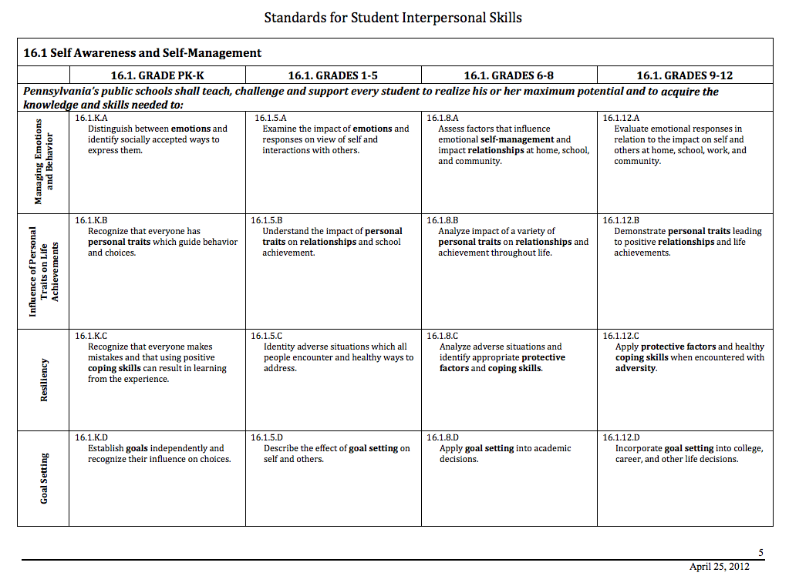
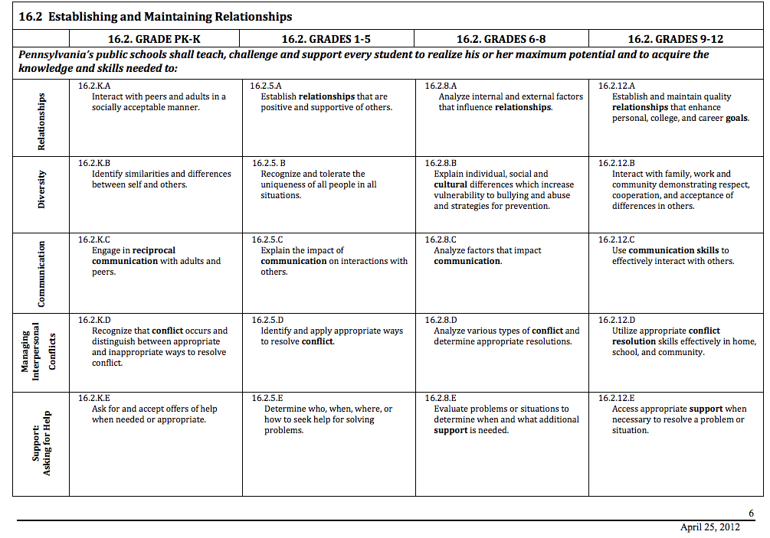
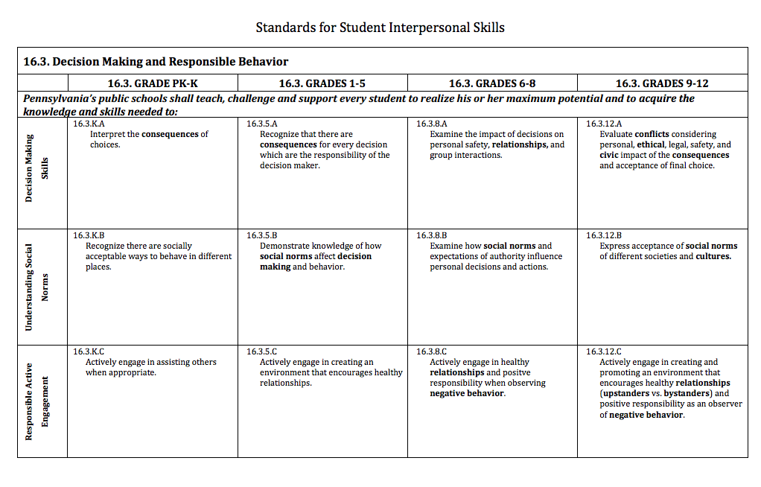

At the elementary level, the Comprehensive Guidance Program (CGC) partners with parents to promote school success by assisting students in learning the skills and attitudes necessary to be successful. It emphasizes decision-making skills and awareness of future educational and vocational possibilities. The CGC Program promotes development of positive self‐concept and the acquisition of skills in interpersonal relationships.

At the middle school level, the CGC Program focuses on the rapidly changing needs of young adolescents. The CGC Program at this level is especially sensitive to the developmental struggles of middle school students for identity while, at the same time balancing the demands for academic, career, and social competence, and for community involvement. The activities begun at the elementary level are continued. However, they are adjusted to fit the special needs of middle school students. In addition, school counselors work with students and their parents to begin to explore education/career plans that will cover graduation requirements and beyond. These plans take into account students’ interests, abilities, and educational and career goals.

At the high school level, the CGP further builds on the elementary and middle school curricula, assisting students in becoming responsible adults who can develop realistic and fulfilling life plans based on clear understandings of themselves and their needs, interests, and skills. The education/career plans developed in the middle school are reviewed and updated periodically in accordance with students’ post-graduation educational and occupational goals. Continued attention is given to assisting students to develop competence in decision making, career planning, working with others, taking responsibility for personal behavior, and contributing to the community.

XII. PROGRAM STRUCTURE: FIVE PROGRAM COMPONENTS

1. Guidance Curriculum
The Guidance Curriculum at Berlin Brothersvalley consists of guidance activities presented systematically through the classroom and structured groups K-12. The curriculum is organized around the four areas of academic, career, personal/social, and community contribution. While Berlin Brothersvalley school counselors are responsible for organizing and facilitating the implementation of the guidance curriculum, the support of teachers and administrators is critical. Examples of topics covered include:

Academic Development
Elementary Middle School High School
Listening Skills Student Advocacy 4 Year Course Selection Planning
Following Directions Study Skills Aptitude/Interest Inventories
Decision Making Goal Setting Organizational Skills
Test-Taking Skills Test‐ Taking Skills Goal Setting
Organizational Skills Organizational Skills Transcript Reviews
Goal Setting Strengths/Interests Standardized Testing
Effective Communication Skills Essential Skills Portfolios

Career Development
Elementary Middle School High School
Strengths/Interests Work Values Vocational Skills
Working Together Interests Inventories Career Center Services
School/Work Skills Academics to Work Connection Career-Related Learning
Career Path Awareness Career Path Exploration Experiences
Technology Skills
Resume Writing
SCTC Education
Mock Interviews
Job Shadows

Personal and Social Development
Elementary Middle School High School
Self-Awareness Transition Skills Personal Responsibility
Accepting Differences Empathy Skills Respecting Self and Others
Self‐Acceptance Decision-Making Interpersonal Communication
Personal Safety Social Skills Decision Making Skills
Decision Making Personal Responsibility Self Advocacy
Social Skills/Friendship Skills Self Respect/Image Safety and Survival Skills
Conflict Resolution Interpersonal Skills Problem Solving Skills
Harassment/Bullying Awareness Harassment/Bullying Awareness Responsible Use of Social Media
Resiliency Conflict Management Harassment/Bullying Awareness
Healthy Life Choices Responsible Use of Social Media

Community Involvement
Elementary Middle School High School
Awareness of Community Needs Volunteerism Volunteer Opportunities
Cooperating in Groups Service Learning Community‐based Programs
Leadership Skills Leadership Skills Service Learning Opportunities
Identifying Shared Attitudes/ Responsibility to Community School Leadership Opportunities
Beliefs and Values Co-curricular Activities
Participation in Community Projects

2. Individual Planning
In the Individual Planning component, Berlin Brothersvalley school counselors, working closely with parents, assist all students to plan, monitor, and manage their own learning as well as their personal and career development. Within this component, students develop individual education/career plans, evaluate their educational, vocational and personal goals, and consider their personal contribution to the greater community. Delivered individually or in small groups, school counselors plan and direct activities that focus on personalized planning for next steps. Individual planning is implemented through individual appraisal, educational, vocational and transition planning.

Individual planning is an important tool to help students as they move toward College and Career Readiness. Individual planning is not the same thing as individual counseling. Student planning helps focus students’ academic and career goals. The Career Education and Work Standards feature individual planning in the first strand entitled Career Awareness and Planning. These standards are Pennsylvania-specific and counselors become the natural champions of their integration across all academic standards. “All students are required to have an individualized career and post-secondary plan by the end of Grade 10. Addressing all students’ future plans enhances the counselor’s role as advocate and collaborators within the system so that all staff become involved with this process.

Individual Appraisal: School counselors, in collaboration with other staff, work with students to help them analyze their abilities, interests, skills, and achievement for developing immediate and long-range plans.

Elementary School Middle School High School
Goal setting Needs assessments Course selection
Academic progress Interest/value inventories Interest inventories
PSAT/SAT/ACT tests

Educational and Vocational Planning: School counselors, in collaboration with other staff, work with students individually to use personal-social, educational, and career information in personal, educational, and vocational planning. Schools involve students and parents in planning programs that meet individual student needs so as to:

Elementary School Middle School High School
Personal educational planning Develop career portfolio 4-year plan
Behavior success planning Develop academic portfolio Transcript review
Career strand exploration Research career opportunities SCTC Education
SCTC Education SCTC Education

Transition Planning: School counselors assist students in the transition from school to school, school to career and school to community.

Elementary School Middle School High School
Interest inventories Orientation activities Research colleges
Forecasting assistance Technical schools review Transition assistance Career Activities
Service projects Service projects College applications and scholarships
SCTC Planning
SAT, FAFSA,

3. Prevention, Intervention and Responsive Service

Berlin Brothersvalley School counselors become aware of student issues, concerns, needs, and problems through a variety of sources, including student self-referral, and referrals from faculty, family members, community representatives, friends and/or fellow students. They deliver prevention, intervention, and responsive services to meet the immediate issues affecting the Comprehensive K-12 School Counseling Programs students. Prevention, intervention, and responsive services are available for ALL students. Prevention and intervention services include, but are not limited to, one or more of the following:

• individual counseling • group counseling • family counseling
• school-based referral • community-based referral • peer assistance
• mentor assistance • short-term crisis counseling • consultation
• classroom activities • dissemination of information • workshops

While responsive services are generally delivered to individual and small groups of students, prevention and intervention services can be delivered in a direct setting (individual and group counseling), as a workshop or structured curriculum, or in an indirect manner (consultation or outside referral). These services support each student’s growth and development in the academic, career, and personal/social domains. Students are most successful when school counselors collaborate and consult with administration, faculty, staff, families, and community partners in delivering appropriate prevention, intervention, and responsive services and assist students in meeting the standards. Furthermore, how successful a school or district is in reaching its improvement goals is highly dependent on the degree to which all school members collaborate and work as a team toward this goal.

Pennsylvania counselors are involved in the Student Assistance Programs at all levels. Tiers II & III of the delivery system and RtII are designed for interventions with individual and small groups of students. Pennsylvania has numerous resources for school counselors to enhance responsive services for all students. The Resiliency/Wellness Approach and the Interpersonal and School Climate Standards are important in responsive services for all students.

The table below is a sample of these services in all three domains:

Prevention |  | Intervention | Responsive Services
Students served | All students | Referred Students |  | Students in crisis
Delivery Setting | Classroom  Large Group  Classroom  Workshop | Small Group  Individual  Consultation |  | Small Group  Individual  Consultation  Referral
Academic Domain  Examples | Elementary: Student Assistance Program | High School: Group Advising/Student Assistance Program |  | Middle School: Student Assistance Program
Career Domain Examples | High School Individual Career Plan | Middle School Small group career exploration |  | Elementary: Career/ Exit Interviews
Personal/Social  Domain Examples | Middle School: Bullying Prevention Program | Elementary: Bullying Prevention Program |  | High School: SAP Referral

a. Counseling
Individual/Crisis Counseling: Counseling is provided by Berlin Brothersvalley school counselors on an individual basis for students expressing difficulties dealing with relationships, personal concerns, or normal developmental tasks. The Counselors provide crisis intervention and skill-building and assist in referring ongoing therapeutic needs to community resources. Individual counseling topics include:

Personal Behavioral Academic Crisis
Self-esteem Anger Management Work/study habits Individual counseling
Family relationships Personal hygiene Goal setting Referral services
Peer relationships Substance abuse Academic success planning
Divorce Violence prevention
Death/ grief Social skills
Sexuality Assertiveness training
Stress Truancy/tardiness

Small Group Counseling: Counseling is provided on a small group basis for students dealing with relationships, personal concerns, or normal developmental tasks. Small group counseling assists students in solving problems and building skills.

b. Consultation
As consultants, school counselors may confer directly with teachers, parents, administrators, and other helping professionals to assist students in the school setting. Counselors assist students in dealing more effectively with developmental or adjustment needs. Consultation topics include:

Students Parents Teachers and staff Community agencies
Academic performance Academic performance Academic performance Student behavior
Behavior Behavior Behavior Academic performance
Social/emotional skills Social/emotional skills Teaching techniques Family issues
Ind. Ed. Plans (IEP) Parenting skills Classroom management Emotional issues
Transitions Substance abuse Substance abuse Educational programs
Substance Abuse Transitions Ind. Ed. Plans (IEP) Substance abuse

c. Collaboration
Effective communication between the Berlin Brothersvalley School District Comprehensive Guidance Program and all stakeholders requires the formation of collaborative structures within the school and with the community. These structures may include site councils and program advisory committees. They may also include partnerships with employers and other community members to generate learning experiences, program resources, and individual student supports.
Berlin Brothersvalley School Counselors Collaborate with:
Parents
Parent education
Communication/networking
Academic planning
College/career awareness programs
One-on-one parent conferencing
Interpretation of assessment results
Teachers
Classroom guidance activities
Academic support, including learning style assessment and education to help students succeed academically
Classroom speakers
At-risk student identification and implementation of interventions to enhance success
Administrators
School climate
Behavioral management plans
School-wide needs assessments
Student data and results
Student assistance team building
Students
Peer education
Peer support
Academic support
School climate
Leadership development
Community
Job shadowing, service learning
Crisis interventions
Referrals
Parenting classes
Support groups
Career education
**These examples are not intended to be all-inclusive
d. Coordination
Berlin Brothersvalley School Counselors coordinate guidance activities, educational activities and meetings to address student/parent issues. They also coordinate student schedules and transitions.

e. Case-Management
Berlin Brothersvalley School Counselors are responsible for managing student files that contain both educational records and confidential records. The Counselors may help to manage students’ social/emotional/behavioral needs for both in-school and out-of-school treatment. The School Counselors attend planning meetings both in school and in the community to ensure students’ they receive needed services.

f. Referrals
Referrals are made when the student’s needs or issues are beyond the scope and impact of a school guidance program. Berlin Brothersvalley school counselors make parents aware of community resources such as mental health service providers and agencies, employment and training programs, juvenile services and social services.

4. System Support
The system support and integration component addresses the need for the involvement of guidance and counseling staff in the maintenance and enhancement of the overall district plan. Berlin Brothersvalley school counselors contribute their knowledge and skills by implementing the program throughout the school and overseeing program content. To enhance student learning, Berlin Brothersvalley school counselors provide leadership and advocacy for the integration of the program framework, content, resources, and program components into the overall school improvement plan. Responsibilities consist of the following:

a. Professional Development
Staff roles and responsibilities for the Berlin Brothersvalley School District’s Comprehensive Guidance Program are explicit in program plans, position descriptions, and performance indicators. School counselors are committed to and supported in accessing ongoing professional development to maintain current professional standards and practices in the field. Staff development is provided to upgrade skills and knowledge of all staff involved in the delivery of the program. Staff evaluations address the assigned program activities and individual development needs.

b. Action Plans
The Berlin Brothersvalley School Counselors develop Action Plans in the spring of each year for the next school year. These Action Plans are developed in collaboration with each building administrator and reviewed with the Advisory Council each year. The action plans address school counseling curriculum and school improvement or closing-the-gap competencies. The action plan addresses the needs of the students discovered by the data collected.

c. Program Management/Agreements
Program management is discussed weekly with the Superintendant and Building Principals. Student issues or programming concerns are discussed and solutions brainstormed.

d. Program Evaluation
Berlin Brothersvalley School District’s Comprehensive Guidance Program is data-driven and results-oriented. Continuous program improvement requires ongoing review and evaluation mechanisms.
Student Progress – The Berlin Brothersvalley School District’s Comprehensive Guidance Program exists to support the school’s mission and individual student success. Review and analysis of individual, group, and aggregate data on student progress provide the foundation for program evaluation and program improvement activities. This review process in ongoing at Berlin Brothersvalley and is done by the School Counselors, Building Administrators, Teachers, and Special Education Coordinator.
Staff Development – Staff roles and responsibilities for the Berlin Brothersvalley School District’s Comprehensive Guidance Program are explicit in program plans, position descriptions, and performance indicators. The School counselors are committed to and supported in accessing ongoing professional development to maintain current professional standards and practices in the field. Staff development is provided to upgrade skills and knowledge of all staff involved in the delivery of the program. Staff evaluations address the assigned program activities and individual development needs.
Program Planning and Evaluation – Program planning and evaluation for Berlin Brothersvalley School District’s Comprehensive Guidance Program is an integral part of the overall district improvement planning and evaluation process. Initial planning establishes program objectives and sets a course of action. Regular program evaluations provide accountability measures and data to assist in improvement plans. These ongoing evaluation activities are part of the district’s total assessment process.

e. Consultation with Staff
Professional Staff – Berlin Brothersvalley School District’s Comprehensive Guidance Program requires the participation of all school staff to provide comprehensive, integrated services to each student. Professional staff guides the program team as it plans, designs, implements, documents, and evaluates the program. The presence and leadership of licensed school counselors enhances the likelihood of program success.

f. Community Outreach
The Berlin Brothersvalley School Counselors collaborate with community partners to provide career related and educational programming for students. Students participate in numerous community service projects and do job shadowing throughout the community. In addition, Community Leader’s conduct presentations for K-12 students. Community members are informed of the District’s Strategic Planning Goals via the school website and District Newsletters.

g. Public Relations
The District Superintendent supervises all public relations with the media-outlets: however, the school counselors often play a crucial role in the day-to-day relations with the students’ families. The Berlin Brothersvalley School Counselors take this responsibility seriously and work to maintain a good working relationship with the parents and other members of the community.

h. Technology
The Berlin Brothersvalley school counselor:
a. Promotes the benefits of and clarifies the limitations of various appropriate technological applications. The counselor promotes technological applications (1) that are appropriate for the student’s individual needs, (2) that the student understands how to use and (3) for which follow-up counseling assistance is provided.
b. Advocates for equal access to technology for all students, especially those historically underserved.
c. Takes appropriate and reasonable measures for maintaining confidentiality of student information and educational records stored or transmitted over electronic media including although not limited to fax, electronic mail and instant messaging.
d. While working with students on a computer or similar technology, takes reasonable and appropriate measures to protect students from objectionable and/or harmful online material.
e. Is engaged in the delivery of services involving technologies such as the telephone, videoconferencing and the Internet and takes responsible steps to protect students and others from harm.

i. Tools for System Support

1. School Counseling Description in School Calendars

2. School Counseling Department web-pages on the Berlin Brothersvalley School District Website

3. School Counseling Newsletters

4. District Newsletters

5. Newspapers, radio and other local media

6. School Mailings

7. Parent Education Programs and Trainings

XIII. Organizing Career/Postsecondary Resources

Resource Types | List Resources
Organizations/Agencies
Intermediary Organizations | JARI  SOAR  Goodwill Industries  Southern Alleghenies Regional Career Force Devel.  PA Free Enterprise
Umbrella Organization | Somerset Chamber of Commerce  Somerset County Builder’s Association  Rural Electric Company  Somerset County Camp Cadet  Outdoor Odyssey  Big Brothers/Big Sisters  Boys and Girl Scouts of America  4-H Programs  Girls and Boys Club of America
Community/State Agencies | Career Link  United Way  Goodwill Industries  Somerset County SADD  Somerset County Drug and Alcohol  Twin Lakes  Somerset County Children and Youth Services  Somerset County Employment Office  Hirum G. Andrews
Networking Opportunities
Individual Contacts | Greta Lowry: Outdoor Odyssey  Armed Forces Recruiters  Academic Recruiters from over 30 post-secondary schools  Goodwill Industries  Board of Family Services  Tableland  Family Center  SCI Somerset
Community/Business Meetings | Young Famers  Lions Club  Local Ministerial Group  Somerset County Counselor Association
Community Events | College Career Fair  Financial Aide Workshops  Berlin Community Fair  Somerset County Fair  SCTC Tour and Parent Night
Online/On-land
Internet Based Links | ACRN - Career Development Toolkit:  acrn.ovae.org/counselortk/career-plan.htm  The Career Game by Rick Trow Productions:  www.careergame.com/  Virtual Job Shadow  www.virtualjobshadow.com/  Occupational Outlook Handbook:  www.bls.gov/oco/  Pennsylvania Career Education & Work (CEW) Standards Toolkit :  www.pacareerstandards.com/  Explore careers:  mappingyourfuture.org/planyourcareer/  mycareerchoices.org  pathfinder.org  collegeboard.org
Media/Advertising | Somerset Daily American  WJAC-TV  Johnstown Tribune Democrat  The New Republic  Local Radio  District Newsletter  Guidance Newsletters
Publications/Documents | Occupational Outlook Handbook  Careers Are Everywhere in Pennsylvania Activity Book  Developmental Guidance Classroom Activities for use with the National Career Developmental Guidelines K-12  Career Direction: A Practical Guide for Planning Your Future  Career Counseling: Applied Concepts of Life Planning  Go Places: A User’s Guide to PHEAA’s Early Awareness Program  COIN Workbooks

XIV. Individualized Academic/Career Plan

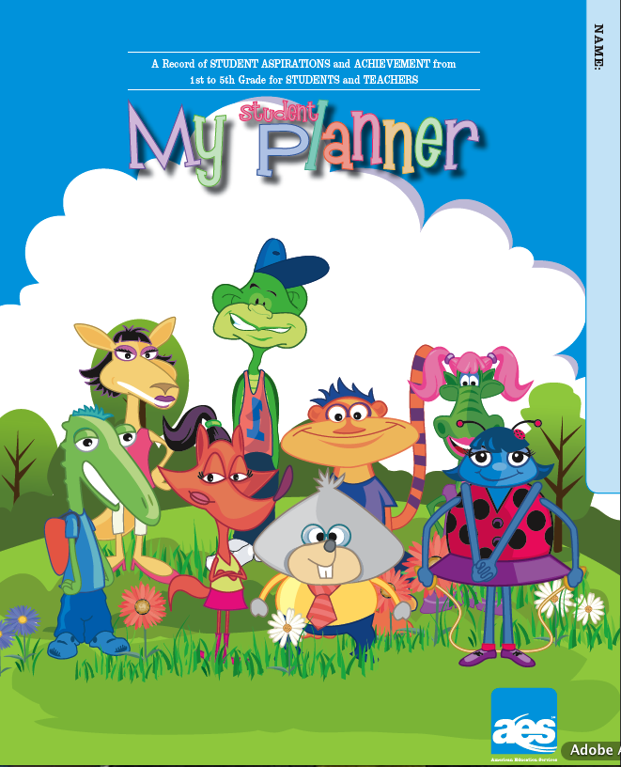

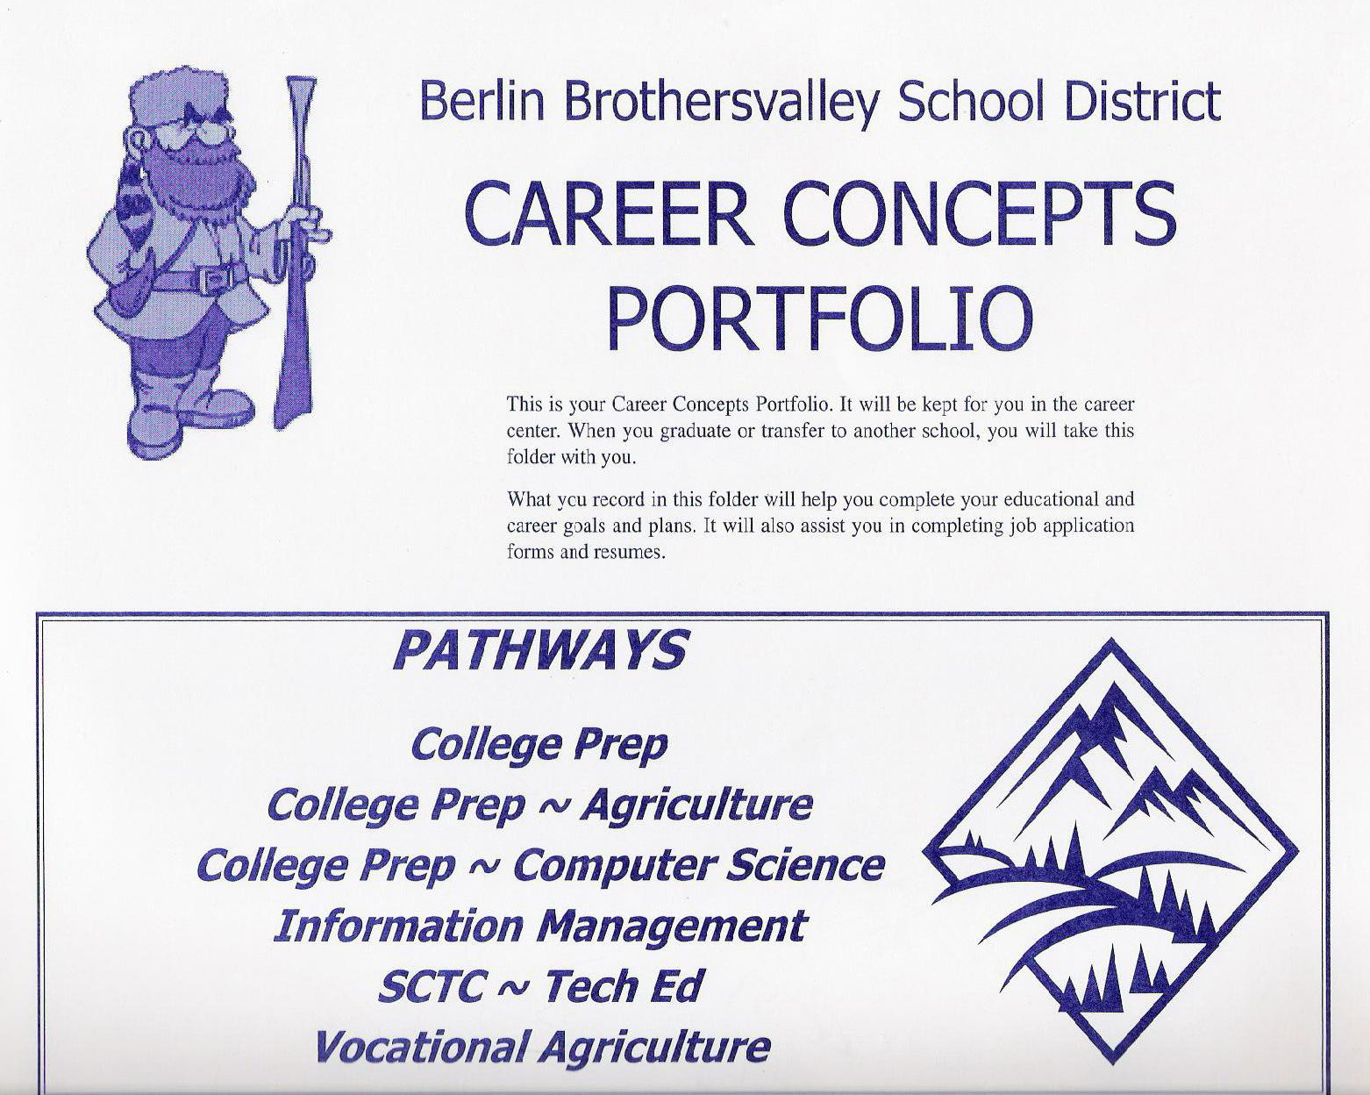
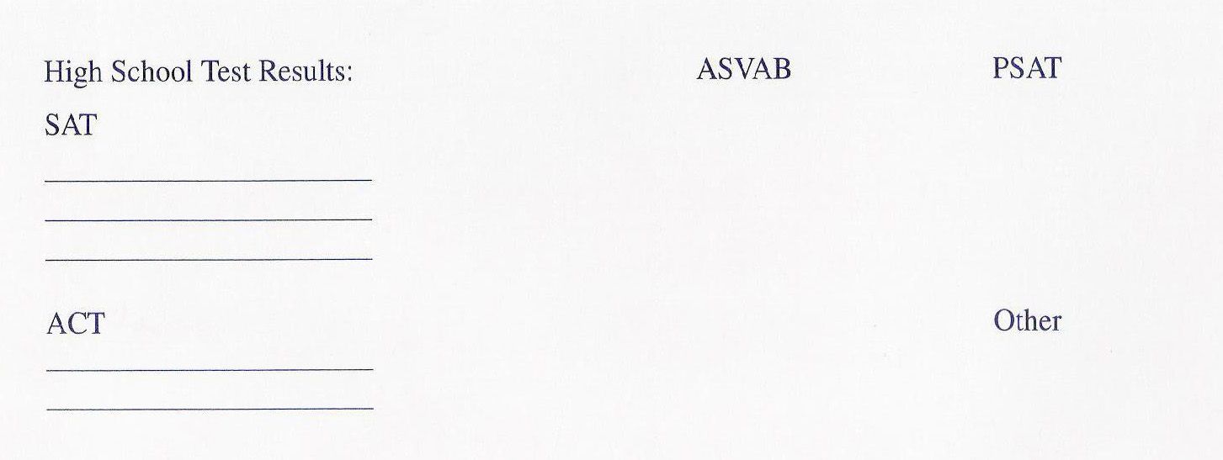
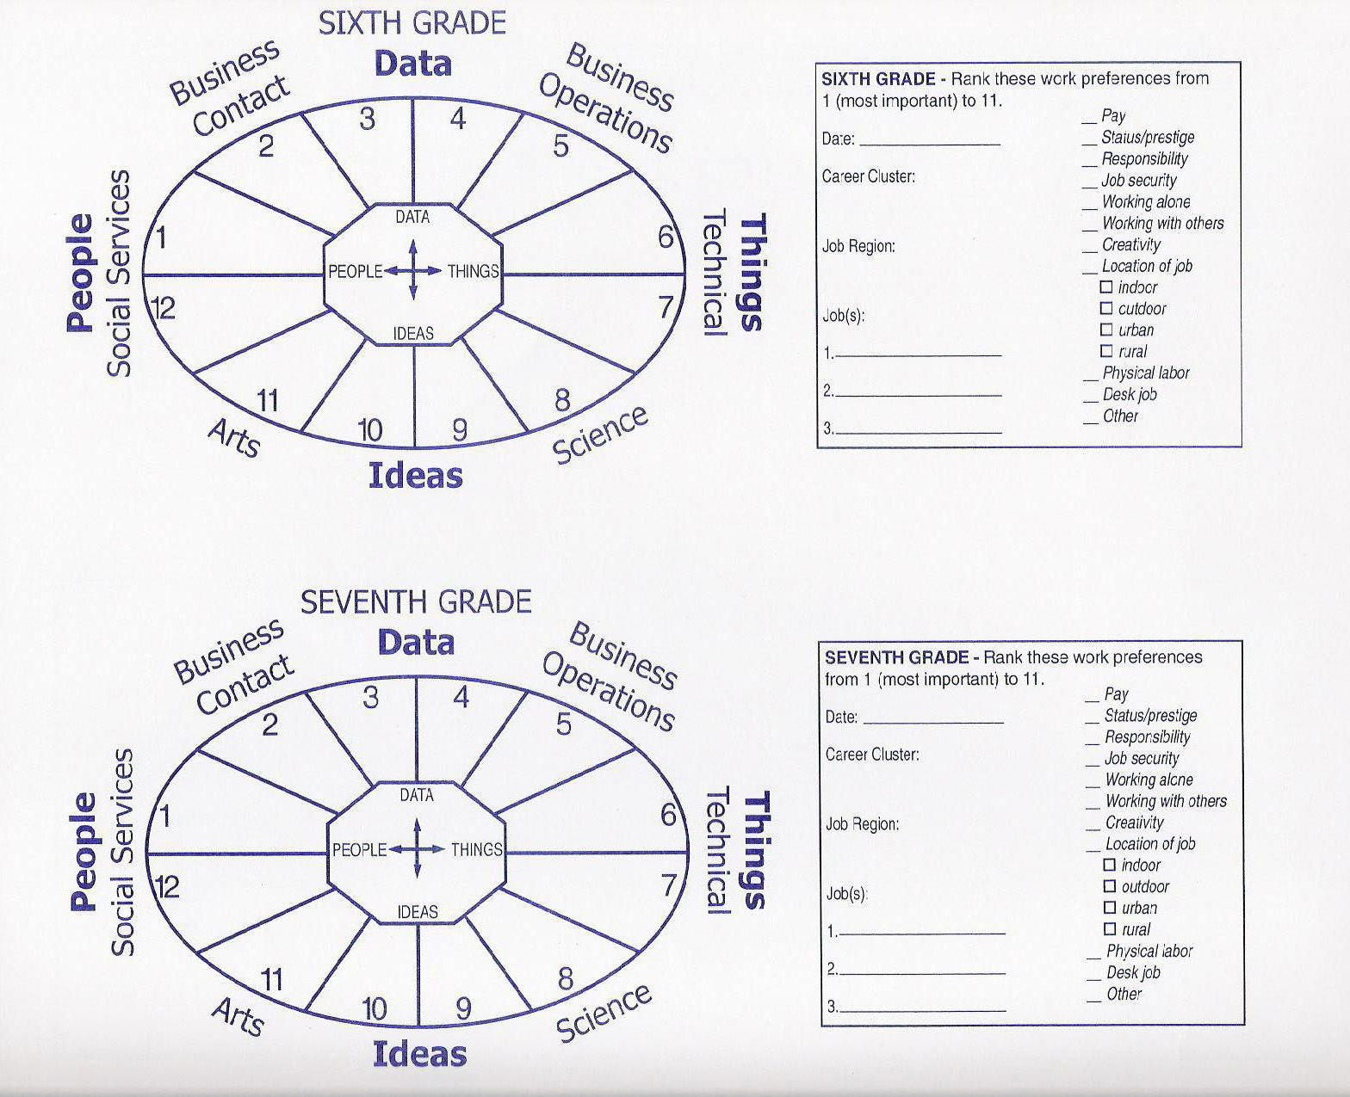
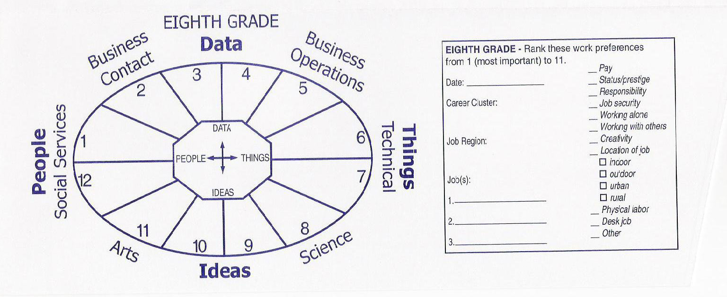
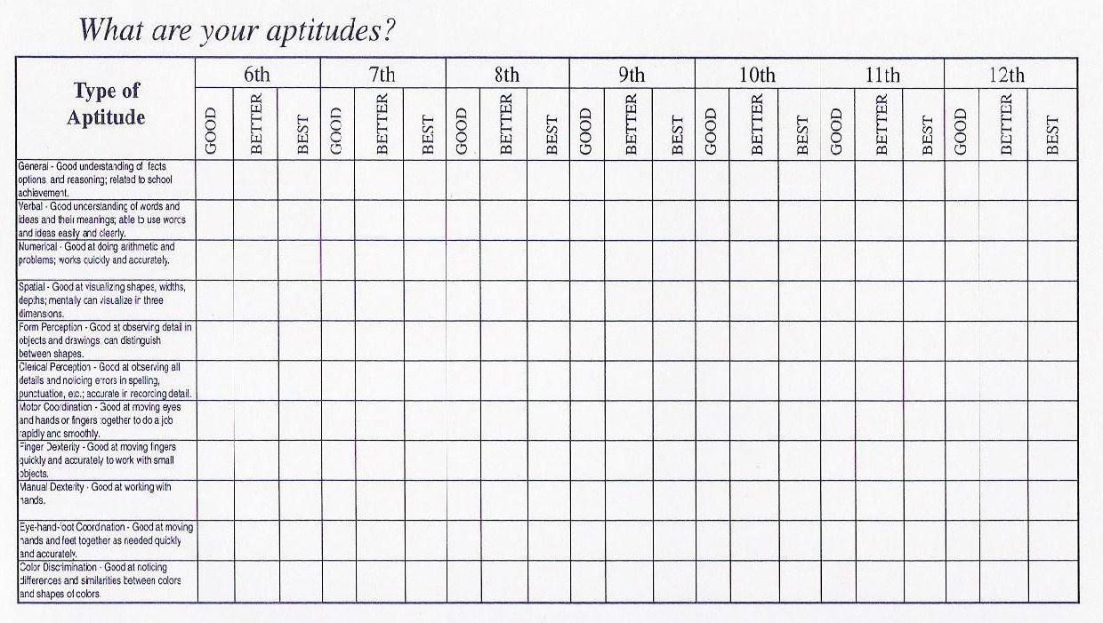
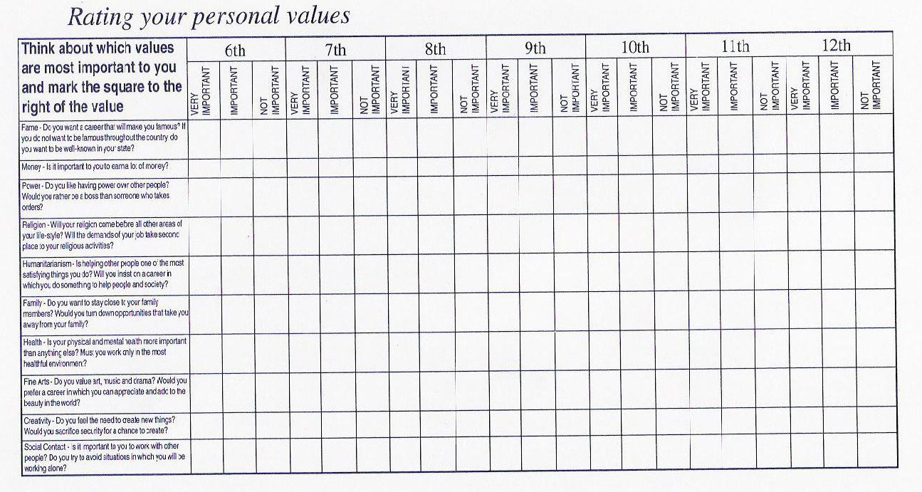
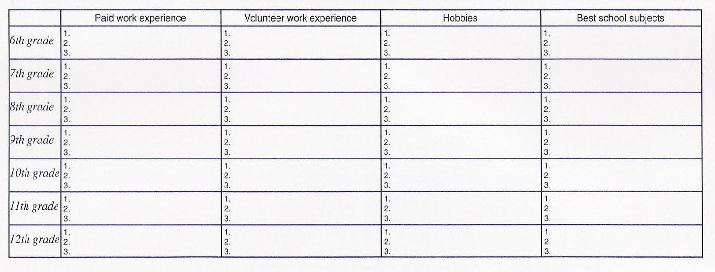
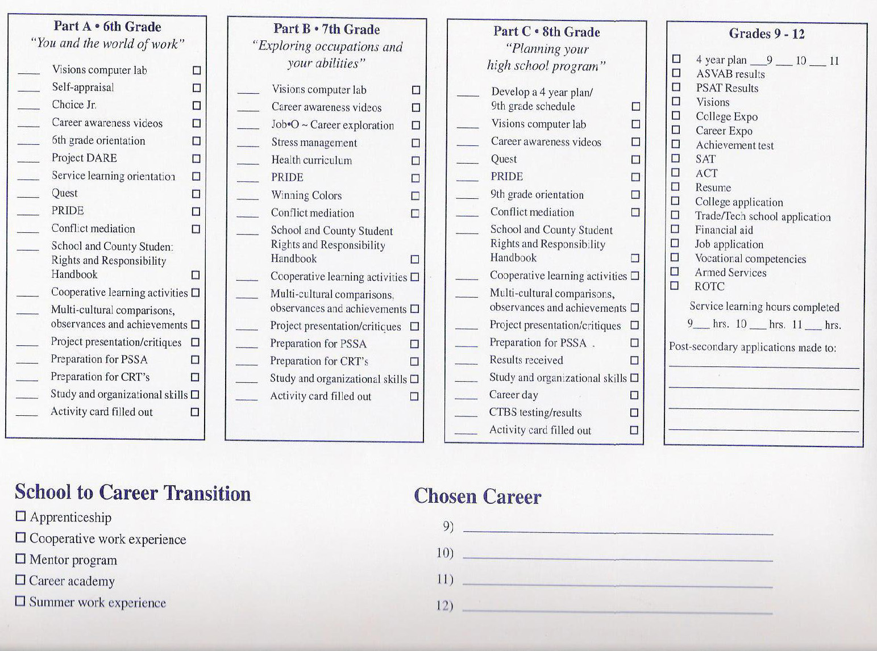
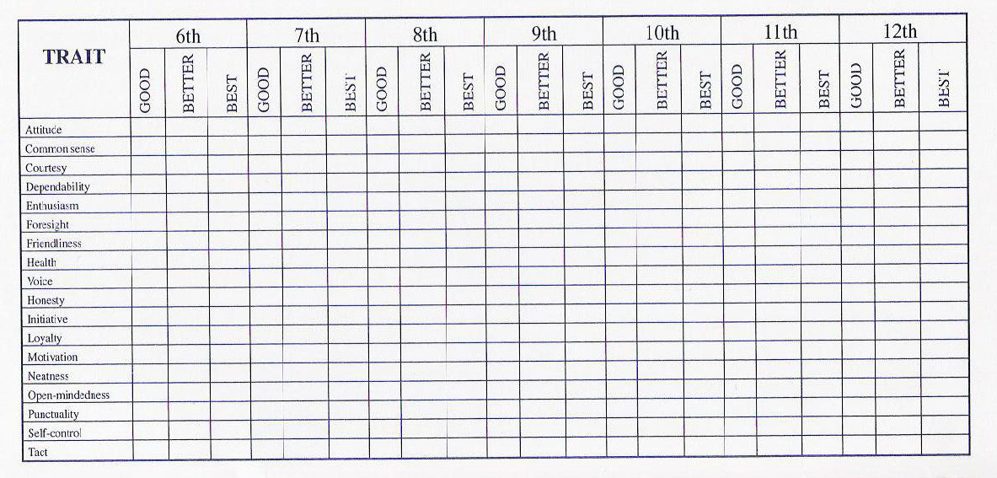

XV. Career and Technical Center Strategy

Student Awareness:
Grade | Intervention/Program/Events | Stakeholder  Delivering | Data Used  Success Indicator | Begin&  End | Contact Person
4 | Fourth Grade Exit Interviews | Guidance Counselor |  | Annual/May | Keith Hay
5/6 | SCTC Career Camp | SCTC | # attendees | Annual/Week long program | Vanessa Gardner
6/7/8 | Career Awareness Lessons | Guidance Counselor | Completion of Student Portfolio | Annual/November/December | Mark Smith
9 | Career Readiness Classes | Guidance Counselor | Grade of 70% or higher | Annual/Yearlong | Christy McMillen/Brian Thompson
9 | SCTC Introduction and Visitation | SCTC Guidance Counselor  Guidance Counselor | # of returned applications | Annual/ September-October | Verna Carberry  Christy McMillen
9-12 | FFA PA Farm Show Trip | FFA Advisors | # of attendees | Annual/January | Dan Miller  Christy McMillen
9-12 | Career Expert Lectures | Individual Pathway Teachers | # of attendees | Annual/Random | Teachers
10 | Career Directions Program | National Guard Recruiter/Guidance Counselor |  | Annual/3 days | Christy McMillen
10/*11/12  (*- Required) | ASVAB | MEPS | ASVAB Score | Annual/December | Military Personnel  Christy McMillen
10/*11/12  (*- Required) | ASVAB Score Interpretation | Guidance Counselor | Ratio of Students interviewed | Annual/January | Christy McMillen
11 | Graduation Project Introduction | Principal/  English Department | Return of Parent/Student Check off | Annual/April | Brian Thompson  Rebecca Nakich
11 | College Fair | Guidance Counselor | # of attendees | Annual/March | Christy McMillen  Maria Murphy
11/12 | CSI Career Camp | Guidance Counselor | # of attendees | Annual/April | Christy McMillen
12 | Graduation Project Presentations | Principal/English Department | Pass/Fail | Annual | Rebecca Nakich
12 | Post-Secondary Readiness Interviews | Guidance Counselor | Completed Post-Secondary Plan | Annual/September-October | Christy McMillen
12 | Wallops Island Trip | Biology Teacher | # of attendees | Annual/May | Erin Karwatsky
12 | Mount Aloysus Health Career Fair | Biology Teacher | # of attendees | Annual/October | Erin Karwatsky  Christy McMillen

Parent Awareness:
Intervention/Program  Events | Date | Stakeholder  Delivering | Data Used  Success Indicator | Contact Person
Fourth Grade Exit Interviews | Annual/May | Guidance Counselor |  | Keith Hay
SCTC Career Camp | Annual/week long program | SCTC | # attendees | Verna Carberry
Freshman Orientation | Annual/January through March | Guidance Counselor | Completed Student Schedule | Christy McMillen
SCTC Introduction and Visitation | Annual/ September-October | SCTC Guidance Counselor  Guidance Counselor | # of returned applications | Verna Carberry  Christy McMillen
College Fair | Annual/May | Guidance Counselor | # of attendees | Christy McMillen  Maria Murphy

Educator Awareness:
Intervention/Program  Events | Date | Stakeholder  Delivering | Data Used  Success Indicator | Contact Person
SCTC Career Camp | Annual/Week long | SCTC | # attendees | Verna Carberry
Somerset County Counselor Meetings | Monthly | Guidance Counselors | Certificate of Attendance | Counselor Association President
Somerset County Unified In-service | Annual/October | Somerset County In-service Committee | Certificate of Attendance/Act 48 | Somerset County In-service Committee
Teacher Act 80 Days | Annual/Random | Staff Members | Certificate of Attendance/Act 48 | Lori Gindlesperger
Continuing Education Conferences/Workshops | Annual/Random | Guidance Counselors | Certificate of Attendance/Act 48 | Conference/Workshop

Update: XVI. BERLIN BROTHERSVALLEY SCHOOL DISTRICT: Job Description

GUIDANCE COUNSELOR

DEFINITION
Under direction, to provide behavioral, educational, career, and vocational counseling to individuals and small groups of students; to assist students in understanding and seeking solutions to social, emotional, or academic problems and issues; to serve as a resource pertaining to student behavior management strategies, and welfare and attendance problems and concerns; and to do other related functions as required.

DISTINGUISHING CHARACTERISTICS
This position classification requires subject matter expertise commonly taught in public schools, and counseling and guidance knowledge and skills. Responsible and directly related experience is required to perform problem analysis using widely prescribed principles and concepts. The position classification performs decision analysis and makes decisions of considerable consequence, requiring the application and interpretation of data, facts, procedures, and policies. The incumbents meet frequently with school administrators, teachers, other staff, and parents to communicate information, data, and alternative problem solutions. This is a sedentary position classification and performs light work involving sitting a considerable portion of the time, but does require walking and standing for extended periods. This position requires accurate perceiving of sound, near and far vision, depth perception, providing oral information, and handling and working with instructional and assessment materials and objects.

Reasonable accommodation may be made to enable a person with a disability to perform the essential functions of the job.

EXAMPLES OF DUTIES
•Performs individual and group counseling and guidance functions and activities, including career and vocational, and social and emotional adjustment counseling.
•Collects, organizes, and analyzes student information through the use of educational historical data, test results, and through the use of interview techniques.
•Appraises student interests, aptitudes, and attitudes utilizing a variety of assessment strategies and techniques.
•Provides information and data to students concerning educational, career, and vocational planning.
•Serves as a resource to District personnel, and members of the school community.
•Meets, confers, and counsels with parents, school personnel, and members of various youth serving agencies in developing alternative solutions to student educational, social, and emotional problems and concerns.
•_Assists in the development and monitoring of individual education plans for students with exceptional needs.
•Maintains a liaison with social service and youth service agencies in pursuing referral follow up activities.
•Pursues evaluation and research activities to determine counseling and guidance effectiveness.
•Assists in the planning, development, and implementation of master student program calendars.
•Assists in identifying school program needs, and participates in developing school instructional programs geared to meet individual pupil needs.
•Assists in the planning, development, and conduct of programs that enhance student educational, career, and vocational opportunities, including speaker programs, student visitation programs, and other similarly related activities.
•Establishes, maintains, and monitors the maintenance of a variety of files and records pertaining to student counseling, guidance, and related matters.
•Assists in dealing with student behavior management problems, and in resolving welfare and attendance problems and concerns.
•Plans, develops, and presents, as requested, a variety of management related reports pertaining to site counseling and guidance functions and activities.

QUALIFICATIONS
Knowledge of:
Principles, methods, techniques, strategies, and trends in educational, vocational, career, social, and emotional adjustment counseling;
Applicable and appropriate aptitude, interest, and achievement appraisal instruments, techniques, and procedures;
Social service and youth service agencies in the local area;
Social, emotional, and behavioral characteristics of K-12 students;
Program evaluation and research techniques, strategies, and procedures;
Appropriate curriculum and instructional programs pertaining to students with a variety of aptitudes and varying interests.

Ability to:
Assist students in effectively analyzing and developing alternative solutions to behavioral, educational, social, and emotional problems and concerns;
Conduct, analyze, and effectively utilize a variety of individual and group testing procedures and instruments applicable to student clients;
Effectively deal with District personnel, parents, social and youth service agencies in resolving student problems and concerns;
Effectively participate in the planning and implementation of school guidance and curricular programs; Communicate effectively in oral and written form;
Understand and carry out oral and written directions with minimal accountability controls;
Establish and maintain effective organizational, public, and community relationships.

EXPERIENCE AND EDUCATION
Any combination of experience and training that would likely provide the required knowledge and skill is qualifying. A typical way to obtain the required knowledge and skill would be:

Education:
Equivalent to the completion of an earned Master of Arts or higher degree in
psychology, counseling and guidance, or a closely related field.

CERTIFICATION REQUIREMENT
Possession of a valid Pennsylvania teaching certificate as a school counselor.

PHYSICAL REQUIREMENTS AND WORKING CONDITIONS
NAME |  |  |  |  |  |  | SUPERVISOR
JOB TITLE: Guidance Counselor |  |  |  |  |  |  | DEPARTMENT Elementary, Middle, High School
EMPLOYMENT STATEMENT OF JOB REQUIREMENTS
A. |  | PHYSICAL DEMANDS | No | O | F | C | B. | Working Conditions (cont) | No | O | F | C
1. |  | Standing |  |  | X |  | 8. | Confined Spaces |  | X
2. |  | Walking |  |  | X |  | 9. | Heights | X
3. |  | Sitting |  |  | X |  | 10. | Constant noise above 85 db |  | X
4. |  | Lifting: Heavy-Max 65 lbs | X |  |  |  | 11. | Intermittent noise above 85 db |  | X
5. |  | Lifting: Heavy-Mod 40 lbs | X |  |  |  | 12. | Vibration | X
6. |  | Lifting: Mod – Max 25 lbs |  | X |  |  | 13. | Fumes Irritant/Toxic | X
7. |  | Lifting: Light-Max 10 lbs |  | X |  |  | 14. | Dust More than nuisance | X
8. |  | Carrying Est. Wt. 10 Lbs. |  | X |  |  | 15. | Gases Type | X
9. |  | Pushing Est. Wt. 20 Lbs. |  | X |  |  | 16. | Lead | X
10. |  | Pulling Est. Wt. 10 Lbs. |  | X |  |  | 17. | Silica-Asbestos | X
11. |  | Pulling hand over hand |  |  |  |  | 18. | Chemical Types  Types | X
 |  |  | X
12. |  | Climbing stairs |  | X |  |  | 19. | Grease and Oils | X
13. |  | Climbing - Use of legs/arms | X |  |  |  | 20. | Working with machinery w/ moving parts | X
14. |  | Balancing | X |  |  |  | 21. | Working with moving vehicles | X
15. |  | Stooping |  | X |  |  | 22. | Working with ladders/scaffold | X
16. |  | Kneeling |  | X |  |  | 23. | Working below ground | X
17. |  | Repeated Bending | X |  |  |  | 24. | Working with hands on water | X
18. |  | Crawling | X |  |  |  | 25. | Working alone |  |  | X
19. |  | Reaching: High/Low Level |  | X |  |  | 26. | Hours worked weekly more than 40 (average) Other |  | X
20. |  | Fingers movement-Repetitive |  | X
21. |  | Repetitive twisting or pressure involving wrist or hands | X |  |  |  | C. | PROTECTIVE EQUIPMENT REQUIRED | No | O | F | C
22. |  | Both hands required |  | X |  |  | 1. | Gloves - Type | X
23. |  | Both legs required | X |  |  |  | 2. | Gown | X
24. |  | Ability for rapid mental/muscular coordination simultaneously | X |  |  |  | 3. | Mask | X
25. |  | Oral communication/speak clearly |  |  | X |  | 4. | Eye Wear - Type | X
26. |  | Hearing – conversation |  |  | X |  | 5. | Respirator – Type | X
27. |  | Specific visual requirements | Near |  | Far |  | 6. | Hearing Protection Type | X
28. |  | Depth perception | Yes |  | No |  | 7. | Hard Hat | X
29. |  | Color Vision | Yes |  | No |  | 8. | Boots - Type | X
30. |  | Operation of truck/motor vehicle - Other | No |  | No |  | 9. | Body Protection | X
B. |  | WORKING CONDITIONS | No | O | F | C | D. | EXPOSURE CATEGORIES
1. |  | Outside | X
2. |  | Outside and Inside | X
3. |  | Heat between 90 – 100 | X
 |  | Heat over 100 | X
4. |  | Cold below 55 | X |  |  |  | O=Occasionally - up to 25% time on job  F=Frequently - 25 - 75 % time on job  C=Constantly - more than 75% time on job
5. |  | Temperature changes  Excessive – Frequent | X
6. |  | Wetness | X
7. |  | Dry atmospheric conditions | X |  |  |  | DATE: 4/11

